Access On Demand

An Analysis of the Accessibility Options
on Streaming Television
Katie Ellis, Kathryn Locke, Gwyneth Peaty, Hersinta and Kai-Ti Kao
August 2021
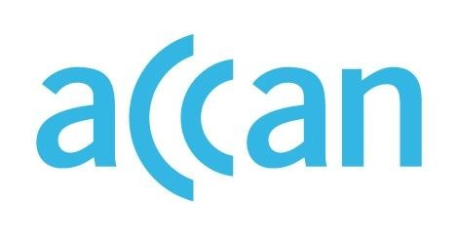
Access On Demand: An Analysis of the Accessibility Options on Streaming Television
Authored by Katie Ellis, Kathryn Locke, Gwyneth Peaty, Hersinta and Kai-Ti Kao
Published in 2021
This project was funded by a grant from the Australian Communications Consumer Action Network (ACCAN).
The operation of the Australian Communications Consumer Action Network is made possible by funding provided by the Commonwealth of Australia under section 593 of the Telecommunications Act 1997. This funding is recovered from charges on telecommunications carriers.
Centre for Culture and Technology, Curtin University
Website: ccat.curtin.edu.au
Email: katie.ellis@curtin.edu.au
Telephone: 08 9266 2509
Australian Communications Consumer Action Network
Website: www.accan.org.au
Email: grants@accan.org.au
Telephone: 02 9288 4000
If you are deaf, or have a hearing or speech impairment, contact us through the National Relay Service: https://www.communications.gov.au/what-we-do/phone/services-people-disability/accesshub/national-relay-service/service-features/national-relay-service-call-numbers
ISBN: 978-1-921974-71-7
Cover: Design by Nathaniel Morrison with images from Shutterstock
This work is copyright, licensed under the Creative Commons Attribution 4.0 International Licence. You are free to cite, copy, communicate and adapt this work, so long as you attribute the authors and “Curtin University, supported by a grant from the Australian Communications Consumer Action Network”. To view a copy of this licence, visit http://creativecommons.org/licenses/by/4.0/
This work can be cited as: Ellis, K., Locke, K., Peaty, G., Hersinta & Kao, K. 2021, Access on Demand: An analysis of the accessibility options on streaming television, Australian Communications Consumer Action Network, Sydney.

Table of Contents
Key Terms iii
Figures and Tables iv
Preface 1
Acknowledgements 2
Executive Summary 3
Recommendation to Governments: review legislation 4
Recommendation to the Industry: increase accessibility and communicate clearly with the audience how and where to access it 4
Recommendation to Audience: keep advocating for improved accessibility 4
Introduction 5
Background and Context: The Streaming Wars 5
Impact of COVID-19 on VOD 6
Mainstream Use and Awareness of Accessibility Features 7
Evolutions in Accessibility in VOD 8
Literature Review 9
CC: From an Accessibility Focus to Mainstream Acceptance 9
AD and Audio-only: The Rise and Rise 10
Methodology 14
Phase 1 – Accessibility Policy Scoping Study 14
Phase 2 – Online Survey 14
Phase 3 – Interviews 14
Phase 4 – Co-designed Tip Sheets 15
Results 16
Accessibility Features and Policies in VOD: A Review 16
Subscription VOD services 16
Broadcast VOD services 17
Survey Results 17
Demographics 17
How and what people watch 18
Experiences for people with disability 20
Experiences for people without disability 23
Interview Findings 24
Demographics and Individual Experiences of Access 24
Social Dynamics 25
User Interface Issues 25
Case Study: Adapting to AD 26
Conclusions 28
Recommendation to Governments: review legislation 29
Recommendation to the Industry: increase accessibility and communicate clearly with the audience how and where to access it 29
Recommendation to Audience: keep advocating for improved accessibility 29
Authors 30
Appendices 32
Appendix 1: Captions, Audio Description and Accessibility Policies on Australian Video on Demand Services 2014–2020 32
Appendix 2: Survey Questions 34
Appendix 3: Interview Questions 38
Appendix 4: Tip Sheets 39
References 44

Key Terms
To help clarify the terminology used in this report, the following table provides definitions of the different accessibility features covered. Note, this table is not conclusive, but reflects the main accessibility features for watching Video on Demand (VOD) highlighted by participants in our survey.
Table 1. Definitions of VOD accessibility features
Feature | Description
AD (audio description) | An audio track of narration which describes important visual elements of a television show, movie or performance
CC (closed captions) | A presentation of the audio component of audio-visual content as text on screen
Spoken subtitles | A reading aloud of interlingual subtitles. Can be generated as a separate audio track by the broadcaster or created by the receiver using text to speech software
Clean audio | A provision of the speech without any (or reduced) background music or other sounds
Talking menus | A built-in voice-guided navigation function which reads menu items aloud
Screen reader support | Hardware that provides a built-in screen reader which reads aloud the content of the screen OR is compatible with screen reader software such as JAWS

Figures and Tables
Figure 1. Updated timeline of the history of VOD in Australia 6
Figure 2. Participants’ household income 18
Figure 3. Participants’ reasons for watching VOD television 18
Figure 4. Participants’ use of VOD services 19
Figure 5. Participants’ preferred devices to access VOD television 20
Figure 6. Participants’ disability type 21
Figure 7. Participants’ responses on the availability of VOD accessibility features 22

Table 1. Definitions of VOD accessibility features iii

Preface
This report focuses on the availability and uses of accessibility features such as closed captions (CC) and audio description (AD) on streaming or video on demand (VOD) platforms in Australia. Audio-visual media now dominates how we communicate, learn and connect; in order to fully participate in Australian society and culture, all people must have access to audio-visual media, both online and offline. This has become even more important since the start of the COVID-19 pandemic in early 2020. The research for this report took place throughout 2020 and 2021 when VOD took on new importance as cinemas, theatres and other arts and recreational events closed, and the population stayed home to save lives during pandemic lockdowns throughout Australia.
While 2020 was an important year for VOD in Australia, so too was 2015 when our first subscription VOD platforms – Netflix Australia, Stan and Presto – were introduced to the market. At that time, the Australian Communications Consumer Action Network (ACCAN) funded the research team to undertake a four-stage pilot study into contemporary developments in Australian subscription VOD. Accessibility options on these platforms in Australia were evaluated against Australian broadcasting legislation, online access recommendations and international services. The project also gained user-centred insights from consumers with disability regarding their current and anticipated use of subscription VOD.
As Australia entered its first period of lockdown in March 2020, the same research team again applied to ACCAN with a proposal to update the 2015 research in light of the changes to both the VOD market and accessibility on television in Australia generally. While some platforms present in 2015 had left the market, there had also been a great influx of newer services. With these services came accessibility features which were mandated internationally but which were not necessarily legislated for Australian audiences; as such, access started to become a consumer issue. At the same time, the Australian public broadcasters ABC and SBS were funded to introduce AD on their broadcast television offerings. While VOD was not included in their initial service, for audiences who had long awaited AD, VOD is the next logical step.
While this research very much speaks to the experience and importance of both accessibility and VOD during COVID-19, the project also updates important research that originally stemmed from a commitment to better include people with disability in the media and popular culture as the world moved further into the digital age.

Acknowledgements
Thank you first and foremost to all the individuals who participated in our survey, interviews and helped to develop the tip sheets. People with disability are often called on to help resolve inaccessibility, but rarely acknowledged as experts in this field. This project aimed to challenge this assumption and incorporate the expertise of people with disability at all stages – from its early development, through to the writing of the report. Your participation is greatly valued and we thank you for your insights and skills.
We also want to thank the advisory group that has worked alongside us during the project, helping to guide and refine our focus, and provide feedback throughout each stage, specifically, Michael Coonan, Ulf Sthamer, Gerry Neustatl, Emma Bennison, Manisha Amin, Wayne Hawkins and Ben Milbourn. Please note that the views and recommendations in this report are those of the Curtin researchers who have authored it, and not the broadcasters whose staff are represented on the advisory group.
Thank you also to Chris Mikul, Bruce Maguire, Chris Edwards, Natasha Eves and Mike Kent for your support. Thanks to Kai-Ti Kao and Hersinta for their internship work, and to admin staff at the School of Media, Creative Arts and Social Inquiry at Curtin University (MCASI), especially Lynda Durack. Thank you to Ceridwen Clocherty for proof reading and editing. A big thank you all for your contribution and generosity.
Lastly, thank you to ACCAN for your continuing support and leadership in the field of accessibility.

Executive Summary
This report details findings of the research project Access on Demand: An Analysis of the Accessibility Options on Streaming Television. The 12 month project updated research on the same topic previously conducted in 2015. In addition to a review of national and international policy, 267 people with and without disability were surveyed, and 12 participated in in-depth interviews.
The aims of this project were to
- Identify what accessibility features Australian consumers with disabilities want from on demand television and investigate how they currently use these platforms
- Evaluate the accessibility of on demand platforms in Australia against existing legislation and community expectations
- Compare the affordances of subscription versus free to access on demand
- Compare access features on current Australian on demand platforms with those available 5 years ago

This report has three parts. Part 1 offers a literature review of the accessibility offered on demand focusing in particular on audio description and closed captions. The review notes that while CC has infiltrated a mainstream audience, audio-based forms of streaming entertainment became more popular during the pandemic and are on the cusp of likewise attracting a wider audience if made available.

Part 2 outlines the methodology undertaken in this project emphasising the importance of co-designing research with both industry and community and recognising the expertise of all people with disability who participate in research.

Part 3 of the report is concerned with the findings of, and offers discussion on, the results of the survey and interview stage of the research project. A total of 267 people (both with and without disability) participated in the survey regarding their use of both subscription and free to air VOD services in Australia. Detailed insights were gained into how people with disability are currently using VOD television, their anticipated usage of newer services being introduced, how and what accessibility features were used, and what factors affected their use. People with disability, their families, carers and the broader community who used accessibility features were sourced as survey respondents through disability organisations, social media, community groups and Curtin University student and staff networks. We triangulated the data obtained through the survey with 12 follow up interviews and discovered:
- Accessibility is becoming valued in the broader community. It has become an increasingly important reason for watching VOD for both people with (46%) and without disabilities (37%).
- The use of accessibility features does not necessarily relate to the presence of disability – people with and without disabilities are using accessibility features.
- AD has become an important part of the VOD landscape.
- For people with disability, AD is the most significant accessibility feature for 45% of respondents (followed by CC for 44% and talking menus 35%).
- Beyond availability, users of AD revealed the importance of the quality, the skill of audio describers, and consideration of AD as part of the content production process.
- The influx of new entrants into the VOD landscape has shifted the issue of accessibility into the realm of consumer choice and expectation.
- Whereas in 2015/6 participants blamed the government for a lack of action on VOD accessibility, particularly around AD, in 2020/1 our participants hold the broadcasters and providers responsible for the provision of accessibility features.
- During COVID-19 lockdowns in Australia VOD became an important form of entertainment. While increased competition was expected in 2020 with the introduction of new platforms, the pandemic instead prompted audiences to diversify and expand their viewing across multiple services. The streaming wars of 2015/6 became a streaming co-existence in 2020/1.
The report concludes with recommendations that emerged from the research findings. These recommendations are:

Recommendation to Governments: review legislation
As the Australian audience migrates towards VOD more than broadcast it is essential that the quality and consistency of AD and CC be addressed. We recommend that the same required quotas of CC currently mandated for broadcast television be replicated for on demand television. Further, we recommend the provision of AD be incorporated into this review as a strategy to compel commercial broadcasters to implement this accessibility feature.

Recommendation to the Industry: increase accessibility and communicate clearly with the audience how and where to access it
We recommend a clear set of Australian standards addressing how and where accessibility features should be housed, for example as a language option or within a dedicated accessibility menu. These standards should be co-designed with the disability community. Accessibility must be addressed from a holistic perspective, that is, to include accessibility features, ensure usable interfaces and menus, and facilitate compatibility with assistive technology.

Recommendation to Audience: keep advocating for improved accessibility
We recommend audiences without disability make demands about the importance of the availability of accessibility features and communicate to the industry the ways AD and CC enrich their viewing experience. To audiences with disability, accessibility could be further improved. We recommend continued advocacy and that this community co-design an even more accessible VOD landscape. The last 5 years show that change is possible.

Introduction

Background and Context: The Streaming Wars
In 2015/6, Curtin University researchers, funded by ACCAN, published the first Australian study examining disability access to subscription video on demand (VOD) services. Encompassing both television ‘catch-up’ services, such as 7plus and ABC iview, and major platforms dedicated to streaming video or VOD such as Netflix, VOD was entering a period of rapid growth. At this time, companies like Netflix, Stan and Presto Entertainment had only just arrived in Australia. As the report notes:
Prior to 2015, there was a small subscription VOD industry in this country. Providers had limited content and the bulk of VOD services used by Australians related to catch-up television or watching user-generated videos on YouTube or Vimeo (Ellis et al., 2016, 4).
In 2015 and 2016 Australia was just entering the “streaming wars” and mainstream VOD was in its infancy (Tucker, 2016). Since then, the exponential growth of these platforms has transformed the entertainment landscape. Figure 1 updates the timeline published in our 2015/6 report. While the previous timeline finished in 2016 with Quickflix going into voluntary administration, since then Presto Entertainment ceased operating and another 12 streaming services launched in Australia.
Screen Australia’s Online and On Demand (2017) survey reported that 68% of respondents watched VOD in 2017, compared to just 37% in 2014. By 2019, media commentators were reporting that “Australia is a battleground for worldwide entertainment behemoths and local players vying for our collective eyeballs and our streaming dollars” (Eales, 2019). According to a report from the Australian Government’s (2021) Bureau of Communications, Arts and Regional Research, the number of households with a subscription or pay-per-view service reached 77% in June 2020. In 2021, Finder’s consumer tracker estimated that up to 88% of Australian adults had viewed at least one VOD service, with Netflix the most popular by far (Binsted, 2021). This aligns with the results of the Digital 2021 report which found that 88.1% of Australians watch online videos each month (DataReportal, 2021). A boom in VOD consumption is corroborated by our survey results; 93% of participants in 2021 watched VOD in contrast to just 52% of participants in the previous survey (Ellis et al., 2016, p. 37).
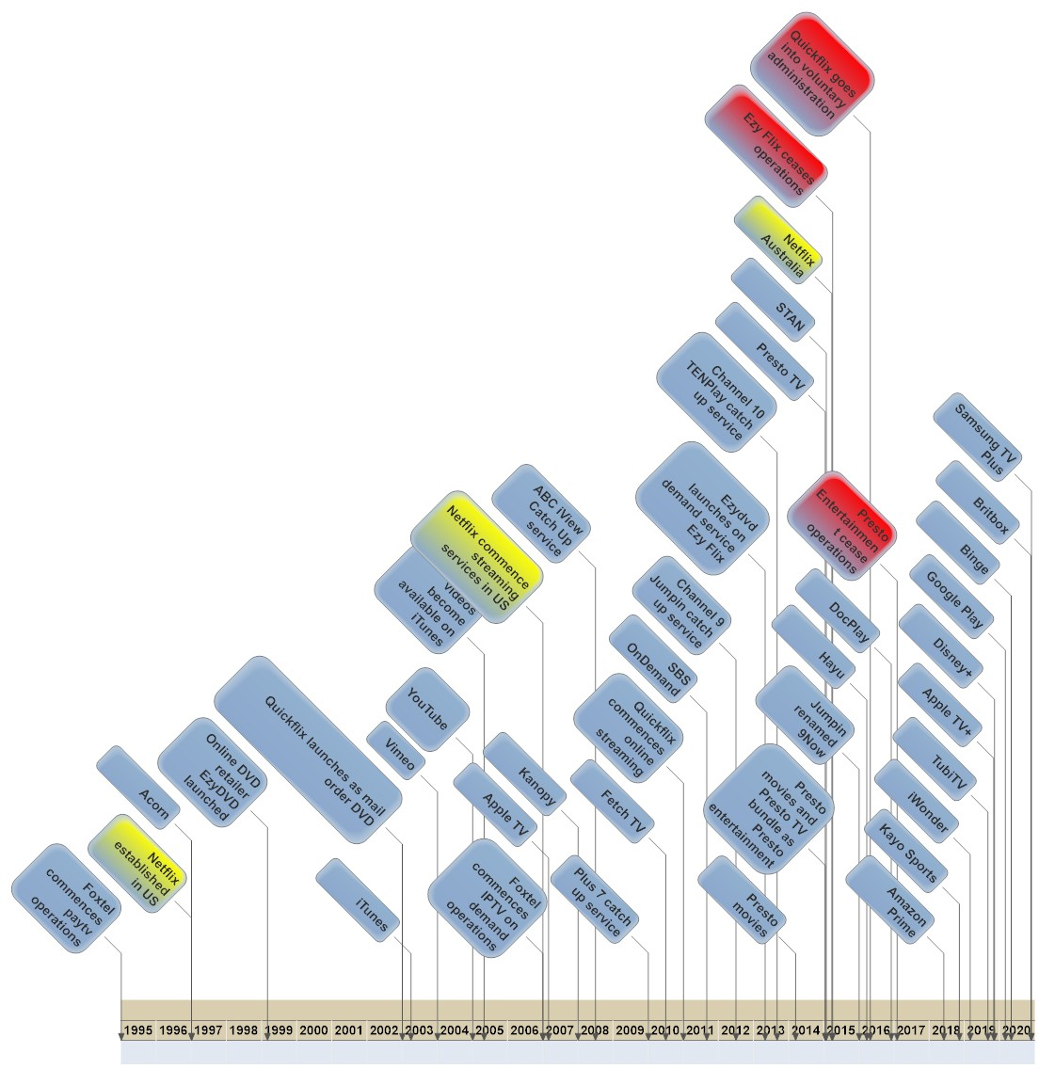
Figure 1. Updated timeline of the history of VOD in Australia

Impact of COVID-19 on VOD
2020 was predicted to be a year in which the VOD industry became increasingly competitive due to new platforms emerging and an increasing pressure to grow subscribers (Rizzo & FitzGerald, 2020). Instead, lockdown measures implemented at the start of the COVID-19 pandemic triggered a huge shift in audience behaviour and media consumption. People were restricted and quarantined at home, unable to attend cinemas or enjoy outside entertainment, so they were drawn to VOD in large numbers. In Australia, this was reflected in significant boosts to platforms such as Netflix, Amazon Prime, Disney+ and Stan (Mason, 2020). Viewers diversified and expanded their viewing across multiple services, so “instead of a streaming war, there’s been streaming coexistence and parallel growth” (Nesho, cited in Rizzo & FitzGerald, 2020). As other industries struggled to survive lockdowns, VOD platforms only grew:
The coronavirus pandemic has been a boon for the Australian streaming market, with new research showing consumers aren’t picking winners and losers, and are growing the amount of services they’re subscribing to (Mason, 2020).
This can be contextualised as part of the larger growth of video as an online media format. 2020 has been described as “the year of video” by Henry Tirri, CTO of tech company InterDigital, because “the world’s circumstances have aligned with a ubiquity of consumer devices and more time spent looking at our screens” (cited in Streaming Media, 2021). Video became central to not only entertainment, but economic productivity, service provision, and personal relationships. Apps and platforms that allow people to video chat while physically isolated are increasingly important; 46% of Australian mobile phone users made video calls or used video chatting platforms such as FaceTime in 2021 (DataReportal, 2021). As the pandemic continues to cause major disruptions and health crises around the world, this trend is likely to continue; it is estimated that video content will account for 82% of all internet traffic in 2022 (Streaming Media, 2021).

Mainstream Use and Awareness of Accessibility Features
Such massive shifts in the media ecosystem are inevitably reflected in the changing expectations of media users and consumers. We have observed that the growing cultural and social prominence of online video and VOD, have also increased the mainstream public’s interest in and use of accessibility features. Australians are becoming more savvy consumers, with higher expectations of their video providers. Our survey results support this – even those participants without a disability cited accessibility features as an important element of VOD viewing; 28% used VOD platforms because of their accessibility features and 56% cited that accessibility features made television watching easier for them. Indeed, a much larger proportion of people without disability showed interest in the topic of this study than was evident in the earlier survey; 37 people or just over 20% of participants in the 2015 study identified as not having a disability, whereas nearly half of our 2021 respondents (132) stated they did not have a disability, and a further 17 selected the ‘Other’ category. While this might be partly explained by an emphasis on diversity in our promotion of the new survey, it reveals an increasing and far-reaching interest in accessibility features across a wide spectrum of viewers. This shows that, in addition to being an essential tool for people with disability, accessibility features are also becoming a factor in consumer choice for mainstream viewers.
Indeed, other research indicates that accessibility features can be of great benefit to many people, whether they identify as disabled or not. Audio description (AD), for example, has advantages as an aid for learning and comprehension. AD provides additional audio narration to accompany visual texts and can help students, particularly those who are auditory learners, to understand concepts contained in charts, graphs and diagrams by reinforcing the key visual elements (Sauld, 2020). Originally created to assist people with vision impairment, AD can also be beneficial for developing language skills among children as they can learn new vocabulary by learning to associate words with specific actions and behaviours (Calvello, 2020). One study on AD implementation in the classroom investigated the increasing lexical competencies and idiomaticity for students learning Spanish as an additional language (Moreno & Vermeulen, 2013). The study used an AD task-based approach where students were given a task to audio describe a clip from a Spanish film titled Sin Ti. The results showed AD to be a useful pedagogic tool for teaching languages as it contributes to the development of language skills, particularly in lexical and phraseological competence (Moreno & Vermeulen, 2013).
In other research, Bernabe and Orero (2020) acknowledge the rise of “the new AD-for-all service” that will go beyond the use of AD purely as an accessibility tool for blind and low vision users. They argue that AD provides a service which supports increased comprehension from more diverse users – the elderly, people with learning difficulties and low-level reading skills, children, non-native speakers, including second-language learners, and readers with reduced literacy, e.g., with dyslexia and aphasia (Bernabe & Oreo, 2020). In particular, modern AD services should emphasise the quality of AD, such as sound and semantic content, to provide a better audience comprehension performance (Bernabe & Oreo, 2020). In addition, AD can be beneficial for those users who are multitasking while also watching entertainment media (Udo & Fels, 2010). As such, as more people are exposed to accessibility features on VOD such as AD, awareness of such diverse uses is growing.

Evolutions in Accessibility in VOD
Clearly, a lot has changed in the Australian television landscape since our first study of disability and VOD in 2016. Major theatrical releases, such as Marvel’s Black Widow (2021) and Disney’s Cruella (2021), are now being made available in cinemas and on VOD platforms simultaneously. The rapid uptake and widespread sharing of VOD has shifted it from being a new technology to an overwhelmingly popular mainstream pastime.
However, accessibility is only just becoming more important in this context, even though people with disability must be able to access VOD in order to participate in daily conversation and public debate. For example, despite a great potential for accessibility, our 2016 report found that people with disability risked being left out of the VOD revolution if the content and hardware to access it were not made accessible. The first survey found that:
Exclusion is a significant concern for PWD [people with disability] due to the lack of accessibility features in popular subscription VOD services. In particular, the lack of captions, AD and interfaces that do not comply with international web accessibility standards are resulting in many PWD being unable to fully participate in the preferred viewing platforms of family and friends (Ellis et al., 2016, p. 6).
Our current survey therefore explores how these issues have evolved in the context of the increasing growth of VOD platforms in Australia. We consider how questions of access and inclusion are being addressed by VOD platforms in 2021 and what advances have been made.

Literature Review
Previously we identified both a lack of research on the accessibility of VOD and an absence of legislation in Australia that mandated its provision, and this remains largely the case six years later. In particular, the areas that continue to be highlighted in discussions of television and VOD access surround the availability, quality and outcomes of closed captioning (CC) and AD. The shifts and evolutions of these accessibility features in the past six years are discussed below.

CC: From an Accessibility Focus to Mainstream Acceptance
At the time of our initial 2015 research into the accessibility of VOD in Australia, captions – while mandated on Australian broadcast television – were not required on either the broadcasters’ VOD offerings nor on subscription VOD. During the course of the project the Australian platform Stan quietly introduced captions to their service. At the time, captions were still very much considered an accessibility feature for audiences who were d/Deaf or hard of hearing. For hearing audiences captions were viewed as a nuisance if they happened to be onscreen (Ellis, 2019).
This started to change alongside binge-watching practices of television viewing prompted by VOD. With audiences increasingly watching large amounts of television within short periods of time, captions became a tool that audiences used to stay focused on the screen and pick up necessary information (Farley, 2017; Kehe, 2018). An era of well-made, big budget ‘prestige television’ coincided with these new binge-watching practices. The complicated storylines that began appearing in these prestige series such as Game of Thrones then initiated an audience-led innovation of captions as audiences began demanding, and using, the captions track to stay abreast of the storyline (Ellis, 2014). As a result, captions entered a new era where they became an accepted and useful tool for large portions of the audience.
Today, three key topics dominate the academic and industry literature surrounding captioning on television. Firstly, the diverse audience comprising d/Deaf, hard of hearing, and hearing audiences. Secondly, an associated focus on caption accuracy stemming from the increasing mainstream audience use, coupled with technological change. Finally, a focus on the legislative requirements around the availability of captions.
In terms of audience, the research is divided. A significant body of work considers the experience of d/Deaf and hard of hearing audiences for whom captioning is vital for social inclusion. Despite this need, accessibility for audiences with disabilities is rarely prioritised by broadcasters and VOD platforms unless legislation mandates otherwise (Downey, 2008; Ellcessor, 2011; Ellis & Goggin, 2015; Ellis, Kent, Locke, & Latter, 2017; Goggin, Ellis, & Hawkins, 2019; Gregg, 2006; Merchant, Ellis, & Latter, 2017). Even then the bare minimum is offered. For example, in Australia, despite captioning being required on all content aired on the primary digital channel between 6am and midnight, captions are not always made available online even if the technology allows and the caption track has been created (Ellis, 2019; Ellis et al., 2017).
Katie Ellis (2019) argues the traditional approach taken to social change, disability access and captions in Australia has been determined by legislation. Such an approach is problematic because, with each new form of television technology, the fight for legislation must start from the beginning as broadcasters follow the letter of the law and offer the minimum legal amount. However, this is changing; the mainstream audience has appeared in recent years as an important and emerging audience demographic. Following the introduction of Facebook’s autoplay function, captions became a popular tool for social media audiences to use when turning on the sound would be inappropriate (Facebook business, 2016). Now, 85% of Facebook users watch video with the sound off (Huxley, 2018). Furthermore, consumers were 12% more likely to engage with a video if captions were available (Facebook business, 2016), thus making them a good business decision. With captions becoming more available in consumers’ social media and entertainment lives, the zeitgeist has shifted around this accessibility feature and captions have increasingly come to be viewed as simply a part of audio-visual media.
Furthermore, as captions have become more widely available, expectations regarding their accuracy have changed for both the hearing and d/Deaf audience. d/Deaf audiences acknowledge that during the 1980s they were happy with whatever captions they could get, at whatever quality (Newell, 1982). However, this is not the case today as audiences are willing to complain to regulators (in Australia, reports made regarding a breach of closed captioning requirements are investigated by the Australian Communications and Media Authority) and litigate. In recent years there has also been a significant technological shift with the affordances of machine learning and the ability to create automatic captions using artificial intelligence. In this context the literature has focused on accuracy and the reduced lag time in live captioning. While in 2016 Ericsson partnered with the BBC to create a new method of AI live caption to reduce delays (Varshney, 2016), a comprehensive machine learning system had been proposed a decade earlier in order to leverage a wider audience for people engaging the captions track such as those speaking another language (Yuh & Seo, 2006).
Australia captions are mandated under the Broadcasting Services Act (1992) and the Disability Discrimination Act (1992) more broadly. For commercial free-to-air channels, the ABC and SBS, as well as free to air multi-channels, captions must be provided 6am until midnight and on all programs. However, this legislation does not apply to VOD or catch-up television. As such, while captions are largely available on VOD platforms, particularly international ones due to international legislation, there is no requirement they be made available when streamed in Australia. For example, legislation such as the US 21st Century Communications and Video Accessibility Act (2010) has had an international impact on the availability of captioning. This Act mandates that all content previously broadcast with captioning must be captioned within 15 days as of broadcast (Federal Communications Commission, 2014). Following this legislation, captions are also required on 100% of new programming and 75% of pre-rule programming distributed by cable operators, broadcasters, satellite distributors and other multi-channel video-programmers. As a result, captions are widely available on global platforms such as Netflix, Amazon Prime, Disney+, Apple TV+, Google Play, and impacting the provision of captions for Australian VOD services including Stan and Binge.

AD and Audio-only: The Rise and Rise
As noted in the introduction, the media landscape has changed drastically since our 2015 survey. While the COVID-19 health crisis has shut down public events, businesses and entertainment around the globe, the world of audio is experiencing a renaissance. As reported in The Conversation, 2020 saw the introduction of AD on Australian broadcast television for the first time (Ellis & Peaty, 2020), after its trial by the ABC in 2015. This has coincided with a larger mainstream trend toward audio in other forms of media and culture, spurred on by recent developments.
For example, building on “eight straight years of double-digit revenue growth”, audiobooks quickly took on an important role during the pandemic (Audio Publishers Association, 2020). The already popular media format became a source of comfort and distraction as lockdowns “intensified our engagement with the spoken word” (Preston, 2020). For example, Buzzfeed reporter Arianna Rebolini (2020) claimed audiobooks were “saving [her] sanity” by providing distraction from the busy monotony of lockdown – “I listen to books while I’m taking [my toddler] Theo for walks, while I’m watching him at the park, while I’m cooking, while I’m cleaning. It’s multitasking that doesn’t feel like multitasking”. Similar to VOD subscriptions, sales of audiobooks increased rapidly as “the public turns to reading to escape pandemic cabin fever” (Sweney, 2020). But this technology is not solely beneficial for healthy people sheltering in place. Listening also provides solace to those who are battling COVID-19. The Guardian writer Alex Preston (2020) turned to audiobooks when struck down by the virus – “One of the first things I did when I undertook my own Covid-19 journey in early April – three weeks of coughing and night-sweats in the spare room – was to draw the blinds and put on an audiobook”.
Other forms of audio drama, such as podcasts, are likewise extremely popular. As the pandemic stretched on and people started to suffer from ‘zoom fatigue’, audio became an even more attractive media option. Journalist Sigal Samuel (2020) notes:
These days, I prefer listening to looking. Staying at home means a lot of my work and social life happens on Zoom, and staring at a computer screen for so many hours each day feels draining. So when I want to give my eyes a rest and my emotions a boost, I go hunting for podcasts.
Dawn Ostroff, the Chief Content and Advertising Business Officer for Spotify, explains that listening patterns have changed as fewer individuals commute to work. Instead, families are gathering to consume audio in the home – “What we’ve seen through the pandemic is that people are really sitting down and listening to podcasts in a group” (Ostroff, cited in Flynn, 2020). As many around the world are forced to isolate, the power of audio to transcend physical distance, soothe anxiety, and establish an important sense of connection is increasingly obvious. As live events from the Melbourne Fringe to the Festival of Chamber Music go online, the ability to listen from home has become essential.
Developments in VOD have also been shaped by this context, and a fresh focus on audio – including AD – has been the result. However, further innovations relevant to accessibility are also emerging such as the potential addition of ‘audio-only’ modes on VOD platforms. Reports began circulating in late 2020 that Netflix was trialling an audio-only mode on its Android mobile app. This mode allows users to switch off the video and focus only on the audio of a show (Vonau, 2020). The feature was originally spotted by XDA Developers in October 2020 during a teardown of a new version of the app (Vyas, 2020). At that time it was still in development and did not begin to roll out to users until December when it began to pop up on a limited number of Android devices, indicating that the company was still trialling this new feature.
Yet, despite the media attention the Netflix audio-only mode has attracted, most news media outlets don’t seem to know what to make of it so far. Netflix themselves have explained this feature as targeting users who want to “continue listening to shows or movies while using other apps or when [their] screen is locked” (Kan, 2020). This has prompted some reflection on the types of shows that would be best suited to this feature, with commentators variously suggesting that it can be used for re-watching familiar movies (Murphy, 2020), stand-up comedy specials and sitcoms (Keeley, 2020), or documentaries (Liszewski, 2020).
However, many reports on the feature demonstrate relatively little awareness of how the inclusion of AD can improve the audio-only experience. While Lifehacker’s article on the feature includes a tweet by Juan Alcazar, a legally blind filmmaker, highlighting the important role that AD content can play with Netflix’s audio-only mode, the Lifehacker article itself makes no mention of combining it with this accessibility feature. Instead, the audio-only mode is variously being portrayed as an odd quirk, a convenience feature, or a tactic to conserve battery life and bandwidth. This indicates there is still work to do in order to raise awareness of AD more generally. One article that does point out the benefits of combining this feature with AD content, also points out that the audio-only mode could potentially be used to learn another language by playing a well-loved and familiar show in a different language (Keeley, 2020).
Others have also speculated that Netflix is positioning itself as a potential competitor for audio-focussed streaming services such as Spotify or Amazon’s audiobook service, audible. An article by The Verge refers to the audio-only mode as “an intriguing update... if only because audio is having a moment” (Carman, 2020). Despite the flippancy of this comment, audio services have indeed been gaining more attention in recent years. Twitter began offering an audio-only broadcast feature on its Periscope platform in 2018 (Statt, 2018), although this disappeared when Periscope shut down in March 2021. The platform has since launched Twitter Spaces, a feature that enables Twitter users to have live, audio-only conversations. YouTube offers its premium subscribers the option of using “song mode” where they can play audio in the background (Spangler, 2020). The growth of audio-only social networking apps, such as Clubhouse, has also inspired platforms such as Facebook to develop their own live audio chat ‘rooms’ (Menegus & Carmen 2021; Yurieff 2021). On the whole, streaming audio services have seen a marked increase in use during the COVID-19 pandemic (‘Time Spent With Streaming Audio Is Also Growing Amid the COVID-19 Pandemic’, 2020) and now form a significant share of the streaming media market (Grant, 2020; Colburn, 2021).
All of these aside, it is still streaming giant Netflix’s testing of an audio-only mode that is gathering the most attention; this is seen as not simply an attempt to move in on the streaming audio market, but rather an attempt to widen their share of the entertainment market overall. In a report outlining their long-term view for their investors, the company states:
We compete for a share of members’ time and spending for relaxation and stimulation, against linear networks, pay-per-view content, DVD watching, other internet networks, video gaming, web browsing, magazine reading, video piracy, and much more. Over the coming years, most of these forms of entertainment will improve (Netflix, 2020).
This suggests that although Netflix are aware that features such as AD content and the audio-only mode will benefit their blind and low-vision user base, their primary motivation in developing such innovations is a desire to position themselves more competitively in the overall media market.
It is also worth noting that this is not the first time Netflix has considered making forays into audio territory (Roettgers, 2020). An article by Protocol observes that, as part of efforts to nurture more diverse content, Netflix launched “what can best be described as audiobooks with video… [teaming] up with Black celebrities like Tiffany Haddish, Lupita Nyong’o and Jill Scott to read children’s books from Black authors” (Roettgers, 2020). The idea of Netflix offering an audiobook-like experience was also raised back in August 2017 during a ‘hack day’ event in which employees were encouraged to experiment with new ideas and technologies. One of the ideas touted was an AudioBook Mode which specifically linked the option of an audio-only mode to the availability of AD tracks. The showcase video for this idea explained that:
Audio-only Netflix is not new to Hack Day… But by using Audio Descriptions, an accessibility feature available for lots of great titles… AudioBook Mode is more than just dialog (NetflixOpenSource, 2017).
Other features of the proposed AudioBook Mode included the ability to listen to the audio with the Netflix app running in the background, and variable speed playback enabling users to listen at up to twice the normal speed. It should be noted that the variable speed feature has already been released to Android and iOS users as of August 2020 and, although it has received some backlash from directors and content creators, has been applauded by accessibility advocates who say it makes content easier to consume for those who have hearing or vision difficulties (Alexander, 2020).
It should be noted that the audio-only mode is currently only available on Netflix’s Android app and has not been rolled out to all users yet. Given that testing is still ongoing, it should not yet be considered confirmed as it can still be pulled if Netflix determines that it is not worth pursuing further. While there is a work-around for Apple iOS users to get a similar audio-only experience, it involves playing the Netflix content as usual and locking the screen, thereby consuming the same amount of bandwidth as usual (Sharma, 2020). It appears, however, that Netflix is investing in a different audio experience for iOS users, with reports indicating that they are exploring Apple’s spatial audio technology which will provide users with a surround sound-like experiencing when using Apple’s wireless AirPods headphones (Miller, 2021).
With audio description being introduced on Australian public broadcasters the ABC and SBS broadcast television offerings in 2020, the increasing popularity of audio description on international streaming platforms discussed in this review suggests Australian audiences are likely waiting for an increased availability of audio description on streaming platforms.

Methodology
This project updates prior ACCAN-funded research into the accessibility of VOD in Australia (Ellis et al.,2016.) and incorporates a study into the accessibility of free-to-air catch-up television offerings. The project used a predominately qualitative approach to the topic, incorporating some quantitative data through the survey stage. The project embraced a ‘start to finish’ methodology to gain a comprehensive overview of VOD accessibility in Australia. Prior research (Ellis, 2016) suggests VOD is an augmented product that requires accessibility from sign up (start) to viewing (finish).
We began the project by assembling an advisory group with representatives from broadcasters, the disability sector and academic expertise. In consultation with this advisory group, online survey questions were established.
The project adopted a multi-modal methodology and proceeded in four phases:

Phase 1 – Accessibility Policy Scoping Study
In the initial phase of the project we undertook a content analysis of accessibility policies published by subscription VOD services (Stan, Netflix Australia, Amazon Prime, Disney+, Apple TV+ etc.), and free-to-air platforms (ABC iview, SBS On Demand, 9Now, 7plus, 10play). Specifically, the provision of CC and AD was observed, and whether providers communicated what accessibility features were offered and how customers could activate them. These results were also compared with the findings of the previous 2015 study.

Phase 2 – Online Survey
Insights were gained into both how people with disability are currently using VOD television, their anticipated usage of services being introduced in 2020, how and what accessibility features were used, and what factors affected their use. The questions were largely based on those posed in 2015 to allow for comparative data to be obtained and analysed. People with disability, their families, carers and the broader community who used accessibility features were invited to participate in the survey. This invitation was disseminated via disability organisations and community groups, a dedicated project Facebook page, and Curtin University student and staff networks. The survey responded to the particular characteristics of the target group (e.g. concentration limits, physical factors impacting engagements with technology) and was housed on Survey Monkey to allow translation by a screen reader or other assistive technologies. The final sample size was 267.

Phase 3 – Interviews
Participants in the survey who were willing to contribute to the project further were contacted for in-depth interviews. Data obtained through Phase 1 and 2 were triangulated with these 12 interviews. Interviews were conducted via phone, Skype and email. Interviewees were provided with a $50 voucher to compensate them for their time.

Phase 4 – Co-designed Tip Sheets
The development of tip sheets – documents that provided clear and accessible information on the ways in which people with specific disabilities could use VOD –were an important part of this project. They were incorporated in the project design to offer both an educational outcome that could be accessed from both ACCAN’s website and the project website, and a collaborative method in which people with disability were prioritised as experts in the process of accessibility (Hamraie and Fritsch, 2019).
Reflecting our overarching aim to employ the disability social justice ethos “nothing about us without us” at all stages of the research project, tip sheets were developed with people with disability via a process of co-design. Recruited via the survey and interview components of the project, participants who indicated interest in contributing to the project partook in a focus group discussion to outline the components of the tip sheet. Researchers then wrote a draft based on this feedback which participants then edited and commented on. Critically, participants were reimbursed $250 for their time, again emphasising their role as experts in accessibility not just simply as recipients of accessible design.

Results
This section begins with the findings of the review of accessibility features and policies of VOD providers on Australian television, including both subscription and broadcast VOD services. It then provides a discussion on the results of the survey, detailing the demographics of the survey cohort and the participants’ thoughts on which provider they use, if any, the use of accessibility features and assistive technologies and aids, and their initial set up experiences. Also considered was how participants watched VOD, for example on what device. Distinctions were made between the experiences of those respondents with a disability and those without. The final section outlines the interview findings of the research project, including demographics, individual experiences of access, user interface issues and an AD case study.

Accessibility Features and Policies in VOD: A Review
VOD has become an entrenched and significant part of the Australian media landscape, reflected in the burgeoning number of providers and a dramatic increase in subscribers as well as VOD options for all broadcast stations. However, in our review of the current providers in late 2020, we found that accessibility policies are largely absent, and the inclusion of key accessibility features – specifically CC and AD – remains inconsistent.
Our review contextualises the findings in comparisons with our research conducted in 2015 to identify how the accessibility of VOD has shifted in the last five years. The table at Appendix 1 (Captions, Audio Description and Accessibility Policies on Australian Video on Demand Services: 2014–2020) shows the changes in provision of CC on VOD services from late 2014, to 2016, to late 2020. It also identifies the current availability of AD. Finally, we recorded whether accessibility policies are publicly displayed (via their websites) by each provider and, if so, what style of language was used. It should be noted that several providers are incorporated in the table that no longer operate in Australia and that some were not active in Australia in 2014, thus are marked as n/a.

Subscription VOD services
Of the seven services we reviewed in late 2015 to early 2016, only five continued to operate in Australia in 2021. All five – Netflix, Stan, Foxtel Now, Apple TV+ and Google Play – have increased the accessibility features offered, specifically increasing the availability and percentage of CC content and, in the case of Stan, Apple TV+ and Netflix, also introducing AD. However, accessibility policies remain vague or absent in most cases with the exception of Netflix and Apple TV+. These two services also offer multiple features beyond AD and CC, including the capacity to modify caption presentation, ‘remote free’ access, and support for assistive technologies.
Multiple other services have also emerged since early 2016, including Amazon Prime, Kayo Sports, Disney+, Binge, Tubi, Kanopy, iWonder, Acorn TV and Docplay. However, without the presence of any governing legislation that ensures accessibility for VOD providers in Australia, including the presence of captions, each service has addressed accessibility at varying levels. Only five services offer AD on some content and, while most offer CC, three do not, and most services offer captions on some but not all content.
Influenced largely by US legislation and US and international advocacy efforts, Netflix continues to offer the highest accessibility standards; however, new entrants to the market such as Disney+ are also offering an increasingly accessible service. As noted in the literature review of this report, the rise in interest in both diverse audio accessibility and AD has begun to impact the proliferation of this feature on the VOD services.

Broadcast VOD services
The free broadcast VOD services have increased their captioning provisions in the past five years, including the presentation of captions for live content; however, despite AD trials conducted by the ABC, and the provision of some AD content on SBS broadcast services, the free to air VOD services are yet to offer AD content.

Survey Results
In late February 2021 we launched the survey via Survey Monkey; this remained open until May; a full list of questions is shown in Appendix 2. In total, 267 responses were collected, with a 61% full completion rate. The vast majority of respondents, 93%, watched VOD. In comparison, in our 2015 survey, only 52% of participants used VOD (see Ellis et al., 2016). However, unlike 2015, we surveyed both people with disability and those without, emphasising that the survey was open to anyone who used accessibility features.

Demographics
In 2021, 31% of the respondents were male, 64% were female, 4% were non-binary, and 1% listed ‘Other’. Most respondents were between the ages of 18–24 (38%), 21% were 25–34, 12% were 35–44, 14% were 45–54, 9% were 55–64 and 6% were over 65. In the 2021 survey, we found that there was some decline in the rates of use of VOD for those over 55. While 93% of all respondents used VOD, when we focused on those over 55, 77% stated they used VOD.
The majority of respondents, 81%, lived in urban areas of Australia. In both regional and urban areas, participants noted they had a reliable internet connection, with only 5% stating they did not. However, these statistics did not always correlate with the comments provided in other parts of the survey, where better and faster internet were commonly cited in the question of what participants thought would improve access to VOD television.
The cost of VOD was also commonly cited as an area that could be improved, or reduced, something which also reflected the household income of participants. The largest proportion of survey respondents, 28%, earned below $30,000 per annum, while 14% earned over $150,000 (Figure 2).
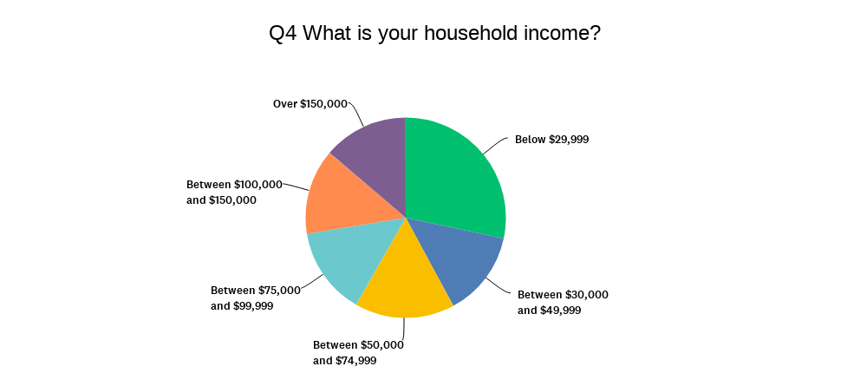
Figure 2. Participants’ household income

How and what people watch
While 93% of respondents watched VOD, 3% wanted to but could not figure out how to use it, and 6% did not. Of these 6%, the reasons given for not using VOD included cost, not wanting to watch it, inaccessibility, preference for other video content sources, such as YouTube, and lack of internet. Those that did watch VOD did so primarily for the flexibility of viewing and for content choice but, as noted, the accessibility features offered were also a significant reason (37%) (Figure 3). For people with disability, accessibility became more pertinent, with over 46% citing this factor as a reason for choosing a VOD service.
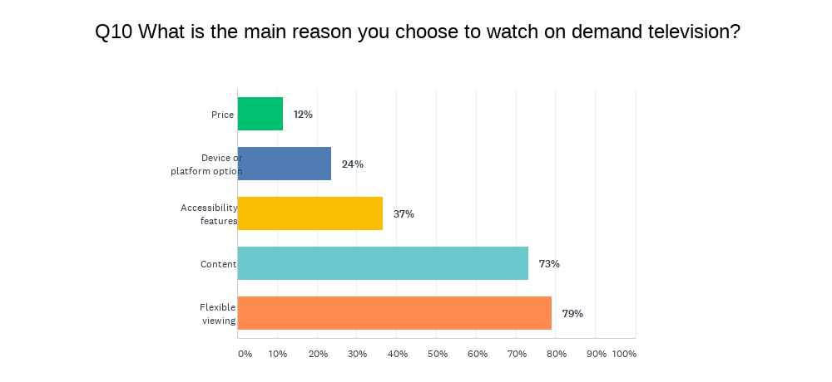
Figure 3. Participants’ reasons for watching VOD television
Most participants used a combination of both free-to-view and paid subscription services (63%), whilst 30% used only subscription VOD; 6% of respondents used only free, broadcast VOD services.
While the Australian VOD market has expanded rapidly over the past five years, with multiple streaming options, Netflix continues to dominate the market, and is also the most accessible. For all respondents (people with and without disabilities) almost 88% watched Netflix, followed by the two national broadcaster’s VOD services – ABC iview (58%) and SBS On Demand (49%). Amazon Prime, Disney+ and Stan were also popular streaming services, each cited by over 40% of respondents. Other services that were not listed in our survey, but mentioned by respondents included Fetch TV, AnimeLab, Twitch, YouTube, other international platforms, and pirated content providers (Figure 4). Notably, most respondents cited using multiple services – most listing four or more VOD providers.
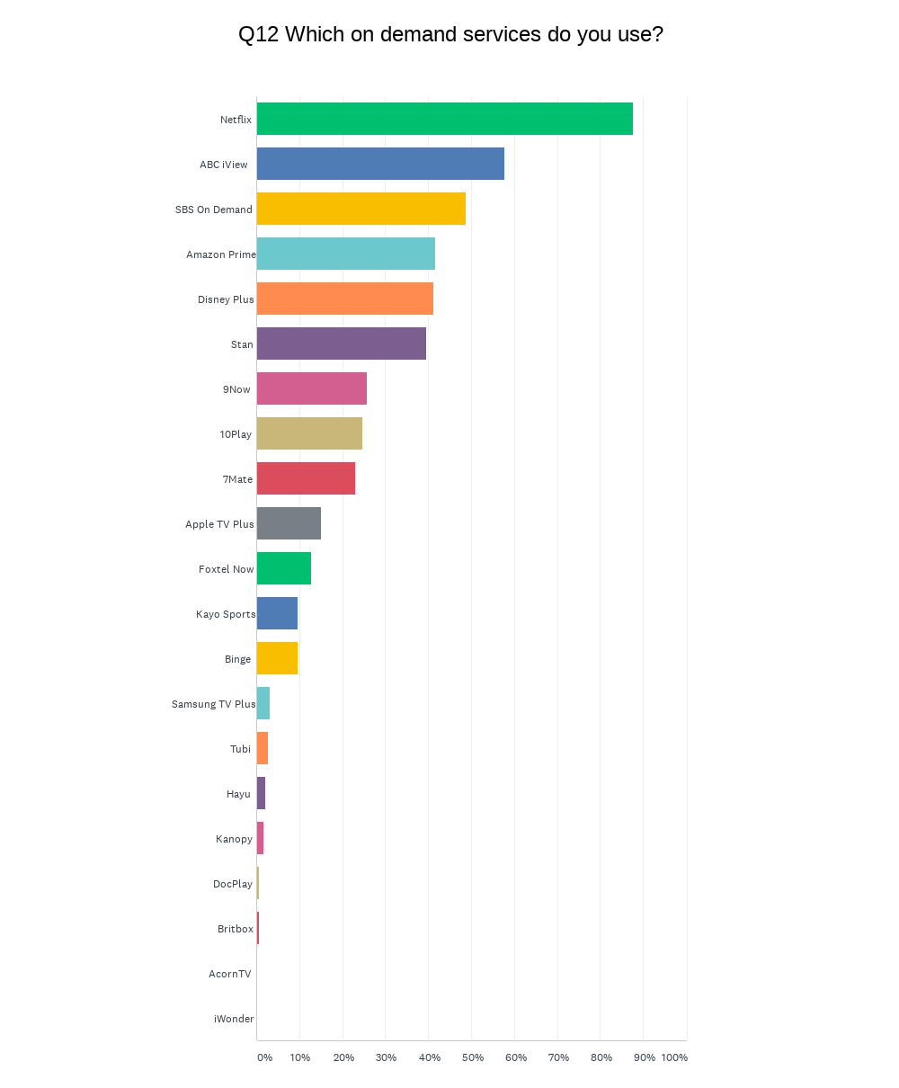
Figure 4. Participants’ use of VOD services
People are also not simply accessing multiple services but are also using multiple devices to watch them. The computer, whether it be a laptop or desktop, has become the most common device used for watching VOD (57%), followed by the smartphone. Smart televisions were used by 50% of respondents and 39% used a video streaming player, such as Chromecast, connected to their television (Figure 5). Again, most people used more than one device, listing combinations of two or three devices.
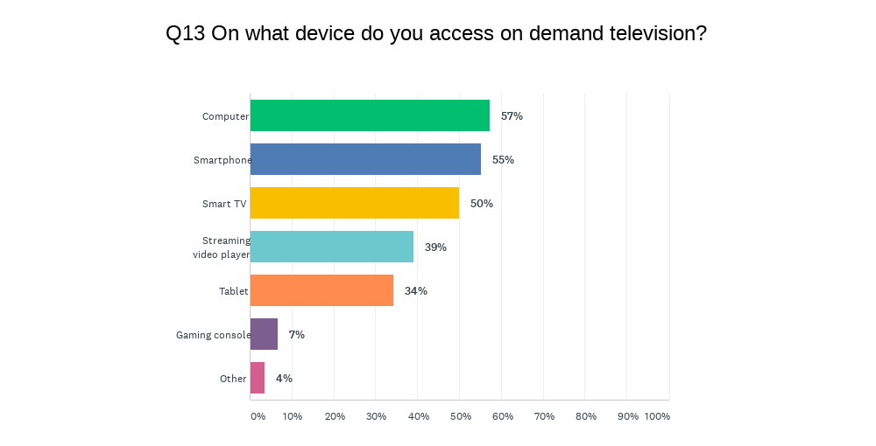
Figure 5. Participants’ preferred devices to access VOD television
For people with disability, the preferred choice of device to watch VOD television was a smartphone, particularly for people with low vision or blindness; for this group, 65% used a smartphone. Indeed, the experience of disability affected different dimensions of watching VOD, from the accessibility features used, to the preference of content provider, and the device of choice.

Experiences for people with disability
Of the 127 people who noted a disability, most had a vision-based disability (48%), followed by chronic illness (25%), and hearing-based disabilities (22%). A significant 19% listed other disabilities, predominantly ADHD (attention deficit/hyperactivity disorder), as well as mental health conditions, sensory or sensorimotor disabilities, and chronic pain (Figure 6).
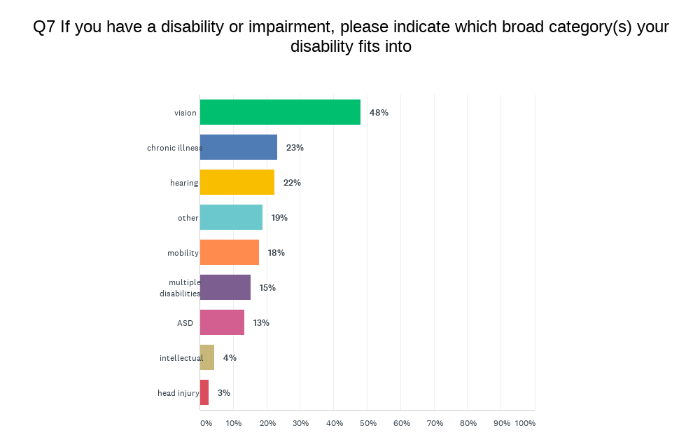
Figure 6. Participants’ disability type
These diverse experiences correlated to different experiences of VOD. For example, those with vision-based disabilities used more services which offered AD, relied more on assistive technology to access the internet, and found accessible features were ‘sometimes’ or ‘rarely’ available on VOD. People with a hearing-based disability used smart televisions and computers more, accessed content using CC, and found this feature to be ‘usually’ or ‘always’ available to them.
However, accessibility was important to people with a range of disabilities, and whilst CC made television watching easier for people who were d/Deaf or hard of hearing, captions were also utilised by people with autism spectrum disorder (ASD) (53%), chronic illness (65%) and ADHD (100%). Likewise, AD was used by people who were fully sighted, but experienced other disabilities. People with ASD (34%) and hearing-based disabilities (24%) also used AD.
Overall, there were a broad range of accessibility features used by people with disability, and often respondents listed multiple features that would make television watching easier. Reflective in part of the high percentage of respondents with a vision based disability, the most prominent feature cited was AD (45%), a feature which was rarely available five years ago. CC was listed by 44%, followed by talking menus (35%) and screen reader support (32%); 30% cited more compatibility with assistive technologies, 29% clean audio, 28% spoken subtitles, 15% large or colour-coded remote control keys, and 3% signing (provision of a sign language interpreter). Additionally, 17% suggested other accessibility features would be useful, from ‘better quality’, adjustable or consistent captions, to more accessible, better designed interfaces, to voice command remotes.
Some participants also used assistive technology to access the internet (including VOD), primarily screen readers (29%), magnifiers (15%) and voice activation (15%). However, almost half of people with disability used no additional assistive technology.
However, while the accessibility of VOD has increased since our survey in 2015, when asked how available these features were on the VOD they used, almost half of all participants stated it was never, rarely or sometimes available (Figure 7). As previously noted, perceptions of availability may also align with increasing expectations by consumers that accessibility features are offered by service providers.
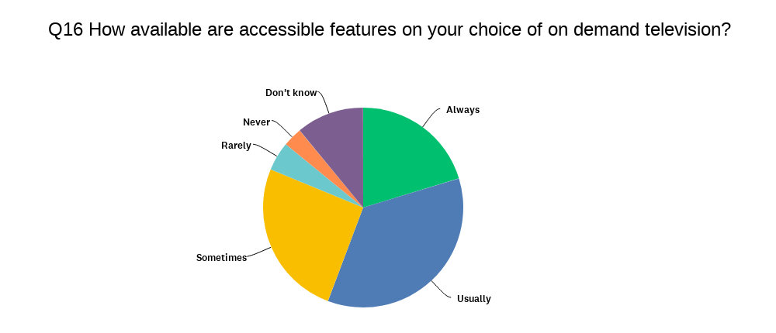
Figure 7. Participants’ responses on the availability of VOD accessibility features
However, access to VOD is not confined to the availability of accessibility features – notably 30% of respondents with disabilities had problems finding accessible content. Moreover, 23% said it was either very difficult or difficult to set up VOD, and 38% asked someone to help with set up, predominantly family or friends.
The variations between service providers – both in relation to set-up, locating accessible content, and availability of accessible features – is pertinent to the results of the survey. For example, 50% of respondents used CC or AD content menus to find accessible content; however, in our review we found that only two services – Netflix and ABC iview – provided specific accessible content menus. Likewise, set-up was easier for some providers, but not all, and the variations between providers created challenges for several respondents.
These ‘layers of inaccessibility’ were expressed in the comments section, where participants were asked to state what they would like to improve about the accessibility of VOD:
Make setting up easier, simplify search options (menu/s), and a larger number of technical support ‘FAQs‘ available online/in thee manuals in order to not have to contact tech support by phone (being that I am hard of hearing).
Participants also wanted more consistency in the way captioned content could be searched for, noting that while accessibility features, like captions, might be provided, it was often difficult to find captioned content and variations between providers made finding and accessing content difficult:
Semi-standardise the way that services set up their menu so that content can be found easily across all services.
Simplified app interfaces maybe a section or filter that only shows programmes with certain features e.g. show only programmes with closed captions.
Likewise, participants suggested that providers could do more to both promote – we note, for example, in our literature review that some providers, like Stan, brought in AD without promoting this as a newly available feature – and advise users how to access these features:
Always having closed captions available. Having a quick tutorial on how to access different features at the beginning of using the app or website.
Promote the accessibility of the services so that people know prior to purchase how limiting the service is.
Quality, adjustability and consistency of captioning and AD was again brought up by respondents, aligning with findings from our earlier study:
More programs that support captions, and consistently do so over episodes and seasons. Also, making them spoiler-free would be a bonus, as currently the subtitles may give away a joke, a moment of shock (for example, captions would show a normal conversation being interrupted before it actually happens on screen), or it would sometimes read something different.
Despite ongoing accessibility issues, 49% of respondents thought VOD was more accessible than broadcast television (24% said it was ‘about the same, and only 7% thought it was less accessible), with the ability to control when and how they watch television a significant asset. Respondents also noted the improvement not only in the amount of captioned content, but also the quality of captioning. Indeed, in comparison to our research in 2015, the improvements in accessibility, particularly the inclusion of AD on four service providers, has been an important moment for the rights of people with disability and reignited broader discussions around the value and importance of access on Australian television.

Experiences for people without disability
A significant distinction between our 2015 survey and this one was an increased response rate from people without disabilities. Almost half of respondents (132) cited they did not have a disability, with a further 17 selecting the ‘Other’ category (but often listing a disabling experience or category in the description). Significantly, accessibility features were also an important part of the VOD viewing for those without a disability; 28% used VOD services due to their accessibility features, and 56% cited using accessibility features that made television watching easier for them. Of these, the most used accessibility feature was CC (76%), followed by clean audio (35%), spoken subtitles (20%) and AD (11%).
We noted a range of reasons for the use of accessibility features. Firstly, there were a proportion of respondents who did not cite a disability but experienced disabling conditions. For example, of the 149, 11% listed a broad category of disability they experienced, noting in particular varying levels of vision and hearing or suspected but undiagnosed conditions. Secondly, several participants noted that they had family members or share housed with people with disability, and the use of an accessibility feature allowed them to “watch television together”. Thirdly, the use of captions to support language learning was cited in several comments in different sections of the survey. While we did not include an explicit question about the use of captions or other accessibility features to support language learning, respondents incorporated their experience in this context in feedback. For example:
Usually use [captions] to comprehend different accents and languages.
I use CC, often I‘ll miss words or not hear characters mumble. Sometimes if other people are in the room I can turn the volume down but still follow the story with subtitles. I also watch TV/movies in other languages I don‘t speak, so I use translated subtitles.
Furthermore, the use of accessibility features to enhance and personalise the viewing experience of mainstream audiences, as noted in the literature review and expanded in the discussion section of this report, may also be a factor in the rate of use by participants in the survey without disabilities.

Interview Findings
Once the survey was completed, we approached participants who had provided contact details about whether they would also like to be interviewed for the project, and offered a $50 voucher to reimburse them for their time. The interview questions (Appendix 3) were designed to add complexity and detail to the survey results, and specifically to capture in-depth experiences of using VOD for people with disability.

Demographics and Individual Experiences of Access
A total of 14 individuals agreed to be interviewed, and 12 were conducted. Of the 12 people interviewed, 11 had disabilities – three had hearing-based disabilities, one had chronic illness, two had sensory-motor disabilities, three had ASD, and five were blind or had low vision – and half of those interviewed cited having more than one disability. CC or subtitles were used by five individuals, AD was used by six, and assistive technology – from noise cancelling headphones, voice controlled remotes, and remotes with gyroscopes – was used by three people.
The intra-disability diversity and individual experience of access were an important and consistent component of all interviews. The ability to adjust, control and personalize their television viewing was particularly pertinent to participants with sensory-motor disabilities and with ASD. One participant described his disability as “different everyday” and stressed the importance of viewing flexibility and compatibility – with other assistive technology – when watching VOD:
I have sensitivity to lights and sounds, but it comes and goes – some days the TV is too loud even with a low volume [on these days I use smaller devices like my smartphone]. To watch television I often need to use noise cancelling headphones that remove every sound other than the TV. My neurology doesn’t conform to a pattern or schedule though – I need to be able to do things when I can – so everything I watched on TV is streamed, nothing is live. I watch movies and television shows that show typical people, in difficult situations, which gives me insight into how people think and respond, because in real life people confuse me. I use these shows as a type of study, to learn about people.
However, across each interview there was no singular, consistent experience of accessing VOD, regardless of shared disabilities. Along with specific experiences of disabilities, technological literacies and the social dynamic involved in their television watching experience were key distinguishing factors. For example, each respondent articulated a range of technical literacy and awareness of accessibility features, from one participant not being aware of the presence of AD on VOD, to others being proficient users, active in AD advocacy groups.

Social Dynamics
The interviews also recognised the social dynamics involved in both watching and accessing VOD. Across most interviews, participants noted the way in which (accessible) VOD facilitated shared cultural experiences, both in allowing people with different disabilities better access to popular culture, and a capacity to watch television in a shared social setting. Again, the interviews revealed varying social experiences and contexts when watching VOD. Five participants lived alone and, as such, their VOD use was personalised for their individual viewing requirements, but access was also sometimes challenged without having someone to assist them in their home. Those that lived with family/partners often expressed the value of accessibility features allowing their family to “watch television together” and acknowledged the integral role of their partners in setting up and facilitating accessible viewing. This experience was reiterated by the participant who did not have a disability, but who lived with her mother who had a visual disability. When asked what accessibility features she used, the participant responded:
At home we use audio description because my mum has a visual disability. So I’ve gotten used to having it on. [AD] also helps me when there is some interruption around me. Or sometimes I’m on a phone call or video call, but I still would like to watch the movie. It helps a lot, especially when you are speaking another language, you can still keep up with the movie, which is pretty nice.
In this interview the participant highlighted the multiple ways that accessibility features were facilitating television watching in her household, originally put in place to aid a family member with a disability, but also becoming a ‘mainstream’ feature that allowed for multi-tasking and for assisting when other languages are spoken at home. Another interviewee explained his sighted friends enjoyed AD as a way of experiencing content in a different way, noting they often took something new away from a program or learned more from a story.

User Interface Issues
However, participants also noted consistent issues that impeded accessibility. A consistent theme was issues with user interfaces, identifying that despite the presence of accessibility features, such as CC or AD, variances between and issues with the accessibility of the platforms themselves inhibit the use of these features:
It would be really good to have more attention to the total navigational experience so that there isn’t focus stealing, lagged input capturing stray clicks and getting you stuck in something you didn’t want to load…
The biggest challenge with navigating [video on demand] systems is the constant changes [to their interfaces]. Every time they update, the screen operates differently with the gestures you use with your remote [if that’s what you use].
Interface issues were also expressed in relation to the devices, with several low vision or blind participants noting that there is a lack of compatibility between screen readers and VOD services when using a computer. Another interviewee, who experiences neurological sensorimotor disabilities, articulated problems with smart television interfaces:
I also am very frustrated with “smart TV” interfaces, because the computational power does not keep up even when the panel is still fine, and the lagginess makes it almost impossible for me to use, as the nonresponsiveness is just too much for my eye hand communication when it comes to navigating the options. Also, I sometimes will use my ipad to login to services on my TV with the linking code, where available, as it greatly facilitates access. I have a hard time putting in passwords with the remote.
AD was a pertinent subject and feature discussed by participants – it was used by all five with low vision or blindness, as well as by the participant without a disability. For these individuals, the quality, consistency and continuity of AD was often raised as a pertinent issue, as well as the general lack of this feature across most service providers and, for those that offered it, only on limited content. Two individuals noted the role of pirated AD content and websites that currently ‘filled the gap’ left by providers. Reflections on the quantity and quality of AD varied – one participant reflected on the value of audio describers and the heightened quality of content that was developed and written with and alongside AD, rather that it being ‘tacked on’ at the end of the production process. This interviewee reflected on the artistic role of the audio describer, and the way accent, narrative skill and age/gender appropriateness were integral to the storyline.
While for some low vision or blind users, the presence of AD completely determined whether or not they would use a service – choosing to watch Netflix or Disney+ over other providers because of the larger AD content base – notably two participants had problems accessing AD for VOD, relying on AD broadcast television. A case study on access to AD is highlighted below.

Case Study: Adapting to AD
An identifiable issue with the accessibility of VOD was the lack of promotion of available accessibility features by providers. While there has been a significant increase in the provision of features such as CC by most providers, and several have implanted AD, these features often emerge on services with little promotion, and users are left to seek out information on what and how much accessibility each platform provides. Moreover, as several participants noted, the quantity of accessible content, e.g. what percentage of content has AD and/or captions, is rarely disclosed by each provider. During one interview, a participant with low vision expressed that he had been unaware that Netflix had AD, but had enjoyed watching broadcast SBS and ABC when they had AD content. At the conclusion of the interview, he expressed that he would trial Netflix and detail his experience so we could better understand what and how access was achieved for a new user:
I‘ve just spent an hour or so playing with Netflix to see if I could find audio description.
The short answer is that after some fiddling around, I finally found it, and was able to set it up.
In detail, I decided not to search the Internet in advance for info, but just to turn it on and have a look!
What I found:
- There was AD info in the Netflix settings
- I went to Search and entered “Audio Description”. (One letter at a time, very tedious)
- The search results displayed a list of AD programs in various languages
- In the English section, there were 42 programs. I recognised 3; there were at least 5 cartoons in the list.
- I selected Episode 1 of “The Crown”
- Tried lots of things here but found nothing about AD until I pressed the remote‘s Info button
- In the Choice of Language menu, there is English AD
- Once selected, the AD starts immediately, in this instance with a high quality English voice providing the AD
- I also tried a program called “The Office” with the same result, although the voice wasn‘t as good (very subjective)
So while there‘s nothing there at the moment I would watch, I‘ll definitely keep an eye on it and hope for regular content updates.
Thanks for pointing me towards Netflix AD.
This participant’s experience highlighted issues of inaccessibility within accessible features. As Lewthwaite, Sloan and Horton (2019) explain, accessibility should be understood:
… through the lens of user experience as: a core value, not an item on a checklist; a shared concern, not a delegated task; a creative challenge, not a challenge to creativity; an intrinsic quality, not a bolted-on fix; about people, not technology.
The availability of AD on Netflix could be perceived as a ‘resolution’ to the inaccessibility of VOD content for people who are blind or have low vision. However, the experience detailed above exemplified the findings of this research project, that inaccessibility is generated at several levels – from a lack of communication of the availability (or absence) of accessibility features, insufficient or elusive instructions on how to use them, and availability on limited content.

Conclusions
When we began planning this follow-up this research we expected that there would be changes to the accessibility landscape of the Australian VOD and streaming environment. We discovered that there have been many improvements but also the persistence of issues we had previously identified, such as a lack of information about how to locate and use accessibility features and an assumption that the majority audience does not require or prefer accessibility. Our prior research had made three recommendations: first that governments introduce legislation, second that VOD providers recognise people with disability as a significant portion of their consumer base, and finally that people with disability participate in advocacy efforts to demand more accessible VOD.
While the legislation we recommended has not been put into practice, the Australian public broadcasters the ABC and SBS were funded by the Federal government to introduce an AD service on broadcast television. As the industry has matured with the introduction of more providers often bound by international legislation, people with disability are now recognised as an important audience sector by VOD providers. This shifting environment has also mobilised people with disability to advocate on behalf of themselves as consumers for a more accessible VOD experience.
The main conclusions we draw from this project are
- Accessibility is becoming valued in the broader community. It has become an increasingly important reason for watching VOD for both people with (46%) and without disabilities (37%). Indeed, we discovered the use of accessibility features does not necessarily relate to the presence of disability with people with and without disabilities using accessibility features.
- AD has become an important part of the VOD landscape. For people with disability, AD is the most significant accessibility feature for 45% of respondents (followed by CC for 44% and talking menus 35%). Beyond availability, users of AD revealed the importance of quality, the skill of audio describers, and consideration of AD as part of content production process.
- The influx of new entrants into the VOD landscape has shifted the issue of accessibility into the realm of consumer choice and expectation. Whereas in 2015/6 participants blamed the government for a lack of action on VOD accessibility, particularly around AD, in 2020/1 our participants hold the broadcasters and providers responsible for the provision of accessibility features.
- Analysis of the accessibility policies of the various VOD providers suggests accessibility continues to be undervalued because accessibility policies are largely absent, and the inclusion of key accessibility features – specifically CC and AD – remains inconsistent.
- During COVID-19 lockdowns in Australia VOD became an important form of entertainment. While increased competition was expected in 2020 with the introduction of new platforms, the pandemic instead prompted audiences to diversify and expand their viewing across multiple services. The streaming wars of 2015/6 became a streaming co-existence in 2020/1.
As a result of these findings we make the following recommendations, again directed towards the key groups involved in potentially improving the accessibility of VOD: governments, industry and audience.

Recommendation to Governments: review legislation
Legislation has continued to be an important motivator for accessible features on VOD with international legislation benefitting Australian audiences through a widespread provision of captions on international subscription platforms. However, the quality of these captions and at times the availability is inconsistent and not bound by the same regulation that addresses broadcast television. As the Australian audience migrates towards VOD more than broadcast it is essential that the quality and consistency of AD and CC be addressed. We recommend that the same required quotas of CC currently mandated for broadcast television be replicated for on demand television. Further, we recommend the provision of AD be incorporated into this review as a strategy to compel commercial broadcasters to implement this accessibility feature.

Recommendation to the Industry: increase accessibility and communicate clearly with the audience how and where to access it
While significant gains have been made in the last five years and we applaud the industry for their increasing recognition of people with disability as an important sector of the audience, more can be done and we recommend continuing to increase the availability and consistency of accessibility features. With this in mind, further research is essential. Focused research into how other groups use CC and AD for example people with Autism or non-disabled family members and friends wanting a social television experience with someone with a disability will help the industry to understand both who is using their accessibility features and why.

It is clear throughout this research that while sectors of the industry have made a commitment to continually improve accessibility, others have not yet commenced in relation to AD in particular. For the people with and without disability that we spoke to in this project, communication about how and where to access AD and CC is as important as the availability of these features themselves. To address these two issues we recommend a clear set of Australian standards addressing how and where accessibility features should be housed, for example as a language option or within a decided accessibility menu. These standards should be co-designed with the disability community. We recommend accessibility be addressed from a holistic perspective, that is, to include accessibility features, ensure usable interfaces and menus, and facilitate compatibility with assistive technology.

Recommendation to Audience: keep advocating for improved accessibility
The grass roots efforts we highlighted in our previous research had resulted in a more accessible VOD environment – we are now in a new era of accessible VOD. Both audiences with and without disability use CC and AD. This can be attributed both to the demands of the disability community but also to the influx of more providers in what was previously a very small market. We recommend audiences without disability make demands about the importance of the availability of accessibility features and communicate to the industry the ways AD and CC enrich your viewing experience. To audiences with disability, accessibility could be further improved. We recommend continued advocacy and that this community co-design and even more accessible VOD landscape. The last 5 years show that change is possible.

Authors

Professor Katie Ellis
Katie Ellis is Professor in Internet Studies and Director of the Centre for Culture and Technology at Curtin University. Her research is located at the intersection of media access and representation and engages with government, industry and community to ensure actual benefits for real people with disability. She has authored and edited 17 books and numerous articles on the topic of disability and the media, including most recently the monograph Disability and Digital Television Cultures (Routledge, 2019).

Kathryn Locke
Dr Kathryn Locke is a Researcher and member of the Digital Disability research program at Curtin University. Kathryn has worked in academia for the past decade in research and teaching roles, most recently in the field of accessibility and disability. She has held research roles on significant projects including the ARC Discovery project Using Smartphones to Navigate Urban Spaces and is published in seven journals, including several papers that contributed to the advocacy for audio description on television. Kathryn has recently completed her PhD on the changing nature of accessibility in contemporary urban discourses.

Gwyneth Peaty
Dr Gwyneth Peaty is a Research Fellow in The Centre for Culture & Technology at Curtin University. She holds a first-class Honours degree in Communication Studies and a PhD in English and Cultural Studies from the University of Western Australia. Her research specialisations include disability, access, popular culture, digital media, horror, and technology. Recent publications include "Developing accessible technologies for a changing world: understanding how people with vision impairment use smartphones" in Disability and Society (with Kathryn Locke, Leanne McRae, Katie Ellis & Mike Kent), “Joyful Encounters: Learning to Play Well with Machines” in the Cultural Science Journal (with Eleanor Sandry), and “The familiar places we dream about: Pokémon GO and nostalgia during a global pandemic” in the Australasian Journal of Popular Culture (with Tama Leaver).

Hersinta
Hersinta is an adjunct postdoctoral fellow at Curtin University. Her research experiences include working with Indonesian civil society organisations to develop assistive communication applications for users with Autism. She has published several articles on autism and advocacy on the internet. Hersinta also lectures in the Mass Communication department at LSPR Communication and Business Institute in Jakarta, Indonesia. Prior to working in academia, she worked as a journalist and radio broadcaster at several Indonesian media companies. She has been acting as an advisory board member in the Centre for ASEAN Autism Studies (CAAS) since 2016.

Kai-Ti Kao
Kai-Ti Kao is a Research Assistant and PhD candidate with the Centre for Culture and Technology (CCAT) at Curtin University. Her research interests lie in social engagement with digital media, particularly in relation to power, representation and inequality. Her current PhD research examines the sociotechnical construction of AI imaginaries in the news media industry.

Appendices

Appendix 1: Captions, Audio Description and Accessibility Policies on Australian Video on Demand Services 2014–2020
 | CC (2014) | CC (2016) | CC (2020) | AD | Accessibility policy
ABC iview | Yes (most content) | Yes (most content) | Yes (most content) | No | Yes. Accessibility features listed.
SBS On Demand | No (not available on the On Demand app) | Yes (most content) | Yes (most content) | No | Detailed on the SBS website, not specific to SBS On Demand.
7plus | No (“They are not currently available on the PLUS7 app but we’re working on it”) | No (“They are not currently available on the PLUS7 app but we’re working on it”) | Yes (some content) | No | No
9Now | No | No (“Not yet but we are working on it”) | Yes (some content) | No | No
10play | No | No (“Closed captions are not currently a feature on the 10play site”) | Yes (most content) | No | –
Quickflix | Yes (some content) | Yes (some content) | n/a (no longer in operation) | – | –
Foxtel Now (formerly Foxtel Play) | No | No | Yes (some content). The percentage of CC content per channel is also provided. | No | Yes, communicated via media release. “Foxtel today took another step towards making its incredible content more accessible to Australians by expanding Closed Captions to its streamed entertainment service, Foxtel Now.”
EzyFlix | No (plan to introduce) | n/a (no longer in operation) | – | – | –
Apple TV+ | Yes (some content) | Yes (some content) | Yes (most content) | Yes (some content) | Yes. “Apple TV comes with assistive technologies that open up the future of television to everyone.”
Google Play | Yes (some content) | Yes (some content) | Yes (some content) | No | Detailed under Google’s accessibility policy, but not specific to Google Play
Presto | n/a | No | n/a (no longer in operation) | – | –
Netflix | n/a | Yes (most content) | Yes (most content) | Yes (some content) | Yes. “You have options to control how you access and watch Netflix. The following accessibility features are available for those with hearing, sight, or physical mobility needs.”
Stan | n/a | Yes (some content) | Yes (most content) | Yes (some content) | No
Amazon Prime | n/a | n/a | Yes (most content) | Yes (some content) | Yes. "Many Prime Video titles include subtitles, captions, alternate audio, and Audio Descriptions.
Disney+ | n/a | n/a | Yes (most content) | Yes (some content) | Yes. “Disney+ is committed to providing the same exceptional quality and experience to all customers. We strive to stay informed on and adhere to best practices and standards in accessibility.”
Kayo Sports | n/a | n/a | No | No | No. "Closed captions aren’t currently available on Kayo. We hope to enable this setting for you in the near future."
Binge | n/a | n/a | Yes (some content) | No | No
Tubi | n/a | n/a | Yes (some content) | No | No
Kanopy | n/a | n/a | Yes (most content) | No | No
iWonder | n/a | n/a | No ("If you wish for a certain title to be encoded with subtitles, just let us know. No promises, but we will do our best to make it available." | No | No
Acorn TV | n/a | n/a | Yes (some content) | No | No
Docplay | n/a | n/a | No (“At the moment our system doesn’t support subtitles/closed captions”) | No | No

Appendix 2: Survey Questions

1. What is your age?
18-24
25 to 34
35 to 44
45 to 54
55 to 64
65 to 74
75 to 84
Over 85

2. Do you live in Australia
Yes
No

3. Do you live in a regional or rural area, or a city?
Regional or rural area
City

4. What is your household income?
Below $29,999
Between $30,000 and $49,999
Between $50,000 and $74,999
Between $75,000 and $99,999
Between $100,000 and $150,000
Over $150,000

5. Do you have a reliable internet connection?
Yes
No

6. Are you a person who has a disability or impairment?
Yes
No
Other (please specify if and why you use accessibility features)

7. If you have a disability or impairment, please indicate which broad category(s) your disability fits into
vision
hearing
mobility
ASD (Autism Spectrum Disorder)
chronic illness
head injury
intellectual
multiple disabilities
Other - please detail

8. Are you
Male
Female
Non binary
Prefer not to say
Other (please specify)

9. Do you use subscription or broadcast video on demand?
(If you answer 'No' or 'I wanted to but couldn't...' to this question, we would still like to get your answers for questions 14, 15, 18, 22 and 23)
Yes
I wanted to but couldn’t figure out how to use it
No (please indicate why not?)

10. What is the main reason you choose to watch on demand television?
Content
Accessibility features (such as closed captions or audio description)
Different device or platform option
Price
Flexible viewing (able to watch tv at different times/days)
Other (please specify)

11. If you use on demand television, which type do you use?
Subscription only (eg. Netflix, Stan, Amazon Prime etc.)
Free-to-view or broadcast on demand television (eg. ABC iview, SBS On Demand, 9Now etc)
Both

12. Which on demand services do you use?
ABC iview
SBS On Demand
9Now
7Mate
10play
Netflix
Amazon Prime
Stan
Foxtel Now
Disney Plus
Kayo Sports
Binge
Apple TV Plus
Tubi
Kanopy
Hayu
DocPlay
AcornTV
iWonder
Samsung TV Plus
Britbox
Other (please specify)

13. On what device do you access on demand television?
Smart TV
TV with streaming video player (e.g. Chromecast, Amazon firestick, Apple TV)
TV with gaming console
Computer (desktop or laptop)
Smartphone
Tablet (eg. iPad)
Other (please specify)

14. Do you use any assistive technology to access the internet? (Assistive technology are devices, software or systems that help people to perform a task that they may otherwise be unable to do)
Screen reader
Magnifier
Keyboard only
Braille displays
Voice activation
None
Other (please specify)

15. What accessible features would make watching television easier for you?
closed captions
audio description
signing
spoken subtitles
clean audio
large or colour-coded remote control keys
talking menus
screen reader support
more compatibility with assistive technology
Other (please specify)

16. How available are accessible features on your choice of on demand television? Always
Usually
Sometimes
Rarely
Never
Don't know

17. How do you find accessible content?
Closed caption or audio description content menus
Information on individual program description (eg. presence of CC icon)
Website search
Service provider (eg. Blind Citizens Australia)
Friends or family suggestions
I couldn't find it/ it is hard to find
Other (please specify)

18. Do you find on demand television more or less accessible than broadcast television?
More
About the same
Less
In what ways? Please indicate

19. How would you describe the level of difficulty setting up on demand television? Very easy
Easy
Neither easy nor difficult
Difficult
Very difficult

20. Did you need to ask anyone for help?
Yes
No

21. If you needed to ask for help, who did you ask?
Video on demand provider / help service
Family or friends
Support worker
Consulted a website
Disability service provider (eg. Vision Australia)
Other (please specify)

22. What three things would you do to improve access to on demand television?

23. Would you will be willing to participate in later stages of this research, such as interviews? If so please leave your contact number or email address. Please note this is not part of the survey and further participation is strictly voluntary (you can also change your mind and decide not to participate further at any point)

Appendix 3: Interview Questions

Interview questions (for people with disability)
- How does your disability affect the way you watch TV?
- Does your disability affect which services you use? (and is your choice of the video on demand services you use related to their accessibility?)
- Does your disability affect which technology you use to watch VOD?
- Which services (subscription and FTA) have you used?
- How do you access these services? Tell us what accessibility features you use, on what platforms.
- Do you use any assistive technology to help you access these services?
- Do you generally find the services you watch to be accessible? (specify which ones are/are not)
- How do you choose which service to watch?
- Do you find significant differences in services? Is it difficult to learn a new platform?
- Are there any problems that you have accessing video on demand services?
- Do you find they are expensive? Does cost effect how many services you subscribe to?
- What do you see as the main problems with these current services?
- What do you find are the main benefits of these services?
- Are you aware of any specific accessibility features that would make it easier to access these services?
- How do you think video on demand has impacted on the accessibility of television services more broadly?
- If you could change anything about video on demand services in Australia what would it be?
- Do you have any tips about accessing video on demand other people with disability might benefit from?

Interview questions (for people without disability)
- Which services (subscription and FTA) have you used?
- How do you choose which service to watch?
- How do you access these services? Tell us what accessibility features you use, on what platforms.
- What are the main reasons you use accessibility features?
- Are there other accessibility features you would like to use (but are not available to you)? For what purpose?
- Are there any problems that you have accessing video on demand services?
- Do you find they are expensive? Does cost effect how many services you subscribe to?
- What do you see as the main problems with these current services?
- What do you find are the main benefits of these services?
- How do you think video on demand has impacted on the accessibility of television services more broadly?
- If you could change anything about video on demand services in Australia what would it be?

Appendix 4: Tip Sheets

Tip sheet

Accessing video on demand for people who are blind or have low vision
We know that people have a wide range of usable vision, and technical knowledge. This guide is designed to provide a broad range of advice for people who are interested in using audio description when accessing video on demand. This is also a collaborative document, and we invite you to add your tips and feedback to the Access On Demand website. Your input also helps these guides stay up-to-date and relevant as services and technologies change.

What is a video on demand subscription service?
A video on demand service allows a person to access videos including movies and television shows online at any time. While there are many subscription services that typically charge monthly fees (such as Netflix), the broadcast television channels – 7, 9, 10, ABC and SBS – also have free video on demand platforms.

What accessibility features are available to people who are blind or have low vision?
Audio description is now available on several video on demand subscription services. This is when spoken narration is used to describe visual content. Narration is usually included between bits of dialogue and can be used to describe visual elements such as scenes, settings, actions and costumes.
Voice assistants for devices (from smartphones to smart TVs) aid in navigating device settings and content menus.
In addition, the World Wide Web Consortium (W3C) has produced the Web Content Accessibility Guidelines (WCAG) 2.0 to make sure that creators of web and app content can include accessibility features such as captions, audio description and an accessible interface for assistive technology users. A simplified version of this standard can be found at http://www.w3.org/WAI/WCAG20/glance/

How and where can I access audio description on video on demand?
There are now many video on demand providers in Australia, with new services entering the market each year. Currently, five services provide audio description. The following table details the audio description options and how to turn it on.
In most cases, once AD is enabled, it will become your default setting. It should also work between devices. For example, if you set AD up on Netflix on your iPad, it should work when you watch Netflix on your desktop or via your Apple TV+ automatically.

 | Does it have audio description? | Where to find it | How to turn it on
Netflix | Yes, on most titles | At the bottom of the Netflix ‘Home’ screen is a link for audio description. This link takes you to a menu of all AD titles. | Once you begin playing a program, you can select your audio preference from the Language icon on the bottom of the screen – “English – audio description”.
Stan | Yes, on some titles | Once you select a title, audio description (if available) will be listed in the program description as an Audio Language option. | Once you begin playing a program, you can select AD from the Subtitles and Audio icon at the top of the screen – Audio English (audio description).
Amazon Prime | Yes, on some titles | Once you select a title, audio description (if available) will be listed in the program description as an Audio Language option [English Audio Description]. | Once you begin playing a program, you can select AD from the Subtitles and Audio icon at the bottom right of the screen – Audio English (audio description). *note the menu can be complicated - run your finger over the screen until you hear “Audio” and then down for “English AD”.
Disney+ | Yes, on some titles | Once you select a title, audio description (if available) will be listed in the program description as an Audio Language option [English: Audio Description]. | Select a program and begin playback. Select “Audio & Subtitles Menu” icon on the top right of the screen. *note for iOS users you may need to wait 30 seconds for the AD icon to appear.
Apple TV+ | Yes, on some titles | Once you select a title, audio description (if available) will be listed in the program description as AD. | Audio description can be turned on in the Accessibility category in Settings. When VoiceOver is turned on, press the clickpad centre three times.

How do I enable audio description on different devices?
On your smartphone:
- (iOS) Go to settings, accessibility, and under the vision heading toggle Audio Description to on.
- (Android) Once playing a title, select audio/subtitles and turn on Audio Description
On a smart television: On a Samsung Television hold the mute button down for 3 seconds to access the accessibility settings then arrow down to Audio Description and press OK to turn it on.

Other tips
- If you have not used video on demand before, or accessed audio description on video on demand, your smartphone is a great place to start as it has imbedded accessibility.
- Extra help can be found at https://audiodescriptionau.com.au, and additionally Vision Australia has a technical help phone service

Tip sheet

Accessing video on demand for people who are d/Deaf or hard of hearing
This guide is designed to provide a broad range of advice for people who use closed captions and other accessibility features when accessing video on demand. This is also a collaborative document, and we invite you to add your tips and feedback Access On Demand website.
Your input also helps these guides stay up-to-date and relevant as services and technologies change.

What is a video on demand subscription service?
A video on demand service allows a person to access videos, including movies and TV shows, online at any time. While there are many subscription services that typically charge monthly fees (such as Netflix), the broadcast television channels – 7, 9, 10, ABC and SBS – also have free video on demand platforms.

What accessibility features are available to people who are d/Deaf or hard of hearing?
Closed captioning is now available on almost all video on demand subscription services and broadcast video on demand; however, there remain variances in the amount of programs which are captioned, the accuracy of the captions and the use of live captioning (see table below).
Other accessibility features offered include the ability to adjust the presentation of closed captions (including font, size, shadow, and colour), compatibility with listening devices such as hearing aids, and clean audio.
In addition, the World Wide Web Consortium (W3C) has produced the Web Content Accessibility Guidelines (WCAG) 2.0 to make sure that creators of web and app content can include accessibility features such as captions and an accessible interface for assistive technology users. A simplified version of this standard can be found at the W3C website.

How can I access closed captions on video on demand?
Currently, most video on demand on services provide closed captions on some or most content, excluding Kayo Sports, Docplay and iWonder. The free, broadcast video on demand services also provide captions on most content.
Closed captions can be turned on via the ‘language’ option on the screen (often displayed as a ‘pop up’ option at the top or bottom of the screen once a program has begun playing), and content with captions is typically identified via the ‘CC’ icon in the information on the title. Selecting closed captions for one title will often adjust your presence for all titles for that video on demand provider – making it a ‘one and done’ accessibility preference.
The following table outlines how and where to access closed captions on the most popular platforms, and what other accessibility features are available. Note, there are some variances in how the video on demand service appears across different devices.
Video on demand service | Closed captions? | How to find CC content | How to ‘turn on’ CC | Other accessibility features
Netflix | Yes (most content) | The presence of CC can be found in the information on the title. | Once played, captions can be turned on via the ‘pop up’ language setting which looks like a ‘square speech bubble’ icon at the top or bottom of the screen. | Compatibility with hearing devices via Bluetooth, adjustable CC display options
ABC iview | Yes (most content, including live programs) | A full list of captioned programs on ABC iview can be found via the A-Z captioned program list. Titles will also show a CC icon, if available. | In My Account (on the side bar), toggle on ‘enable closed captions’. CC can also be turned on when playing content via the CC icon at the bottom of the screen.
SBS On Demand | Yes (most content, but not advertisements) | The presence of CC can be found in the information on the title. | Once played, captions can be turned on via either the CC icon or the settings option which looks like a cog/wheel. Select ‘Subtitles’.
Amazon Prime | Yes (most content) | The presence of CC can be found in the information on the title. | After selecting the content, subtitle preferences can be set. Once played, captions can be turned on via the CC icon. | Subtitles can be customised for size, colour and font.
Stan | Yes (most content) | The presence of CC can be found in the information on the title. | Once played, captions can be turned on via the ‘pop up’ language setting which looks like a ‘square speech bubble’ icon at the top or bottom of the screen.
Disney+ | Yes (most content) | – | Once played, captions can be turned on via the keyboard icon at the top of the screen. | Subtitles can be customised for size, colour and font.
9Now | Yes (some content) | The presence of CC can be found once the title has begun playing. | Once played, captions can be turned on via the CC icon.
7plus | Yes (most content) | The presence of CC can be found in the information on the title. | Once played, captions can be turned on via the CC icon.
10play | Yes (most content, including live TV) | The presence of CC can be found in the information on the title. | Once played, captions can be turned on via the three vertical dot icon on the top or bottom corner of the screen | –
Apple TV+ | Yes (most content) | The presence of CC can be found in the information on the title. | Go to the settings menu and select ‘accessibility’ to turn on CC and adjust the way captions are displayed. Captions can also be turned on once a title has started playing via the language icon at the top of the screen. | Compatibility with hearing devices via Bluetooth, adjustable CC display options.
Kayo Sports | No | – | – | –
Foxtel Now | Yes (some content) | The presence of CC can be found in the information on the title. | Once played, captions can be turned on via the ‘pop up’ language setting which looks like a ‘speech bubble’ icon at the top or bottom of the screen. Select ‘CC’ to toggle captions on. | –

Other tips
- Sometimes CC icons and settings do not immediately appear, particularly if an advertisement is played at the beginning of a title. Wait for the advertisement to finish before checking for the appropriate icon.
- Some smart TVs can now be set up to always display closed captions. Check your settings to see if this is an option for your device.
- When watching video on demand via a smart television, some remote controls also have a closed caption button which can be used to turn on captions.
- If watching video on demand via a smartphone, closed captions, can be selected as an accessibility option which will apply to various video on demand apps.
- Likewise, closed captions on televisions, smartphones and computers can often be adjusted for size and colour.

References
Alexander, J. (2020, July 31). Netflix is letting people watch things faster or slower with new playback speed controls. The Verge. https://www.theverge.com/2020/7/31/21348693/netflix-playback-speed-slow-fast-mobile-android-web-tv-streaming
Audio Publishers Association. (2020). Audiobooks continue their market rise with 16% growth in sales [Media release]. https://www.audiopub.org/uploads/pdf/2020-Consumer-Survey-and-2019-Sales-Survey-Press-Release-FINAL.pdf
Bureau of Communications, Arts and Regional Research. (2021). Subscription video on demand services continue to boom. https://www.communications.gov.au/departmental-news/subscription-video-demand-services-continue-boom
Bernabe, R., & Orero, P. (2020). Easier audio description: Exploring the potential of Easy-to-Read principles in simplifying AD. In S. Braun & K. Starr (Eds.), Innovation in Audio Description Research (pp. 55–75). Routledge. https://doi.org/10.4324/9781003052968
Binsted, S. (2021). Internet TV streaming statistics 2021. Finder. https://www.finder.com.au/internet-tv-streaming-statistics
Calvello, M. (2020). Why audio descriptions need to be a priority for your content. Learn Hub. https://learn.g2.com/audio-descriptions
Carman, A. (2020, December 17). Netflix adds an audio-only mode to its Android app. The Verge. https://www.theverge.com/2020/12/17/22179398/netflix-audio-mode-app-update-android
Colburn, C. (2021). Digital audio proves resilient during the pandemic. Forrester. https://go.forrester.com/blogs/digital-audio-proves-resilient-during-the-pandemic/
DataReportal. (2021). Digital 2021: Australia. https://datareportal.com/reports/digital-2021-australia
Downey, G. (2008). Closed captioning: Subtitling, stenography, and the digital convergence of text with television. The John Hopkins University Press.
Eales, A. (2019). Streaming Wars: The battle for Australian subscriptions heats up. Michael West Media. https://www.michaelwest.com.au/streaming-wars-the-battle-for-australian-subscriptions-heats-up/
Ellcessor, E. (2011). Captions on, off on TV, online: Accessibility and search engine optimization in online closed captioning. Television & New Media, 13(4), 329-352. https://doi.org/10.1177/1527476411425251
Ellis, K. (2014). Cripples, bastards and broken things: Disability in Game of Thrones. Media Culture, 17(5), http://journal.media-culture.org.au/index.php/mcjournal/article/viewArticle/895
Ellis, K. (2019). Disability and Digital Television Cultures: Representation, Access, and Reception. Routledge.
Ellis, K., & Goggin, G. (2015). Disability and the Media. Palgrave Macmillan.
Ellis, K., Kent, M., Locke, K., & Latter, N. (2017). Who is working on it? Captioning Australian catch-up television and subscription video on demand. Media International Australia, 165(1), 131-145. https://doi.org/10.1177/1329878x17724606
Ellis, K., Kent, M., Locke, K. & Merchant, M. (2016). Accessing subscription video on demand: A study of disability and streaming television in Australia. ACCAN. http://hdl.handle.net/20.500.11937/56414
Ellis, K. and Peaty, G. (2020). Audio description finally comes to ABC and SBS. The Conversation. https://theconversation.com/audio-description-finally-comes-to-abc-and-sbs-141276
Facebook business. (2016, 11 February). Capture attention with updated features for video ads. Facebook. https://www.facebook.com/business/news/updated-features-for-video-ads
Farley, R. (2017, 29 July). Get over your fear of subtitles, please. Refinery29. https://www.refinery29.com/tv-closed-captions-movie-subtitles-benefits
Federal Communications Commission. (2021, 27 January). https://www.fcc.gov/consumers/guides/captioning-internet-video-programming.
Flynn, K. (2020). Spotify staked its future on podcasts. Then the pandemic changed how we listen. CNN Business. https://edition.cnn.com/2020/06/15/media/spotify-podcasts-risk-takers/index.html
Goggin, G., Ellis, K., & Hawkins, W. (2019). Disability at the centre of digital inclusion: assessing a new moment in technology and rights. Communication Research and Practice, 5(3), 290-303. https://doi.org/10.1080/22041451.2019.1641061
Grant, K. W. (2020, May 16). The future of music streaming: How COVID-19 has amplified emerging forms of music consumption. Forbes. https://www.forbes.com/sites/kristinwestcottgrant/2020/05/16/the-future-of-music-streaming-how-covid-19-has-amplified-emerging-forms-of-music-consumption/
Gregg, J. L. (2006). Policy‐making in the public interest: A contextual analysis of the passage of closed‐captioning policy. Disability & Society, 21(5), 537-550. https://doi.org/10.1080/09687590600786793
Hamraie, A., & Fritsch, K. (2019). Crip technoscience manifesto, Catalyst, 5(1), https://catalystjournal.org/index.php/catalyst/article/view/29607/24772
Huxley, S. (2018, 28 August). SILENCE! Optimise your Facebook videos to play without sound. SM Perth. Retrieved from https://www.smperth.com/resources/facebook/silence-optimise-your-facebook-videos-to-play-without-sound/
Kan, M. (2020, December 17). You can now experience netflix in audio-only mode on android devices. PCMag Australia. https://au.pcmag.com/old-video-streaming-services/84474/you-can-now-experience-netflix-in-audio-only-mode-on-android-devices
Keeley, J. (2020, December 16). Netflix introduces an audio-only mode for android. MUO. https://www.muo.com/netflix-introduces-audio-only-mode-android/
Kehe, J. (2018, 26 June). The real resason you use closed captions for everything now. Wired. https://www.wired.com/story/closed-captions-everywhere/?mbid=social_fb
Lewthwaite, S., Sloan, D. & Horton, S. A web for all: A manifesto for critical disability studies in accessibility and user experience design. In K. Ellis, R. Garland-Thomson, M. Kent & R. Robertson (Eds.), Manifesto for the Future of Critical Disability Studies, vol. 1. Routledge.
Liszewski, A. (2020, December 16). Netflix may be introducing an audio-only mode for listening to shows with the screen off. Gizmodo. https://gizmodo.com/netflix-may-be-introducing-an-audio-only-mode-for-liste-1845894272
Mason, M. (2020). Coronavirus streaming surge unlikely to be temporary. Financial Review. https://www.afr.com/companies/media-and-marketing/coronavirus-streaming-surge-unlikely-to-be-temporary-20200813-p55ld8
Menegus, B. & Carman, A. (2021). Facebook’s Clubhouse competitor starts rolling out in the US today. The Verge. https://www.theverge.com/2021/6/21/22540508/facebook-live-audio-rooms-clubhouse-rival-spaces-greenhouse
Merchant, M., Ellis, K., & Latter, N. (2017). Captions and the cooking show. Media Culture, 23(3), http://journal.media-culture.org.au/index.php/mcjournal/article/view/1260.
Miller, C. (2021, January 14). Netflix reportedly testing AirPods spatial audio support. 9to5Mac. https://9to5mac.com/2021/01/14/netflix-spatial-audio-airpods/
Moreno, A. I., & Vermeulen, A. (2013). Audio description as a tool to improve lexical and phraseological competence in foreign language learning. In D. Tsagari & Phlōros Giōrgos (Eds.), Translation in Language Teaching and Assessment. Cambridge Scholars Publishing.
Murphy, D. (2020, December 29). Where to find Netflix’s new audio-only mode on android. Lifehacker. https://lifehacker.com/where-to-find-netflixs-new-audio-only-mode-on-android-1845960561
Netflix. (2020, January 21). Netflix’s view: Streaming entertainment is replacing linear TV. Long-Term View. https://ir.netflix.net/ir-overview/long-term-view/default.aspx
NetflixOpenSource. (2017, August 29). Hack day summer 2017 audiobook mode. YouTube. https://www.youtube.com/watch?v=UeoEDo9REys&feature=emb_title
Newell, A. F. (1982). Teletext for the deaf. Electronics and Power, 28(3), 263-266. https://doi.org/10.1049/ep.1982.0112
Preston, A. (2020). A word in your ear… why the rise of audiobooks is a story worth celebrating. The Guradian. https://www.theguardian.com/books/2020/aug/02/a-word-in-your-ear-why-the-rise-of-audiobooks-is-a-story-worth-celebrating
Rebolini, A. (2020). Audiobooks are — and I can't stress this enough — saving my sanity during COVID-19. Buzzfeed News. https://www.buzzfeednews.com/article/ariannarebolini/audiobooks-saving-my-sanity-during-coronavirus
Rizzo, L. and FitzGerald, D. (2020). Forget the Streaming Wars—Pandemic-Stricken 2020 Lifted Netflix and Others. Wall Street Journal. https://www.wsj.com/articles/forget-the-streaming-warspandemic-stricken-2020-lifted-netflix-and-others-11609338780
Roettgers, J. (2020, October 27). Netflix is testing an audio-only mode to compete with podcasts and audiobooks. Protocol — The People, Power and Politics of Tech. https://www.protocol.com/netflix-testing-audio-only-mode
Samuel, S. (2020). 9 Podcasts that can help Soothe your Coronavirus Anxiety. Vox. https://www.vox.com/future-perfect/2020/5/21/21260355/coronavirus-pandemic-new-podcasts-anxiety-meditation
Sauld, S. (2020). Video accessibility and universal design for learning. 3Play Media. https://www.3playmedia.com/blog/video-accessibility-and-udl/
Screen Australia. (2017). Online & on demand 2017: Trends in Australian online viewing habits. https://www.screenaustralia.gov.au/getmedia/f06697b8-07be-4a27-aa8b-bc3ad365238c/online-on-demand-2017
Sharma, A. (2020, December 16). You’ll be able to listen to Netflix videos like podcasts (Updated: Rolling out). Android Authority. https://www.androidauthority.com/netflix-audio-only-mode-1172113/
Spangler, T. (2020). Netflix is testing out an audio-only option for mobile. Variety. https://variety.com/2020/digital/news/netflix-audio-only-option-mobile-1234864337/
Statt, N. (2018, September 7). Twitter now lets you launch live audio-only broadcasts from Periscope. The Verge. https://www.theverge.com/2018/9/7/17832320/twitter-periscope-ios-audio-only-broadcasts-podcasting-feature
Streaming Media (2021). Video will grow to 82% of internet traffic by 2022: Interdigital/futuresource report. https://www.streamingmedia.com/Articles/ReadArticle.aspx?ArticleID=144177
Sweney, M. (2020). Pandemic drives ebook and audiobook sales by UK publishers to all-time high. The Guardian. https://www.theguardian.com/books/2020/nov/14/pandemic-drives-ebook-and-audiobook-sales-by-uk-publishers-to-all-time-high-covid
Marketing Charts. (2020, July 30). Time spent with streaming audio is also growing amid the COVID-19 pandemic. https://www.marketingcharts.com/industries/media-and-entertainment-114082
Tucker, H. (2016, June 14). Netflix Leads the Streaming Wars, Followed by Foxtel’s Presto. News.com.au. https://www.news.com.au/technology/home-entertainment/tv/netflix-leads-the-streaming-wars-followed-by-foxtels-presto/news-story/7adf45dcd7d9486ff47ec5ea5951287f.
Twitter Help Center. (2020, December 15). How to broadcast on Periscope. Twitter. https://help.twitter.com/en/using-twitter/periscope-broadcast
Udo, J. & Fels, D. (2010). The rogue poster-children of universal design: Closed captioning and audio description. Journal of Engineering and Design, 21(2-3), 207-221. https://doi.org/10.1080/09544820903310691
Varshney, R. (2016, June 3). Ericsson and BBC R&D to reduce latency in live captioning. Express Computer. https://www.expresscomputer.in/news/ericsson-and-bbc-rd-to-reduce-latency-in-live-captioning/17767/
Vonau, M. (2020, December 16). Netflix is bringing an audio-only mode to its Android app. Android Police. https://www.androidpolice.com/2020/12/16/netflix-is-rolling-out-an-audio-only-mode/
Vyas, K. (2020, October 27). Netflix for Android might soon add the background audio feature. Xda-Developers. https://www.xda-developers.com/netflix-prepares-audio-only-mode-background-listening
Yuh, S., & Seo, J. (2006). Multilingual machine translation of closed captions for digital television with dynamic dictionary adaptation. In Y. Matsumoto, R. Sproat, K. Wong & M. Zhang (Eds.), Computer Processing of Oriental Languages. Beyond the Orient: The Research Challenges Ahead. ICCPOL 2006. Lecture Notes in Computer Science, vol 4285. Springer. https://doi.org/10.1007/11940098_44
Yurieff, K. (2021). The Week Social Audio Went Mainstream: An Interview With YouTubers Colin & Samir. The Information. https://www.theinformation.com/articles/the-week-social-audio-went-mainstream-table-an-interview-with-youtubers-colin-samir

These are the video on demand providers identified as the most commonly use by participants in our survey

