

National Consumer Perceptions Survey 2012

About ACCAN
The Australian Communications Consumer Action Network (ACCAN) is the peak body that represents all consumers on communications issues including telecommunications, broadband and emerging new services. ACCAN provides a strong unified voice to industry and government, working towards availability, accessibility and affordability of communications services for all Australians.
Consumers need ACCAN to promote better consumer protection outcomes ensuring speedy responses to complaints and issues. ACCAN aims to empower consumers so that they are well informed and can make good choices about products and services. As a peak body, ACCAN will activate its broad and diverse membership base to campaign to get a better deal for all communications consumers.
The operation of the Australian Communications Consumer Action Network is made possible by funding provided by the Commonwealth of Australia under section 593 of the Telecommunications Act 1997. This funding is recovered from charges on telecommunications carriers.

Contents

1. KEY FINDINGS AND INSIGHTS 3
2. Research context 7
2.1 Research objectives 7
3. Survey design 8
3.1 Summary of research methodology 8
3.2 Key dates 8
3.3 Survey sample 9
3.4 Demographics 10
4. Research findings 17
4.1 Service and Usage 17
Main communication service 18
Fixed line phones 31
Smart mobile devices – experiences and attitudes 34
Satisfaction with internet on smart mobile device 37
Frequency of exceeding data limit on mobile device 39
User attitudes toward smart mobile devices 40
Non-user attitudes to smart mobile devices 47
4.2 Switching and Uptake 49
4.3 Complaints and Hardship 58
Issues experienced and the services they are related to 59
Reasons for unexpectedly high bills 61
Complaints and satisfaction with response 66
Hardship 74
Appendix A 75

- KEY FINDINGS AND INSIGHTS
This document presents findings from a quantitative investigation into consumer experiences, perceptions and concerns in the communications market. ACCAN partnered with Ipsos Social Research Institute to conduct a national telephone survey of 800 respondents in July and August 2012. Minimum quotas were set to ensure the sample was broadly representative by age and gender. The survey is the first in an annual series designed to be an ongoing monitor that will capture trends and changes in the consumer experience.
- Almost one third of survey respondents don’t participate in the communications marketplace in a meaningful way.
The survey revealed that 46% have been with the same provider on their main communications service for 5 or more years. The figure is even higher at 65% for those aged 55 and over.
It also emerges that 31% have never changed providers on any service or at least cannot remember ever having done so.
These people are consuming telecommunications as a utility but not as active consumers in a competitive market. ACCAN’s assessment is that these consumers are more likely on average to be paying more than they should for legacy products which do not provide the best value.
- 58% see a mobile as their main communications service. For the 18-34 age group, it’s 77%.
The survey reveals a marked generational divergence in the way communications are consumed, with 54% of older people (55 and over) saying the fixed line phone is their main service. In contrast, among the 18-34 age group it is only 8%.
- Fixed lines still ubiquitous but usage sporadic
Even though 89% of respondents still have a fixed-line phone at home, the decline of fixed-line phone usage is evident. When it comes to frequency of use, half of respondents reported using their fixed-line phone either once a day or less often.
ACCAN observes that in the current market for ADSL internet and home phone offers, it is common for naked DSL (internet alone) prices to be the same or higher compared with offers which include a phone. This is likely to account in part for the high retention of fixed-line services despite sporadic and declining usage. More data may be sought on reasons for fixed-line retention in future surveys.
- When asked about the last time they had a problem, 76% said they made a complaint to their service provider. Around one-quarter endure in silence. People aged 18-34 years were less likely than the average to make a complaint (66%).
ACCAN observes that the number of consumers who endure a problem without complaining is comparatively low when considered alongside complaint rates for other types of services. This goes to the ‘essential service’ character of phone and internet services.
- 36% of those who had a problem and complained to their service provider were dissatisfied with the response to the last complaint. A healthy 46% said they would take a problem to the Telecommunications Industry Ombudsman (TIO) or ‘the Ombudsman’ if they couldn’t resolve a problem with their service provider.
The latter figure emerged from unprompted responses which indicate relatively high public awareness of the TIO compared with other ombudsman schemes.
- The biggest reason for unexpectedly high bills was excess usage charges or not monitoring usage.
In the coming months ACCAN intends to monitor ‘bill shock’ complaint numbers to ascertain whether soon to commence obligations on providers to send usage alerts to customers has the desired effect.
- Backup power for their fixed-line phone is not a high priority for the majority of consumers.
The NBN rollout has raised the question of whether backup batteries should be supplied to all consumers. Our survey reveals that only 38% of respondents currently have a fixed line phone at home that does not rely on mains power. This suggests that most people have either not considered the issue of power blackouts or have made a decision to rely on their mobiles in such an event.
- Regarding internet use on their mobiles, just over half (52%) say they do not keep track of their data usage. Two thirds of respondents (67%) indicated that they think their service is fast enough to do everything they need to do.
Future surveys may seek reasons from the respondents who say they do not keep track of data usage. In addition, considering that data usage over fixed-line networks is much higher than over mobiles, a further question for future surveys may be required in order to find out how consumers define “everything they need to do” on mobile internet. For example, do consumers psychologically ‘bracket out’ internet uses that are data-intensive and too slow on mobiles?
The Survey also contained several supplementary questions which were intended as a 2012 snapshot of social attitudes and perceptions regarding smart mobile devices.
- Over half of respondents believe that they pay less attention to what is going on around them when they use their smartphone or tablet (53%). Similar proportions said they never switch it off (58%) and they sleep next to it (54%).
- Non-smartphone users are unhappy with the social consequences of smartphones:
More than three quarters of those who do not use smartphones (77%) think that others spend too much time on them. Almost two thirds (65%) agreed that they don’t like others using them in public because it makes them unaware of what is going on around them. Only 17% feel like they are ‘missing out’ by not having one.

- Research context
  - Research objectives
The key objectives of this survey were:
- To discover consumers’ perception of the value and quality of their communications service;
- To discover consumers’ experience and behaviour in the making of complaints;
- To discover consumers’ experiences of switching providers;
- To find out the extent to which consumers are monitoring their usage and experiencing unexpectedly high bills;
- To find out whether consumers feel their mobile broadband service meets their needs;
- To enable ACCAN to make accurate claims about the prevalence of attitudes or experiences in the Australian population regarding smartphones and tablets and the impact of these devices on social life and wellbeing;
- To enable ACCAN to make accurate claims about the prevalence of attitudes or experiences among the Australian population regarding consumer issues in communications; and
- To establish a robust benchmark against which future surveys can be compared

- Survey design
  - Summary of research methodology
A telephone methodology was deemed most appropriate to meet the project objectives. Participants were selected randomly from the population, using a rigorous and (relative to door-to-door interviewing) cost effective process. The sample was drawn from SamplePages, currently the most accurate and representative database of Australian telephone numbers.
A typical criticism of surveys conducted via telephone is that they exclude people who do not have a fixed line telephone at home. In order to ensure that those living in households without a landline telephone were adequately represented in the study, these individuals were targeted through SamplePages. This process involved first identifying mobile telephone numbers with no associated landline, then asking people whether they had a landline at home. In this way, 10% of the sample (n=80 participants) from a ‘mobile phone only’ household were interviewed.
As this slightly underrepresents the estimated proportion of ‘mobile phone only’ households in the population, analysis was undertaken in order to decide whether it would be necessary to weight the sample in this regard. A decision was made not to ‘up weight’ the ‘mobile phone only’ households because there were few significant differences between ‘mobile only’ and ‘fixed line’ consumers in terms of attitudes and perceptions.
  - Key dates
The survey was undertaken between 16 July and 8 August 2012.
  - Survey sample
A total of n=800 participants completed survey. In order to ensure a robust representation of the population, minimum quotas were set to ensure the sample was broadly representative by age and gender. The sample structure is detailed below.
Table 1. Sample structure
 | n= | % of 18+ Population
NSW | 264 | 33.0%
QLD | 155 | 19.4%
SA | 62 | 7.8%
TAS | 19 | 2.4%
VIC | 202 | 25.1%
WA | 78 | 9.8%
NT | 7 | 0.9%
ACT | 13 | 1.6%
MALE | 390 | 48.7%
FEMALE | 410 | 51.3%
Age 18-34 | 242 | 30.2%
Age 35-44 | 156 | 19.5%
Age 45+ | 402 | 50.4%
TOTAL | 800 | 100.0%
  - Demographics
Table 2. Gender
Gender | %
Male | 49%
Female | 51%
SQ1. Gender? Total sample; Weight: Age, gender, location (ABS 2011); base n = 800; effective sample size = 776 (97%)

Table 3. Age
Age | %
18-24 years | 12%
25-39 years | 18%
40-44 years | 19%
45-54 years | 18%
55-64 years | 15%
65+ years | 18%
SQ2. Could you please tell me your approximate age? Total sample; Weight: Age, gender, location (ABS 2011); base n = 800; effective sample size = 776 (97%)

Table 4. Location
Location | %
Sydney | 21%
Rest of NSW | 12%
Melbourne | 19%
Rest of Victoria | 6%
Brisbane | 9%
Rest of Queensland | 10%
Adelaide | 6%
Rest of South Australia | 2%
Perth | 8%
Rest of Western Australia | 2%
Hobart | 1%
Rest of Tasmania | 1%
ACT | 2%
Darwin | 1%
Northern Territory | 0.4%
SQ3. Can you please tell me which part of Australia you live in? Total sample; Weight: Age, gender, location (ABS 2011); base n = 800; effective sample size = 776 (97%)

Table 5. Level of educational attainment
Level of education | %
Postgraduate degree (Honours, PhD) | 13%
Graduate diploma or graduate certificate | 5%
Bachelor degree (undergraduate) | 18%
Advanced diploma or diploma | 8%
Certificate (TAFE) | 17%
Year 12 | 18%
Year 11 | 5%
Year 10 or under | 15%
I’d prefer not to say | 2%
Q35 What is the highest level of education that you have completed? Total sample; Weight: Age, gender, location (ABS 2011); base n = 800; effective sample size = 776 (97%)

Table 6. Work status
Work status | %
Currently in paid employment | 64%
Not currently in paid employment | 36%
Q34 Are you currently in paid employment? Total sample; Weight: Age, gender, location (ABS 2011); base n = 800; effective sample size = 776 (97%)

Table 7. Income
 | %
Less than $15,000 | 4%
$15,000 - $25,000 | 7%
$25,001 - $40,000 | 8%
$40,001 - $60,000 | 10%
$60,001 - $80,000 | 11%
$80,001 – 100,000 | 8%
$100,001 - $150,000 | 10%
Over $150,001 | 12%
I’d prefer not to say | 30%
Q37 What is your approximate annual household income before tax? Total sample; Weight: Age, gender, location (ABS 2011); base n = 800; effective sample size = 776 (97%)

Table 8. Home ownership
Home ownership | %
Own/ mortgage | 75%
Rent | 22%
I’d prefer not to say | 3%
Q36 Do you own or rent the home in which you live? Total sample; Weight: Age, gender, location (ABS 2011); base n = 800; effective sample size = 776 (97%)

Table 9. Language other than English
LOTE | %
Yes | 21%
No | 78%
Q38 Do you or your parents mainly speak a language other than English? Total sample; Weight: Age, gender, location (ABS 2011); base n = 800; effective sample size = 776 (97%)

Questionnaire design
The final questionnaire was designed in close collaboration with ACCAN. The survey took on average just over 11 minutes to administer.
A note on significance testing
Significance testing has been conducted between key subgroups. Testing compares a particular subgroup, for example, those aged 18-24 years to their compliment (those not aged 18-24 years). Where significant differences have been found they are indicated by arrows. An upward arrow (“↑”) means the result for this sub group is significantly higher than overall result, while a downward arrow (“↓”) means a result is significantly lower than the overall result.
Weighting
The sample was weighted to ensure it was representative of the Australian 18+ population by age, gender, and geographic distribution. The weighting scheme was constructed using figures from the Australian Bureau of Statistics 2011 Census.

- Research findings
  - Service and Usage
More people now have ‘smart’ mobile phones compared with ‘traditional’ or non-smart mobile phones (57% vs. 51%). Younger people (aged 18-34 years) are slightly more likely to have a smartphone than to have fixed line phone at home (80% have a smartphone compared to 76% with a fixed line phone). The opposite was true for older respondents (those aged 55 years and over).
Smartphones are considered to be the main communications service for 42% of respondents – more than any other type of service. Smartphones are even more important for younger people, with 64% regarding it as their main service. Those aged 55 years and older are more likely to regard their fixed line at home as their main communications service.
Most consumers interviewed have Telstra as the provider for their main communication service (54%). Optus and Vodafone are the next most popular service providers.
The majority of respondents (80%) have been with their service provider for at least one year. Movement between service providers appears to be more common among younger people.
Overall, the majority of consumers surveyed are generally satisfied with the quality of their main communications service and their service’s value for money. Nevertheless 28% think they are paying more than they expected to when they first signed up.
Fewer than two in five respondents (38%) indicated that they have a fixed line at home that does not need to be plugged into a power point. This suggests that most people have either not considered the issue of power blackouts or have made a decision to rely on their mobiles in such an event.
Most respondents said they use the internet on their smart mobile phone or device. Most people surveyed indicated that they think their service is fast enough to do everything they need to do, that their service is reliable enough to do everything they need to do, and they agree that mobile internet download speeds are getting better. Overall, two thirds of respondents (68%) think their smartphone or tablet has a positive impact on their life in general.
Despite around half of those surveyed indicating that they do not keep track of their data usage when using the internet on the mobile, the majority of respondents said that they never exceed their data limit on their mobile device. Most feel that their service provider gives them enough information to allow them to easily monitor their data usage.

Main communication service
When respondents were asked which services they personally have, almost nine in ten (89%) indicated that they have a ‘fixed line’ phone at home and four in five (82%) have a home internet connection. Over half of respondents have a ‘smart’ mobile phone (57%). Similarly 51% indicated they have a ‘traditional’ or ‘non-smart’ mobile phone. A much smaller proportion (25%) owns a ‘smart’ mobile device (e.g. iPad, other tablet). The results are shown in Figure 1 below.
The impact of the survey methodology, which used fixed line telephones as a sample base and ensured a minimum number of interviews were conducted with those from households without a fixed line phone should be borne in mind when interpreting results from this question.
Figure 1: Communications services currently held
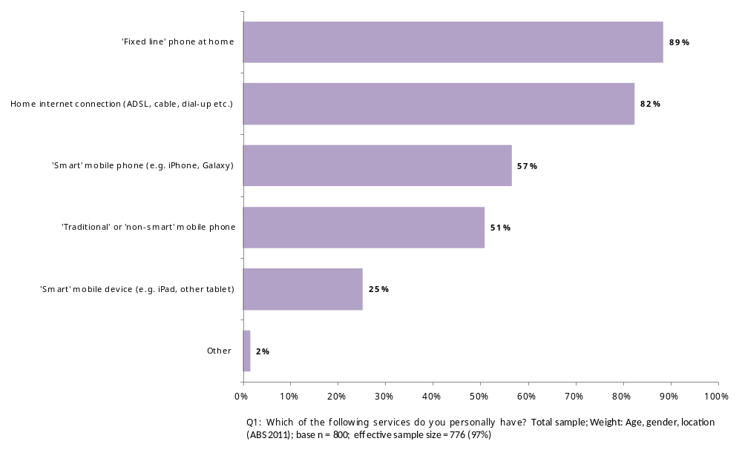
The results for this question by age and gender are shown in Figure 2. Significantly fewer respondents aged between 18 and 34 years said they had a fixed line at home (76%, compared with 89%), while a significantly higher proportion of this age group have ‘smart’ mobile phones (80%, compared with 57%). Significantly more older respondents (55 years and over) have a ‘traditional’ or ‘non-smart’ mobile phone (63%, compared with 51%).
A significantly higher proportion of respondents aged 35 and over (35-54 years, 92% and 55+ years, 96%) indicated that they have a ‘fixed line’ phone at home.
Among respondents aged between 35 and 54 years of age, significantly more have a ‘smart’ mobile device like an iPad or tablet (31%, compared with 25%).
Significantly more respondents aged 35-54 years (90%, compared to 82%) indicated that they have home internet connection.
Figure 2: Communications services currently held
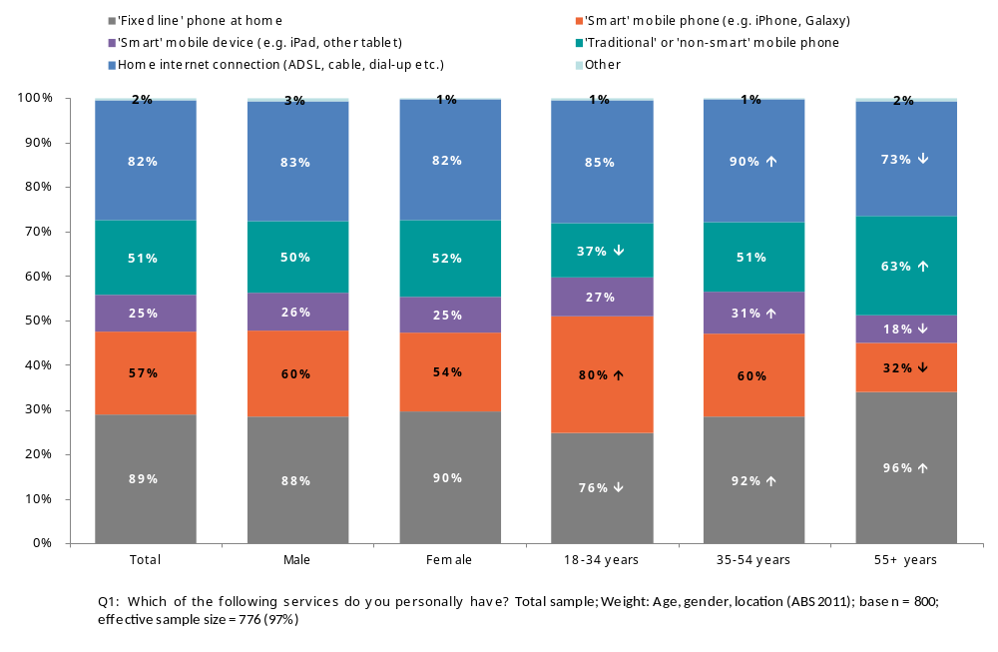
Additional analysis was undertaken comparing those with household incomes of less than $60K per annum to those with higher incomes. Those participants with a gross household income of less than $60K were less likely than those with higher incomes to have smart mobile phones (40% compared to 70%), smart mobile devices (16% compared to 32%), or home internet connections (74% compared to 90%).
As outlined in Figure 3, two in five respondents (42%) regard their ‘smart’ mobile phone as their main communication service, while 29% indicated their main service is their fixed line at home and 16% said it is their ‘traditional’ or ‘non-smart’ mobile phone. More than one in ten (12%) consider their home internet connection (ADSL, cable, dial up etc) to be their main communication service.
Figure 3: Main communications service
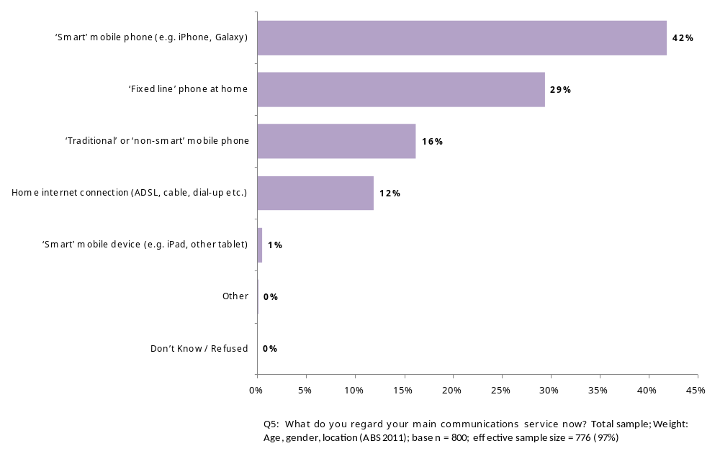

As shown in Figure 4, females (34%) and respondents aged over 55 years (54%) were significantly more likely to consider their fixed line at home to be their main communication service (compared with 29% of all respondents). While younger respondents between the ages of 18 and 34 were significantly more likely to say that their ‘smart’ mobile phone was their main communication service (64%, compared with 42%).
Figure 4: Main communications service
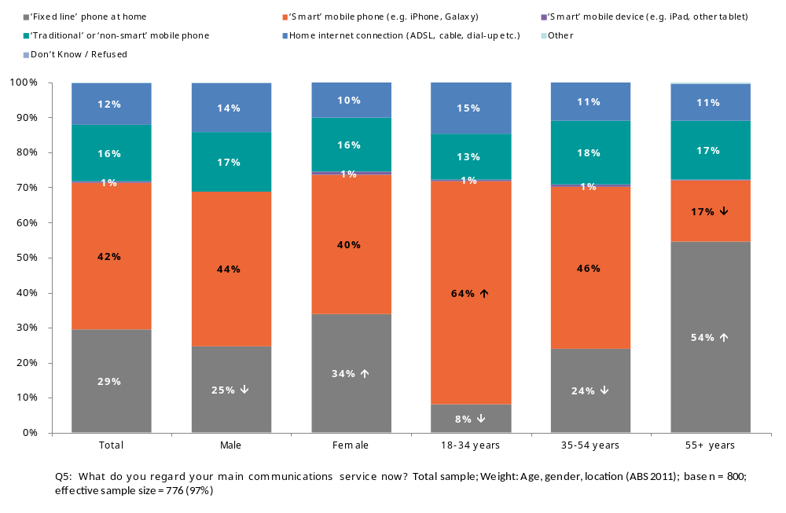
Additional analysis was undertaken comparing those with household incomes of less than $60K per annum to those with higher incomes. Those participants with a gross household income of less than $60K were more likely than those with higher incomes to consider their fixed line phone at home to be their main communications device (43% compared to 18%), and less likely to say that a smart mobile phone was their main communications device (25% compared to 58%).
Figure 5: Main communication service by household income
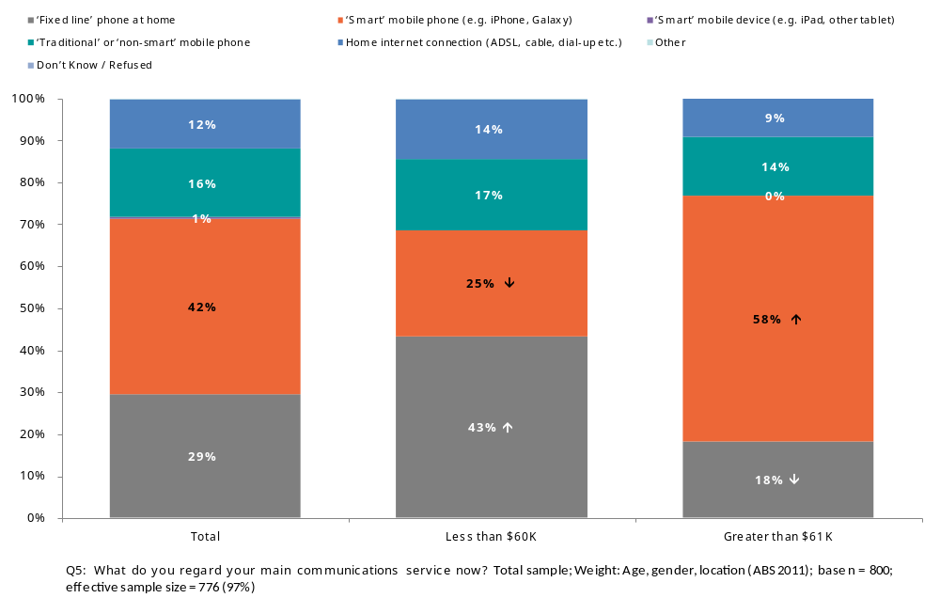
When asked who their service provider is for their main communications service, the majority of respondents (54%) cited Telstra or Bigpond. One in five (20%) indicated they have an account with Optus for their main communications service and one in ten (11%) are with Vodafone. The results are shown below in Figure 6.
Figure 6: Service provider for main communications service
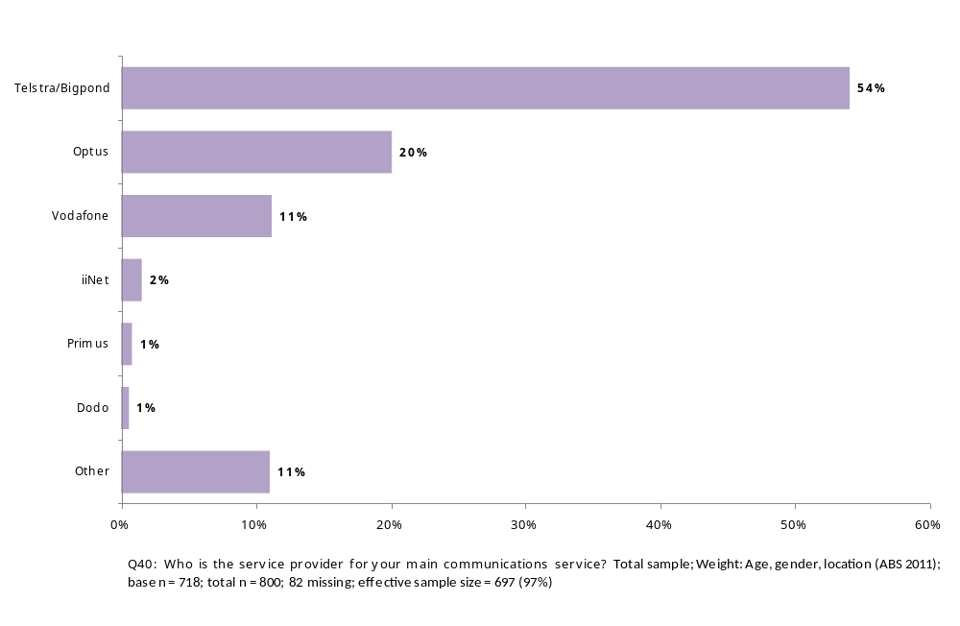
Respondents aged between 18 and 34 years are significantly less likely to have an account with Telstra (41% compared with 54%) for their main communications service and significantly more likely to be with Optus (29% compared with 20%) or Vodafone (18% compared with 11%).
In contrast, respondents aged 55 years and over are significantly more likely to have an account with Telstra (66% compared with 54%) for their main communications service and significantly less likely to be with Optus (13% compared with 20%) or Vodafone (5% compared with 11%).
Figure 7: Service provider for main communications service
 | Total | Male | Female | 18-34 years | 35-54 years | 55+ years
Telstra/Bigpond | 54% | 56% | 52% | 41%↓ | 55% | 66%↑
Optus | 20% | 20% | 21% | 29%↑ | 19% | 13%↓
Vodafone | 11% | 11% | 12% | 18%↑ | 10% | 5%↓
iiNet | 2% | 1% | 2% | 0% | 2% | 2%
Dodo | 1% | 1% | 1% | 0% | 0% | 1%
Primus | 1% | 1% | 1% | 0% | 1% | 1%
Other | 11% | 10% | 12% | 10% | 13% | 10%

Q40: Who is the service provider for your main communications service? Total sample; Weight: Age, gender, location (ABS 2011); base n = 718; total n = 800; 82 missing; effective sample size = 697 (97%)

As shown in Figure 8 below, almost half of respondents (46%) signed up for their service five or more years ago, 24% have had their current service for between one and three years, while 19% joined within the last 12 months.
Figure 8: Length of time with service provider for main service
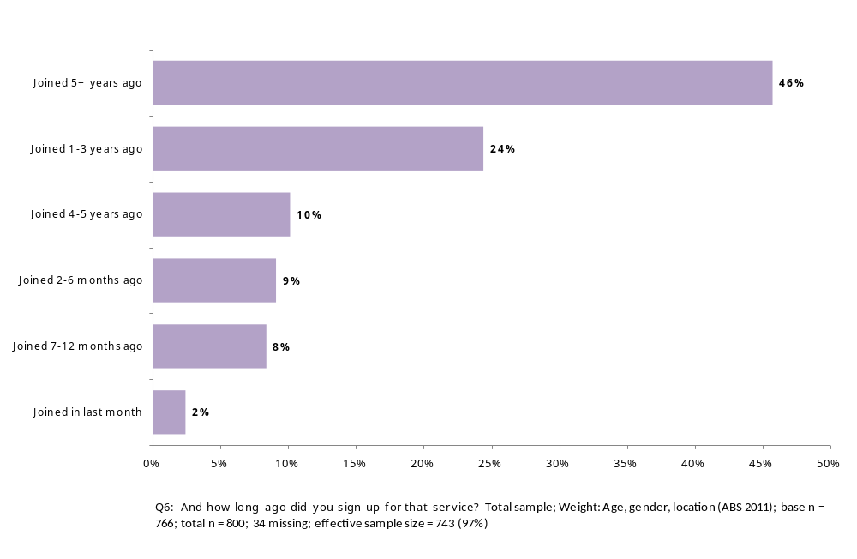
As shown in Figure 9, respondents aged 55 years and over are significantly more likely to have signed up for their service five or more years ago (65%, compared with 46%). While younger respondents (18-34 years) were significantly more likely to have signed up 1-3 years ago (32%, compared with 24%), 2-6 months ago (14% compared with 9%) or 7-12 months ago (13% compared with 8%).
Figure 9: Length of time with service provider for main service
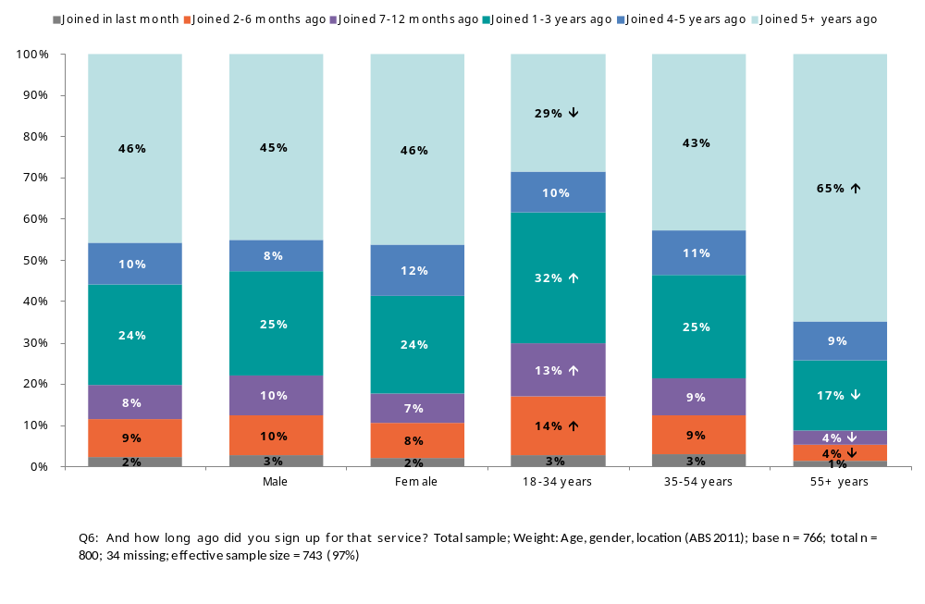
All respondents were asked for their agreement with a number of attitudinal statements related to their main communications service, on a scale of one to five, where one was strongly agree and five was strongly disagree. Nearly four in five (80%) agree that their main communications service is good quality. Seven in ten respondents (71%) agree that their main communications service offers good value for money. While 28% of respondents think that they are paying more than they expected to when they first signed up for this service.
Figure 10: Attitudes towards main communications service
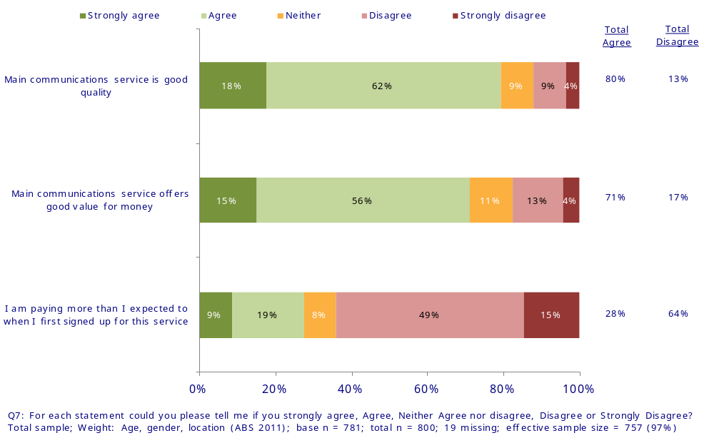
Where there are significant differences by age or gender, a chart and description have been included. Respondents aged over 55 years were significantly more likely to say they agree with the statement ‘Main communications service is good quality’ (71%, compared with 62%). While younger respondents aged between 18 and 34 years were significantly more likely to say they disagree with the statement (13% compared with 9%).
Figure 11: Agreement with 'the service provided is good quality'
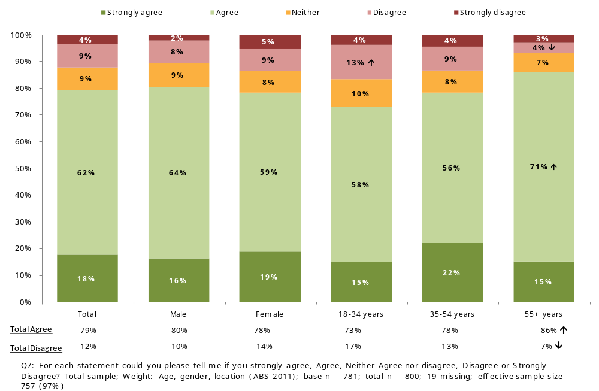

Fixed line phones
Among respondents who indicated they have a fixed line at home, half (50%) on average, use it more than once a day. More than four in five (82%) said they use their fixed line at least 2 or three time a week. The results are illustrated in Figure 12 below.
Figure 12: Frequency of use of fixed line at home
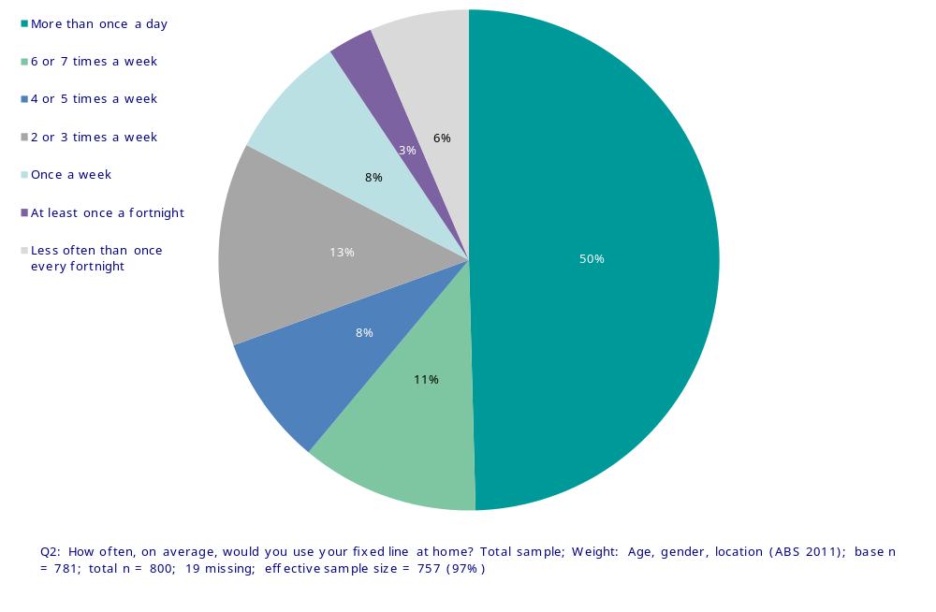
Respondents aged over 55 years were significantly more likely to use their fixed line more than once a day (60% compared with 50%) while significantly more 18-34 year olds said they use their fixed line less often than once a fortnight (13% compared with 6%).
Figure 13: Frequency of use of fixed line at home
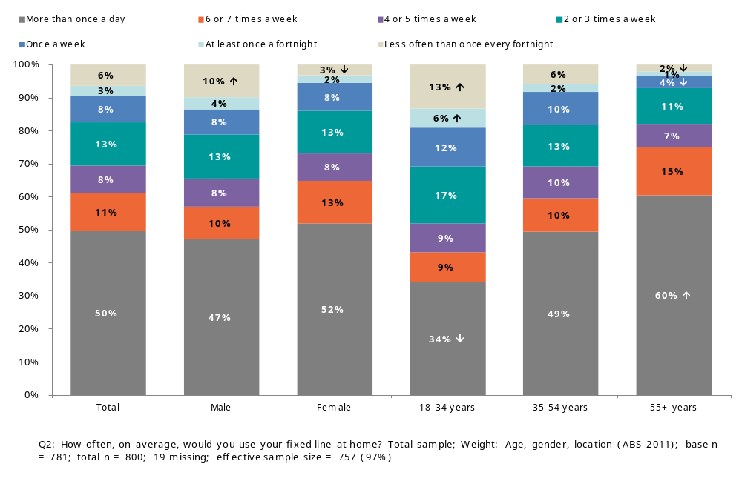

As shown in Figure 14, almost two in five (34%) respondents indicated that they have a fixed line at home that does not need to be plugged into a power point. There were no significant differences by age or gender for this question.
Figure 14: Whether own a fixed line phone that does not require mains power
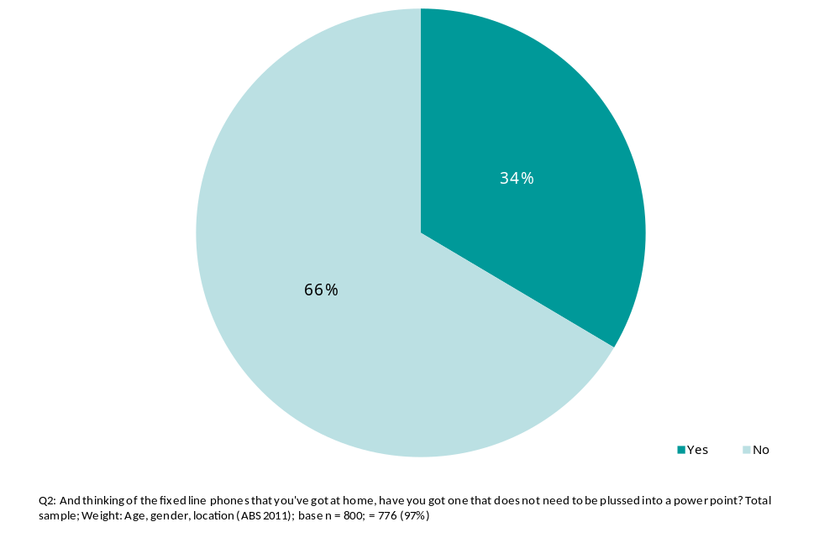

Smart mobile devices – experiences and attitudes
More than four in five respondents (82%) indicated they have a ‘smart’ mobile phone or device – over half (57%) have a ‘smart’ mobile phone and one quarter (25%) have a tablet or similar device. The results can be seen in Figure 1. Respondents aged 55 years and over are significantly less likely to have a ‘smart’ mobile phone (32%) or a ‘smart’ mobile device (18%) (compared with 57% and 25% respectively).
As shown in Figure 15, more than four in five respondents (82%) indicated they use the internet on their ‘smart’ mobile phone or device.
Figure 15: Use of internet on smart mobile device
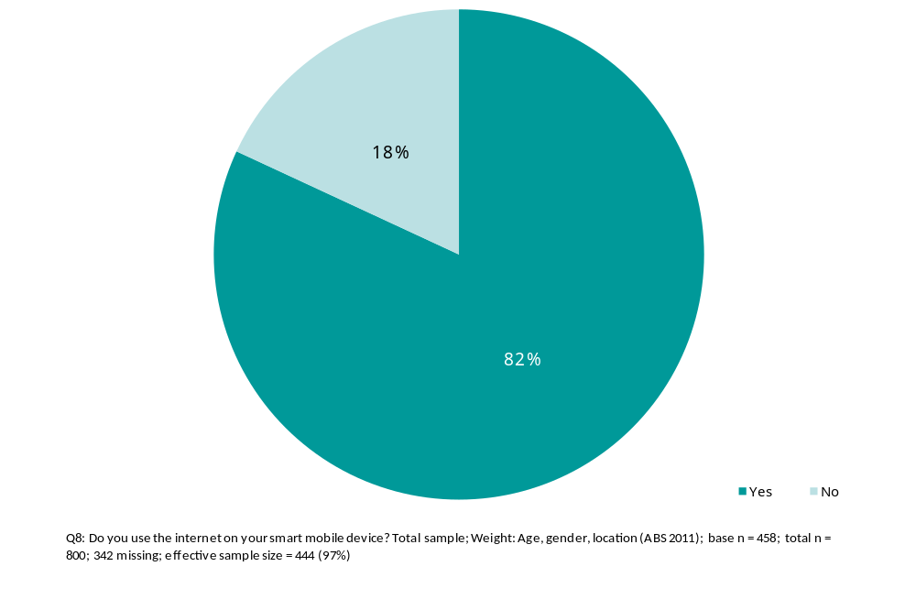
Respondents aged between 18 and 34 years (92%) are significantly more likely to use the internet on their ‘smart’ mobile phone or device as shown in Figure 16.
Figure 16: Users of internet on smart mobile device
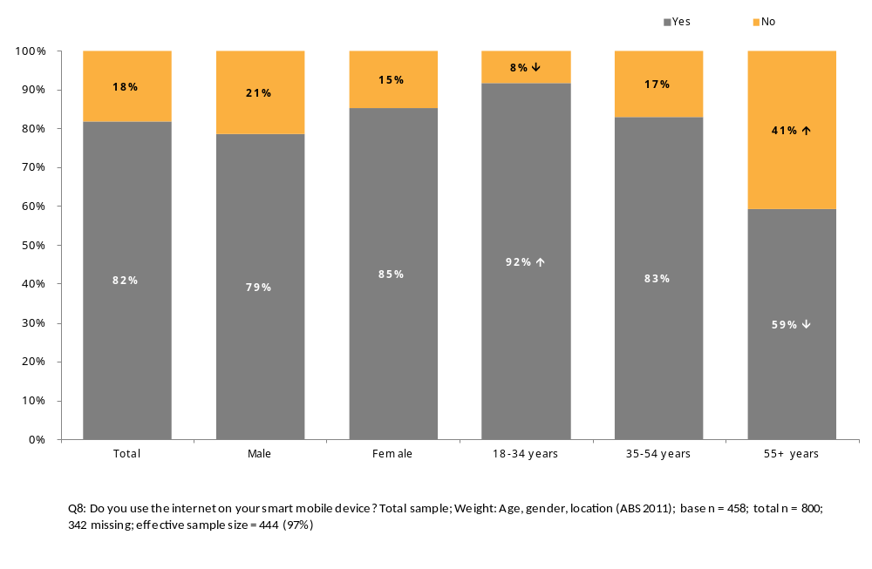
As Figure 17 below shows, almost half of respondents (47%) cited Telstra or Bigpond as their service provider for their ‘smart’ mobile device, while around one in five indicated they have an account with Optus (21%) or Vodafone (19%) for their ‘smart’ mobile device.
Figure 17: Service provider for smart mobile device
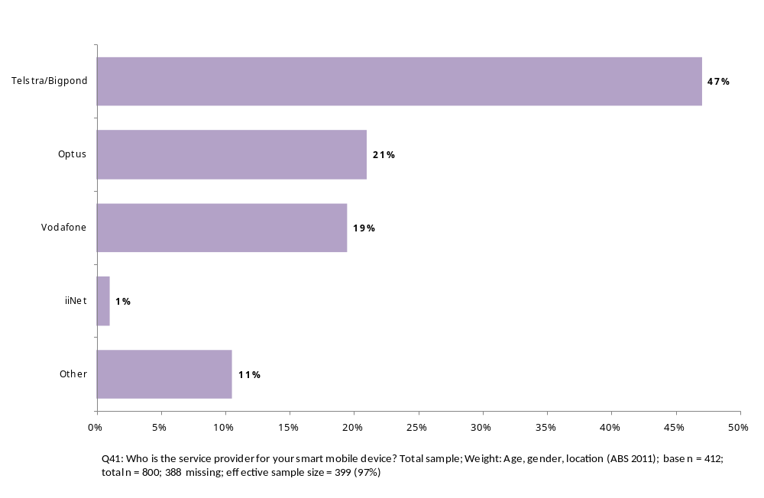
Younger respondents (18-34 years) are significantly less likely than older respondents to use Telstra or Bigpond as their provider for their ‘smart’ mobile device (37%, compared with 47%).

Satisfaction with internet on smart mobile device
All respondents were asked for their agreement with a number of attitudinal statements related to using the internet on their smart mobile device, on a scale of one to five, where one was strongly agree and five was strongly disagree. Results are shown below in Figure 18. Seven in ten respondents (72%) indicated that they think their service is reliable enough to do everything they need to do. Two thirds of respondents (66%) indicated that they think their service is fast enough to do everything they need to do. The majority of respondents (61%) agree that mobile internet download speeds are getting better.
In regards to tracking data usage when using the internet on the mobile, there was a more even split. Just over half (52%) said they do not keep track of their data usage, while 44% said that they do. Two thirds of respondents (67%) feel that their service provider gives them enough information to allow them to easily monitor their data usage.
Figure 18: Satisfaction with internet on smart mobile device
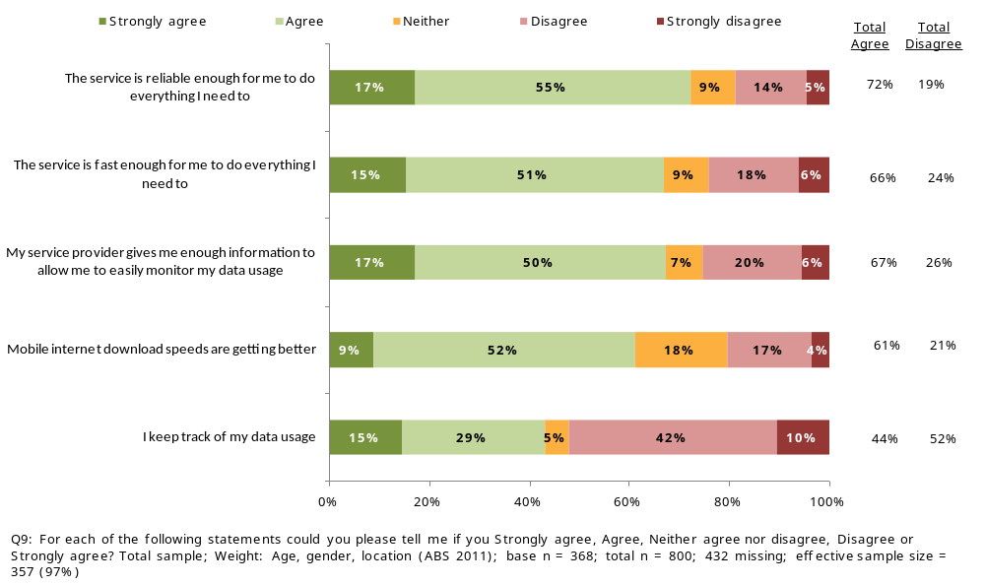
Analysis by service provider found that respondents with Telstra were more likely to say that ‘the service was fast enough to do everything I need to’ (75% agree compared to 67% overall) (see Figure 19). Respondents with Vodafone were less likely to agree that ‘the service was reliable enough to do everything they need to’ (54% agree compared to 72% overall) (see Figure 20).
There were no significant differences by age or gender for any of these statements.
Figure 19: The service is fast enough by service provider
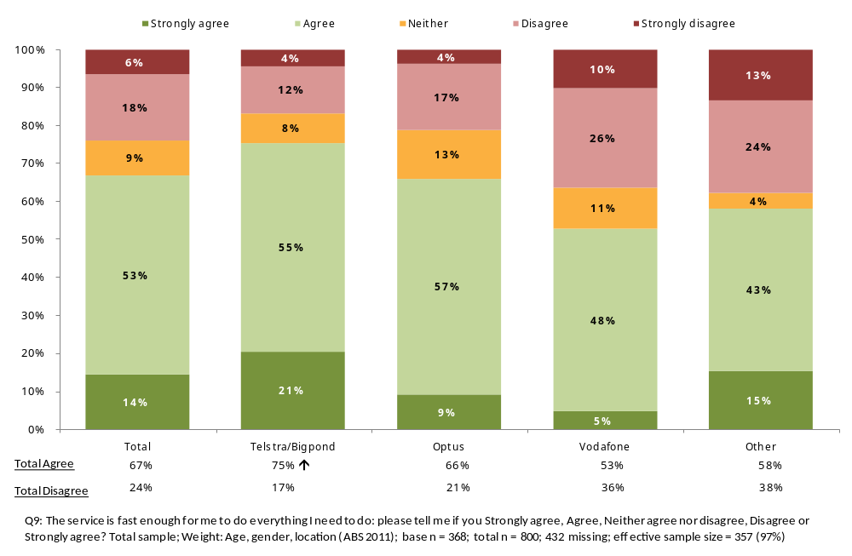
Figure 20: The service is reliable enough by service provider
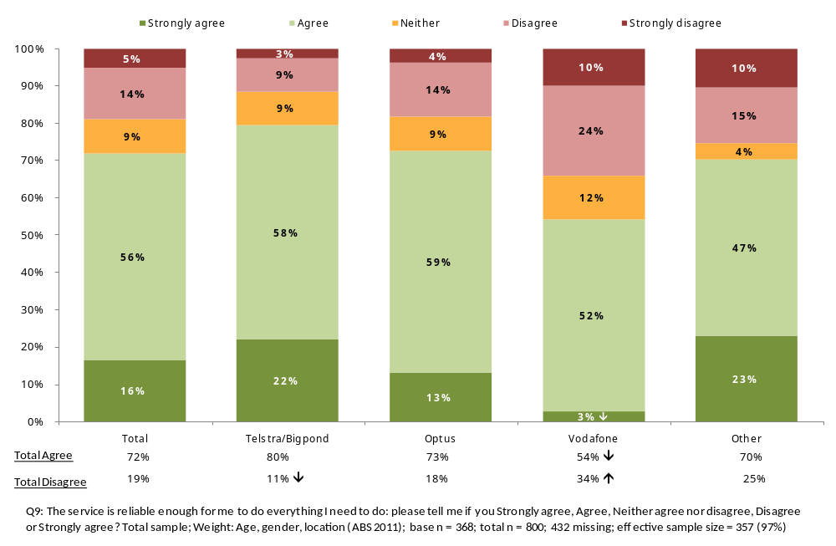

Frequency of exceeding data limit on mobile device
As shown in Figure 21, the majority of respondents (71%) indicated that they never exceed their data limit on their mobile device. A further 17% said they rarely exceed their data limit. There were no significant differences by age or gender for this question.
Figure 21: Frequency of exceeding data limit on mobile device
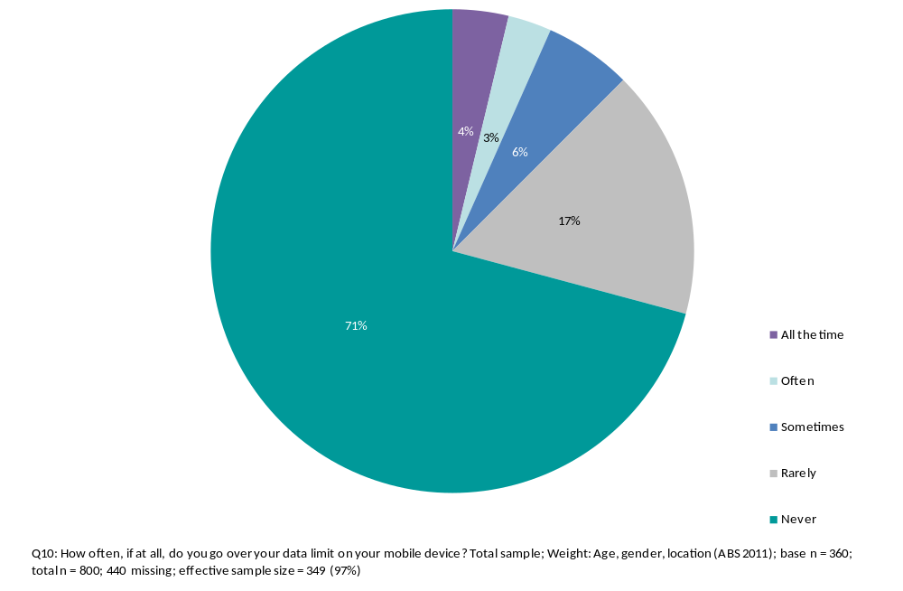

User attitudes toward smart mobile devices
Respondents who indicated that they have a ‘smart’ mobile device were asked for their agreement with a number of attitudinal statements related to smartphones and tablets, on a scale of one to five, where one was strongly agree and five was strongly disagree. The results are shown below in Figure 22.
Just over one in four (28%) indicated that they like using their smartphone or tablet in public places because they can shut out what is going on around them. A similar proportion (27%) said they find the touch screen difficult to use when writing SMS and emails. Less than one in ten (8%) said they experience problems with their eyes because of their smartphone or tablet.
Over half of respondents believe that they pay less attention to what is going on around them when they use their smartphone or tablet (53%). Similar proportions said they never switch it off (58%) and they sleep next to it (54%).
The majority of respondents (73%) said they did not feel anxious when without their smartphone or tablet. Overall, two thirds (69%) respondents think their smart mobile device has a positive impact on their life in general.
Figure 22: User attitudes toward smart mobile devices
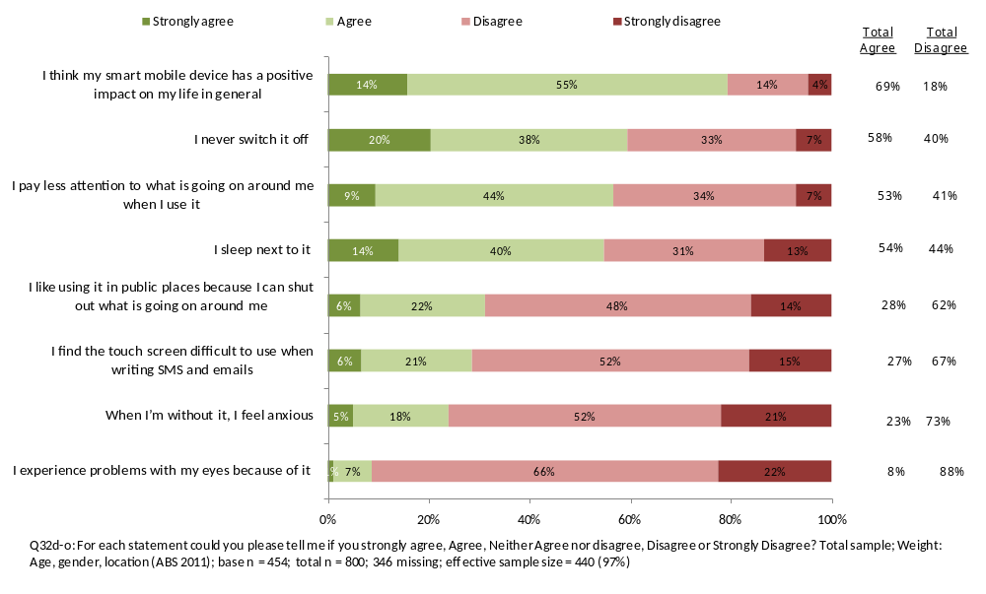
Where there were significant differences by age and gender on an attitudinal statement, a chart and description have been included below.
As illustrated in Figure 23 below, younger respondents were significantly more likely to agree with the statement ‘I like using it in public places because I can shut out what is going on around me’ than older respondents (43% of 18-34 years olds compared with 28% of all respondents). In contrast, respondents aged 55 years and over were significantly more likely to disagree with the statement (66%, compared with 48%).
Figure 23: Agreement with ‘I like using it in public places because I can shut out what is going on around me’
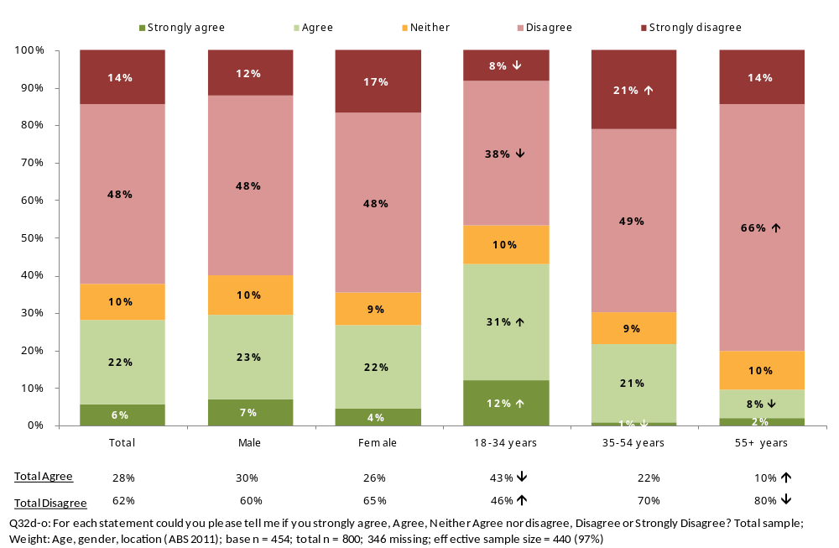
Figure 24 below shows that respondents aged between 18 and 34 years were significantly more likely to strongly agree with the statement ‘When I’m without it, I feel anxious’ (9% compared with 5% overall).
Figure 24: Agreement with 'When I’m without it, I feel anxious'
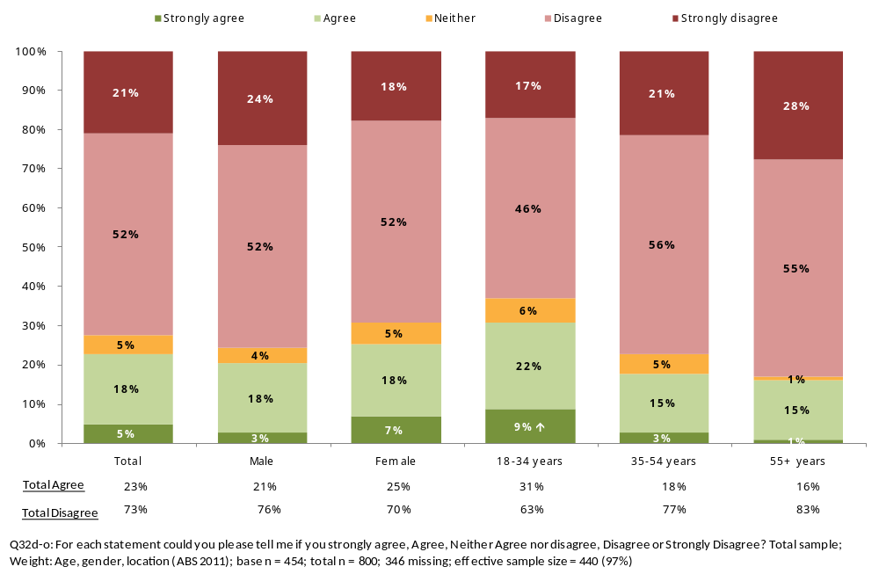
As detailed in Figure 25, respondents aged 55 years and over were significantly more likely to disagree with the statement ‘I never switch it off’ (47% compared with 33%).
Figure 25: Agreement with ‘I never switch it off’
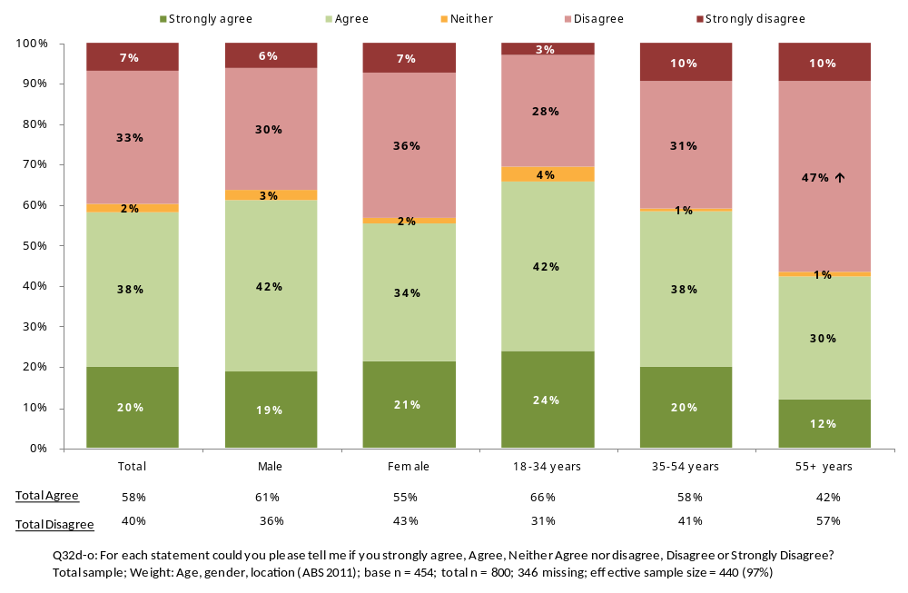
Similarly as illustrated in Figure 26, respondents aged 55 years and over were significantly more likely to disagree with the statement ‘I sleep next to it’ (70%, compared with 44%). A significantly larger proportion of younger respondents aged 18-34 years (69%) indicated that they sleep next to their phones, when compared with all respondents (54%).
Figure 26: Agreement with ‘I sleep next to it’
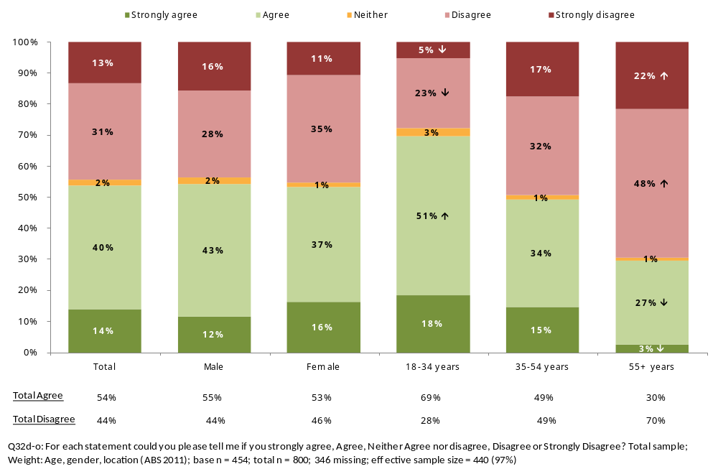
In Figure 27, respondents aged 55 years and over were significantly more likely to disagree with the statement ‘I think my smart mobile device has a positive impact on my life in general’ (25%, compared with 14%).
Figure 27: Agreement with ‘I think my smart mobile device has a positive impact on my life in general’
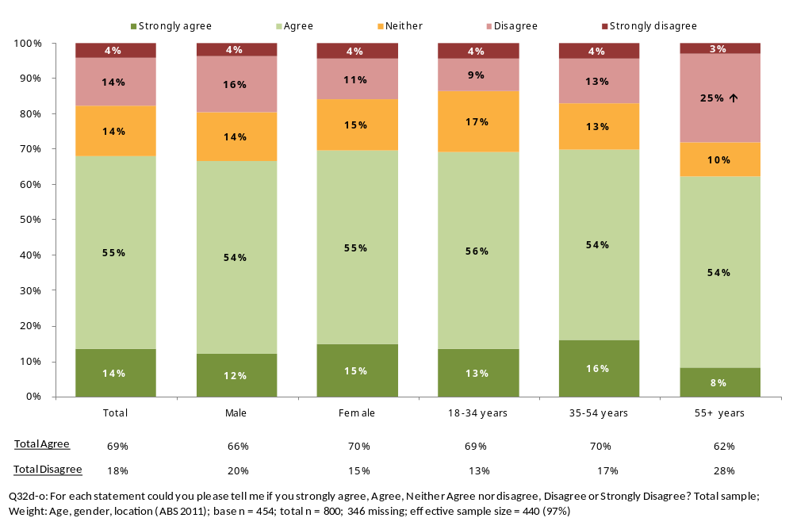

Non-user attitudes to smart mobile devices
Respondents who do not have a ‘smart’ mobile device were also asked for their agreement with a number of attitudinal statements related to smartphones and tablets, on a scale of one to five, where one was strongly agree and five was strongly disagree. The results are shown below in Figure 28. More than three quarters (77%) think that others spend too much time on them. Almost two thirds (65%) agreed that they don’t like others using them in public because it makes them unaware of what is going on around them. Only 17% feel like they are missing out by not having a ‘smart’ mobile device.
Figure 28: Non-user attitudes to smart mobile devices
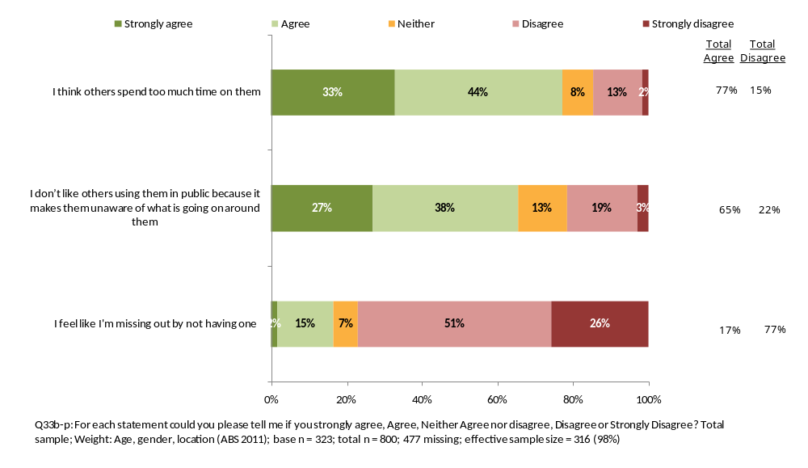
Respondents who are 55 years and over were significantly more likely to strongly agree with the statement ‘I don’t like others using them in public because it makes them unaware of what is going on around them’ (36%, compared with 27%). Results are shown below in Figure 29.
Figure 29: Agreement with 'I don’t like others using them in public because it makes them unaware of what is going on around them'
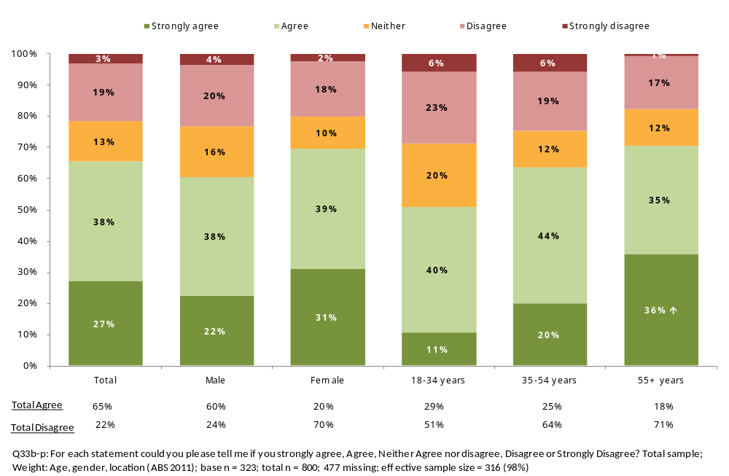
  - Switching and Uptake
While many surveyed said they had never changed service providers or taken up a new service, among those who have changed, most did so more than a year ago.
Reasons for changing providers included cheaper service or better rates with the new service provider, a better deal or better products, or a negative experience with previous provider.
Most who have changed, felt that the process of switching service providers was easy and indicated they thought there was sufficient information available for them to make an informed decision about the deal that was best for them.
Among respondents who indicated that they had taken out a new service with a new service provider, almost half had signed up for a home internet connection, 37% a ‘smart’ mobile phone and 25% a fixed line phone at home.

Respondents were asked when they last changed to a new service provider or took out a new service. The results are illustrated in Figure 30 below. Forty six per cent (46%) indicated that they had changed to a new service provider or took out a new service more than a year ago – 33% joined a new service provider more than two years ago, while 13% joined between one and two years ago. Almost one third of respondents (31%) said they had never changed service providers or taken up a new service.
Figure 30: Last occasion changed provider or took out a new service
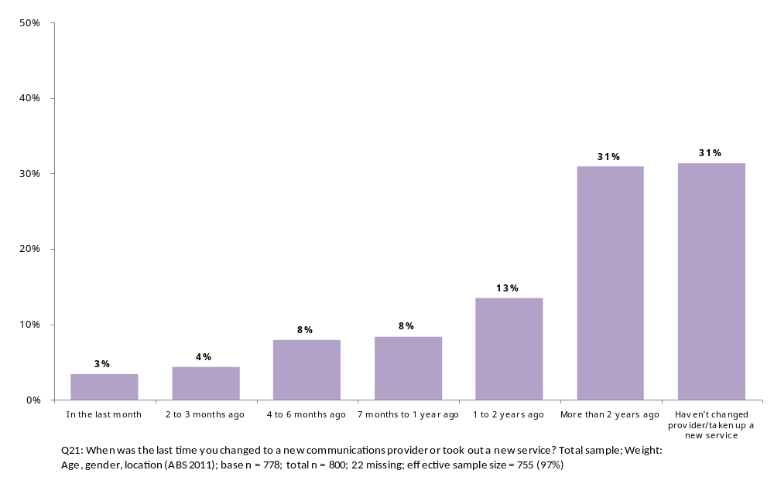
As shown in Figure 31, respondents aged 55 years and over were significantly more likely to have never changed service providers or taken up a new service (40% compared with 31%). Respondents aged between 18 and 34 years were significantly more likely to say they have changed service providers or taken up a new service between seven months and a year ago (13% compared with 8%).
Figure 31: Last occasion changed provider or took out a new service
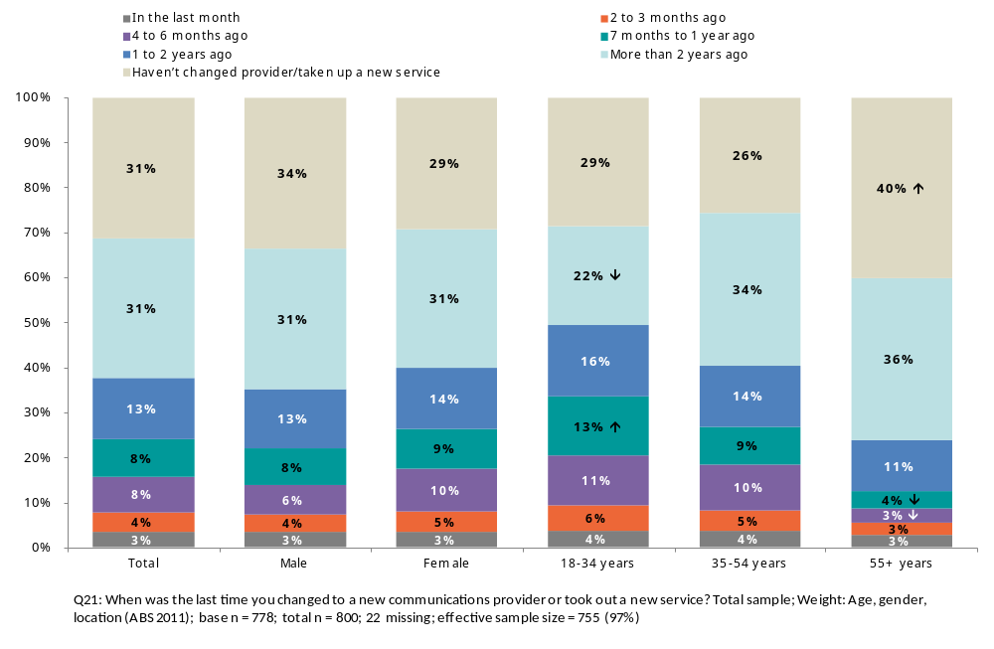
Among those who had indicated that they had joined a new service provider, almost two thirds (64%) said that they had changed providers rather than taken out a new service. Thirty six per cent (36%) said they had taken out a new service.
Among respondents who had changed providers rather than taken out a new service, Figure 32 below shows the types of services respondents changed service providers for. More than two in five (43%) respondents had changed providers for their ‘fixed line’ phone at home, 39% for their ‘smart’ mobile phone and 36% for their home internet connection.
Figure 32: Type of service that was changed to different provider
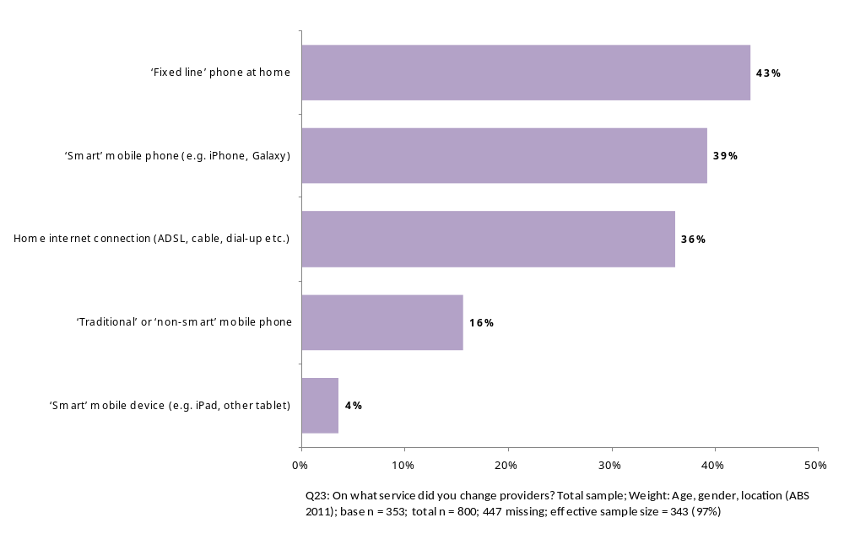
Results by gender and age are shown in Figure 33 below. Younger respondents between 18 and 34 years were significantly more likely to have changed service providers for their ‘smart’ mobile phone (62% compared with 39%) and significantly less likely to have changed service providers for their ‘fixed line’ home phone (24% compared with 43%).
Figure 33: Type of service that was changed to different provider
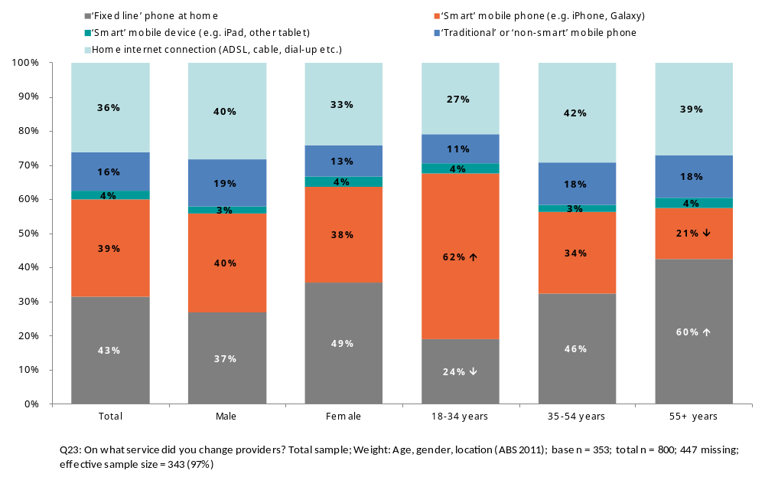
Among respondents who indicated that they had taken out a new service with a new service provider, almost half (46%) had signed up for a home internet connection, 37% a ‘smart’ mobile phone and 25% a fixed line phone at home. The results are illustrated below in Figure 34. There were no significant differences by age or gender for this question.
Figure 34: New services taken up
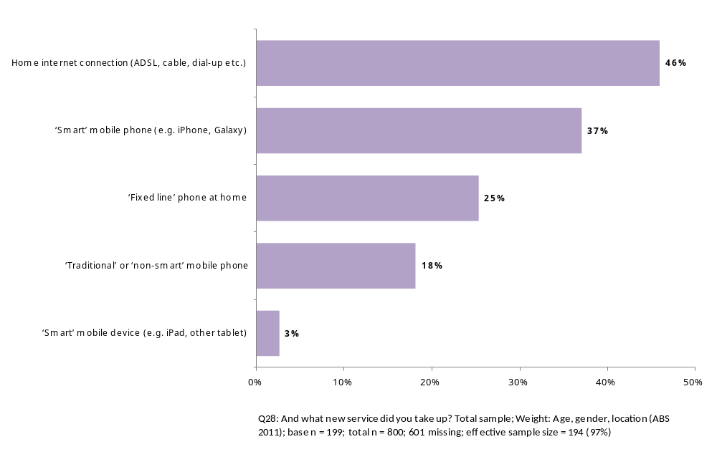
As shown in Figure 35 below, the two main reasons for changing providers included better deal or better products (40%), cheaper service or better rates (38%). The third largest reason for changing was a negative experience with previous provider (22%). There were no significant differences by age or gender for this question.
Figure 35: Reasons for changing service providers
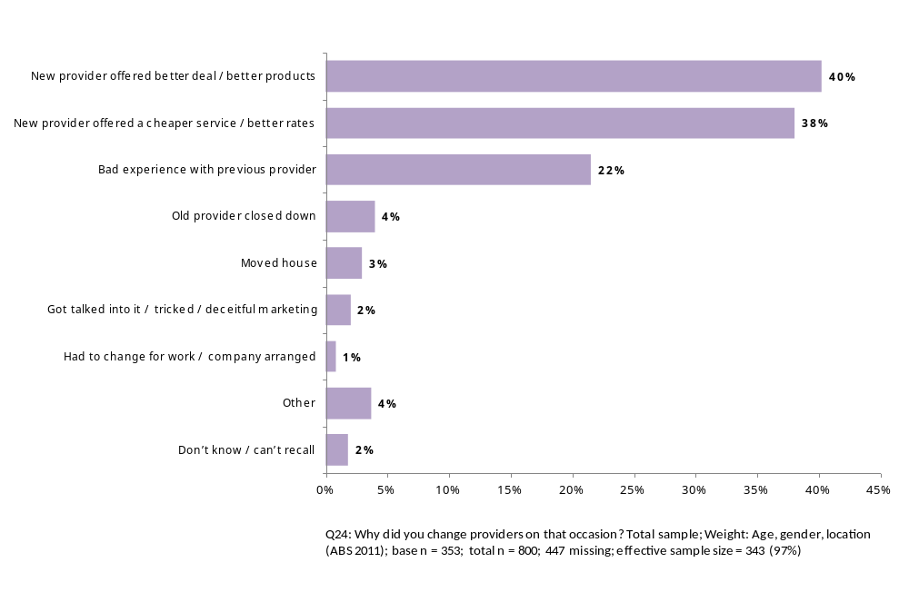

Respondents were asked whether their service was out of action during the switch over between service providers and if so, for how long it was out of action. Almost one third (30%) said that their service was out of action. Among these respondents, two in five (40%) said their service was out of action for less than a day, 38% said that it was out of action for at least a week. There were no significant differences by gender or age for these two questions.
Figure 36: Time service was out of action
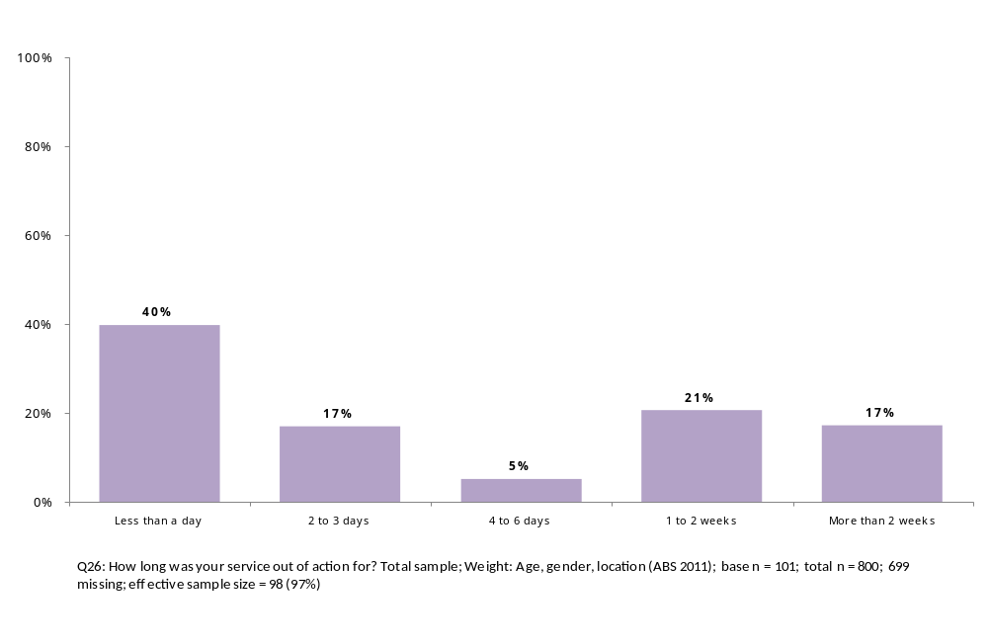
All respondents were asked for their agreement with two attitudinal statements related to changing communications service providers, on a scale of one to five, where one was strongly agree and five was strongly disagree. Results are shown below in Figure 37.
The majority of respondents (83%) indicated they thought there was sufficient information available for them to make an informed decision about the deal that was best for them. Similarly 84% felt that the process of switching service providers was easy. There were no significant differences by gender or age.
Figure 37: Attitudes about changing service providers
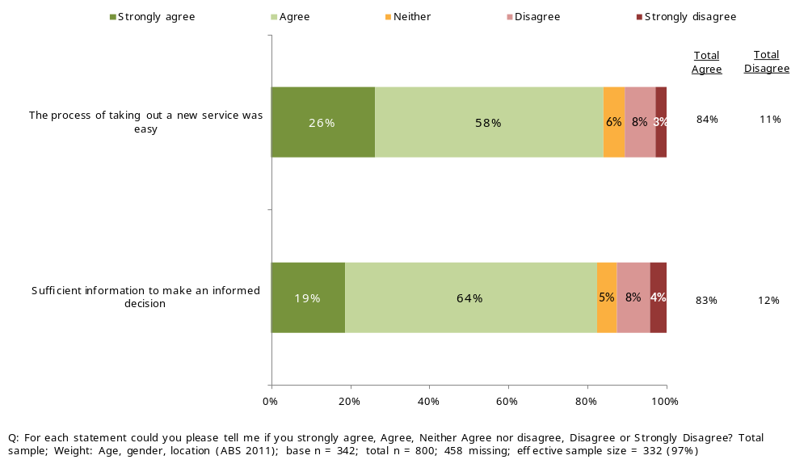

  - Complaints and Hardship
The most common issues with communications services cited were technical problems, unexpectedly high bills, billing problems apart from high bills and customer service issues. However, most people surveyed said they had not experienced problems or issues with their service in the last 12 months.
The survey results indicated that older consumers (55 years and over) were less likely to have experienced any problems or issues in the last 12 months. If they did have an issue with their service, they were more likely to experience issues with their fixed line phone at home, while younger respondents were more likely to experience issues or problems with their mobile phone service.
The three main reasons for unexpectedly high bills in the last 12 months were higher than expected or hidden fees, excess usage charges, and failure to monitor service usage. Nine in ten respondents (91%) said they had not experienced hardship as a result from a bill.
The majority of respondents made a complaint to their service provider the last time they had a problem with one of their communication services. Older people were more likely to have made a complaint about the most recent issue they experienced with their service, while the younger respondents were less likely to have made a complaint.
Most people interviewed were satisfied with the way their complaint had been handled by their service provider. If unsatisfied however, 30% of respondents said they would then go to the Telecommunications Industry Ombudsman (the TIO) while 32% said they did not know who they would go to if their provider had not resolved their problem successfully. Most did not take their complaint to the TIO because their issues had been resolved, while among younger consumers there was relatively low awareness of the Telecommunications Industry Ombudsman.

Issues experienced and the services they are related to
Respondents were asked about the problems or issues experienced with their service in the last 12 months. As detailed in Figure 38, one third of respondents (34%) have had technical problems with their fixed line at home, mobile phone or internet service providers, 17% have had unexpectedly high bills and 13% have had customer service issues. Over half (51%) indicated that they had not had any problems or issues.
Figure 38: Problems experienced in the last 12 months
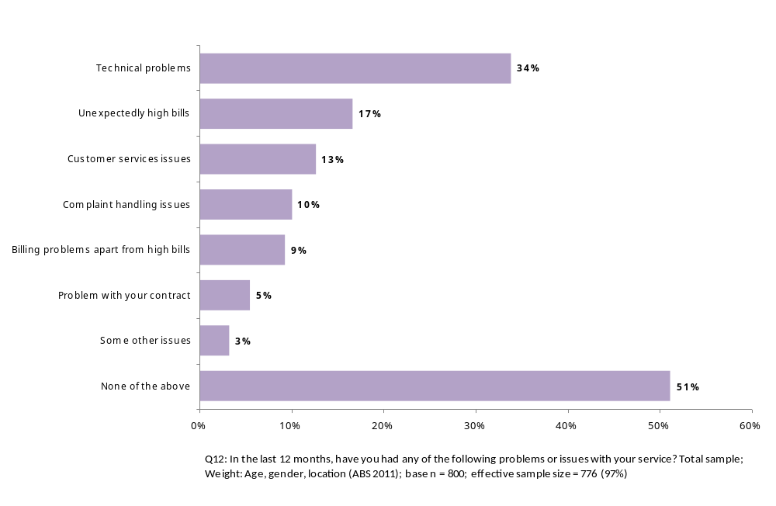
Figure 39: Problems experienced in the last 12 months
 | Total | Male | Female | 18-34 years | 35-54 years | 55+ years
Technical problems | 34% | 30% | 37% | 36% | 39%↑ | 26%↓
Unexpectedly high bills | 17% | 15% | 18% | 21% | 19% | 11%↓
Customer services issues | 13% | 9%↓ | 16%↑ | 18%↑ | 11% | 9%
Complaint handling issues | 10% | 9% | 11% | 13% | 10% | 7%
Billing problems apart from high bills | 9% | 8% | 11% | 12% | 10% | 6%↓
Problem with your contract | 5% | 4% | 7% | 9%↑ | 5% | 2%↓
Some other issues | 3% | 5%↑ | 1%↓ | 3% | 3% | 4%
None of the above | 51% | 56%↑ | 47%↓ | 50% | 45%↓ | 59%↑
Column n | 800 | 391 | 409 | 201 | 312 | 287

Reasons for unexpectedly high bills
Among respondents who had experienced unexpectedly high bills in the last 12 months, just over one in three cited higher than expected or hidden fees (34%), one in four mentioned excess usage charges (25%) and just over one in six (17%) said they had not monitored their usage. The results are shown in Figure 40.
There were no significant differences by age or gender for this question.
Figure 40: Reasons for unexpectedly high bills
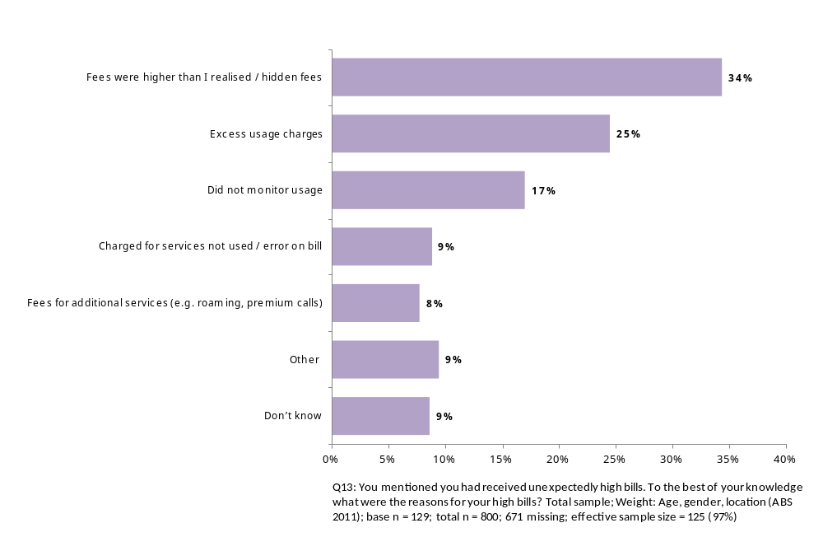

As illustrated below in Figure 41, almost half of respondents (46%) indicated that the last time they had a problem with their service provider for their fixed line phone at home, their mobile phone or their internet service, the issue was related to technical problems. For more than one in ten (12%) it was due to unexpectedly high bills and 9% cited billing problems other than high bills. There were no significant differences by service provider, age or gender for this question.
Figure 41: Most recent problem or issue with a service
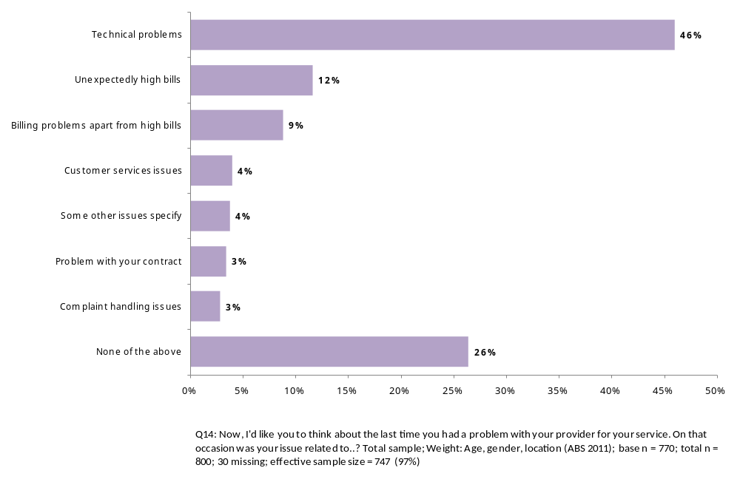
There were no significant differences by service provider for this question (see table below).
Table 42: Most recent problem or issue with a service by service provider
 | Total | Telstra/Bigpond | Optus | Vodafone | Other
Technical problems | 45% | 49% | 38% | 45% | 45%
Unexpectedly high bills | 11% | 12% | 17% | 11% | 11%
Customer services issues | 8% | 13% | 9% | 7% | 8%
Complaint handling issues | 5% | 2% | 3% | 1% | 5%
Billing problems apart from high bills | 3% | 4% | 6% | 3% | 3%
Problem with your contract | 3% | 2% | 3% | 3% | 3%
Some other issues | 4% | 3% | 5% | 5% | 4%
None of the above | 28% | 23% | 23% | 33% | 28%
Column n | 398 | 138 | 76 | 106 | 398
Respondents were asked about the last time they had a problem with their provider and the service the issue was related to. The results are shown in Figure 43 and Figure 44 below. For 27% of respondents their issue with their service provider was related to their fixed line at home, for 31% the issue related to their mobile phone and for 28%, it was the internet.
Figure 43: Service most recent problem related to
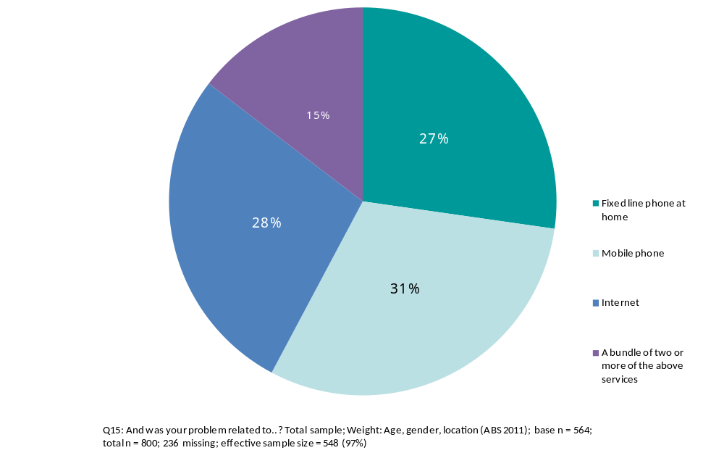

For younger respondents aged between 18 and 34 years of age issues or problems were significantly more likely to be related to their mobile phone service for (44%, compared with 31%), and significantly less likely to be related to their fixed line phone at home (14%, compared to 27%).
For respondents aged 55 years and over, issues or problems were significantly more likely to be related to their fixed line phone at home (43%, compared to 27%).
Figure 44: Service most recent problem related to
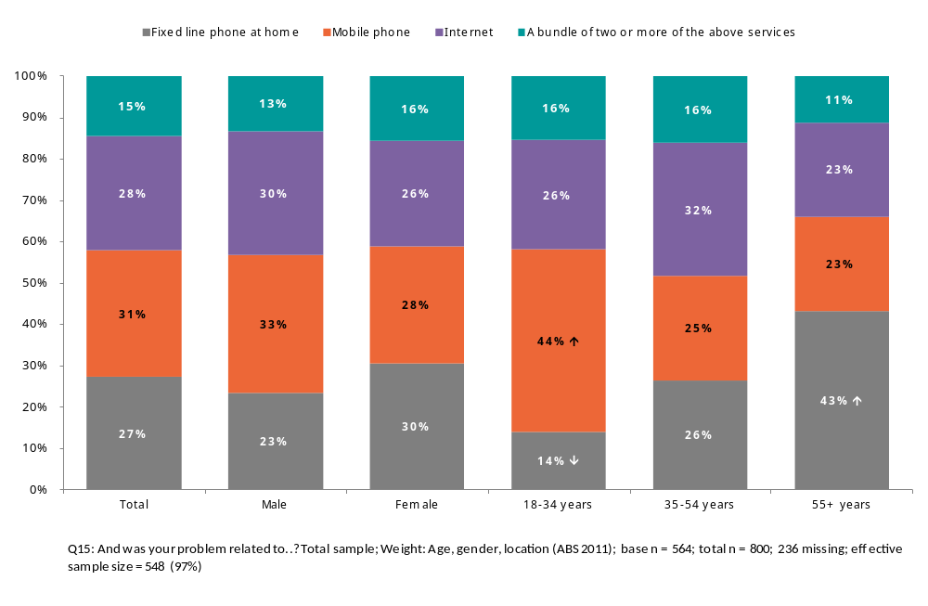

Complaints and satisfaction with response
Respondents were asked to imagine that they had made a complaint against their telecommunications service provider. If they were unsatisfied with the way their service provider had dealt with their complaint, 30% of respondents said they would then go to the Telecommunications Industry Ombudsman (the TIO). Sixteen per cent (16%) said they would take their complaint to the Ombudsman, while 32% said they did not know who they would go to if their provider had not resolved their problem successfully.
Figure 45: Where consumers would take complaints
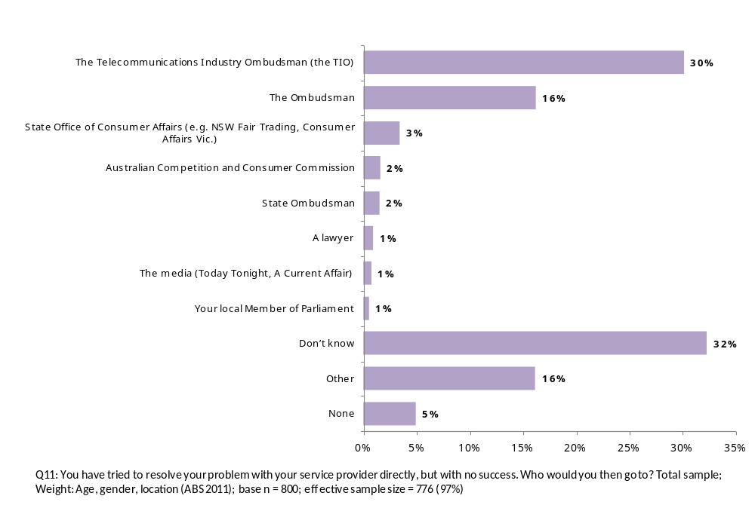
When asked to think about the last time they had a problem with their provider for one of their communication services, three quarters of respondents (76%) said they made a complaint to their service provider.
As shown in Figure 46, respondents aged 55 years and over were significantly more likely to have made a complaint about the most recent problem they experienced with their service (85%, compared to 76%), while respondents aged between 18 and 34 years of age were significantly less likely to have made a complaint (66%, compared with 76%).
Figure 46: Whether complaint was made about most recent problem experienced
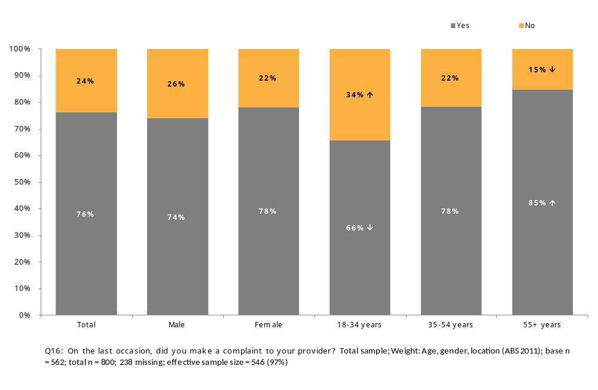
Respondents were asked whether they were satisfied with the response of their service provider in dealing with their last complaint. As shown in Figure 47 below, overall the majority of respondents (56%) were satisfied, while 36% were dissatisfied with the way their complaint was handled.
Figure 47: Satisfaction with response of service provider
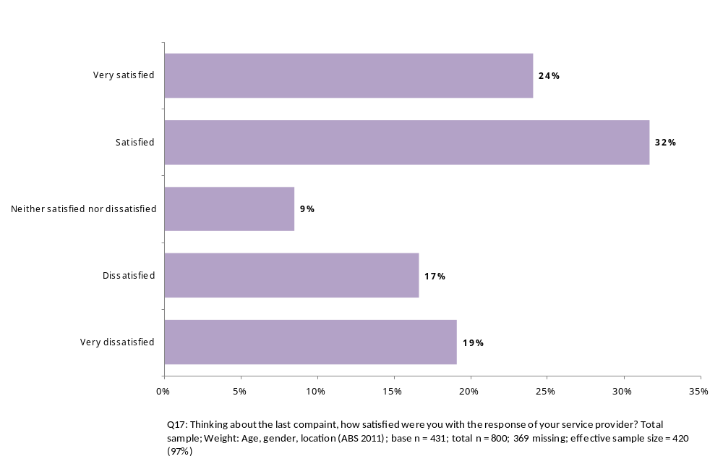
As detailed in Figure 48 below, respondents aged 55 years and over were significantly more likely to be very satisfied with the response of their service provider (34% compared with 24%).
Figure 48: Satisfaction with response of service provider
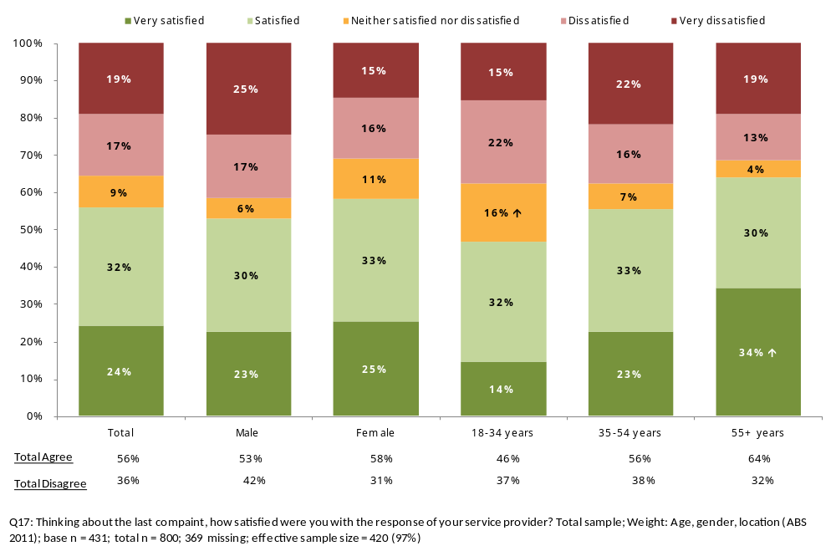

Figure 49: Satisfaction on the response from service provider by service provider
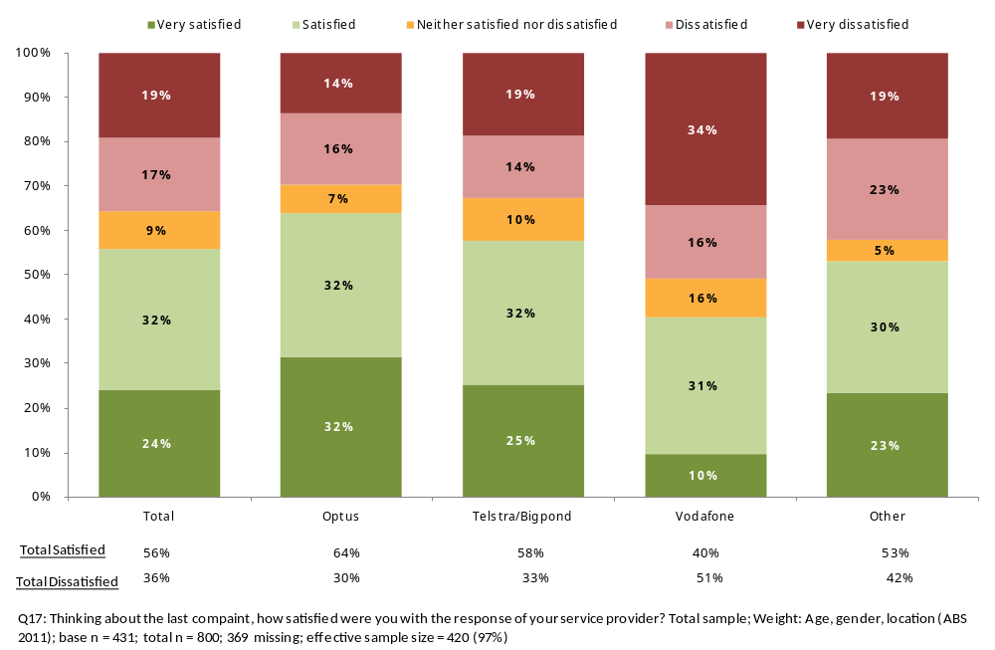
When asked whether they had taken their last complaint to the Telecommunications Industry Ombudsman (TIO), the overwhelming majority (96%) said that they had not. Among those who said they were dissatisfied with their service provider’s response to their complaint, only 11% took their last complaint to the telecommunications industry ombudsman (TIO). There were no significant differences by age or gender for this question.
Figure 50: Whether complaint made to TIO
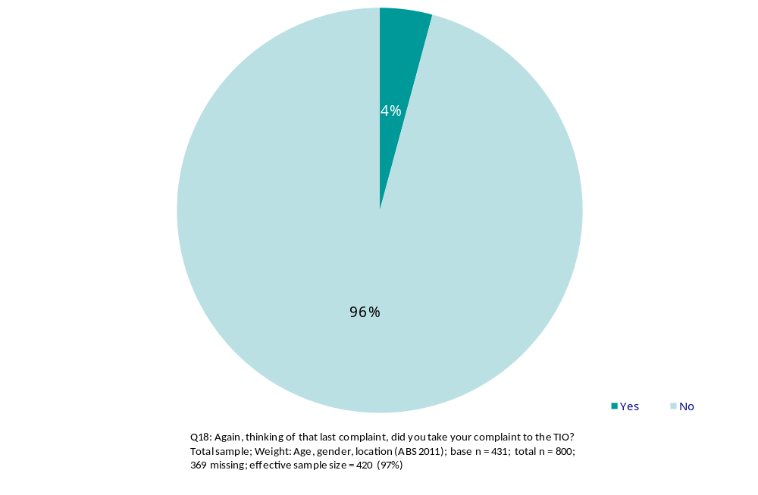
When asked, over half of respondents (58%) said they had not taken their last complaint to the telecommunications industry ombudsman (TIO) because their complaint had been resolved. One in ten (10%) said they didn’t know about the TIO, while 12% cited ‘too much effort or too much hassle’ as the reason for not taking their last complaint to the telecommunications industry ombudsman (TIO). The results are shown in Figure 51 below.
Figure 51: Reasons for not taking complaint to TIO
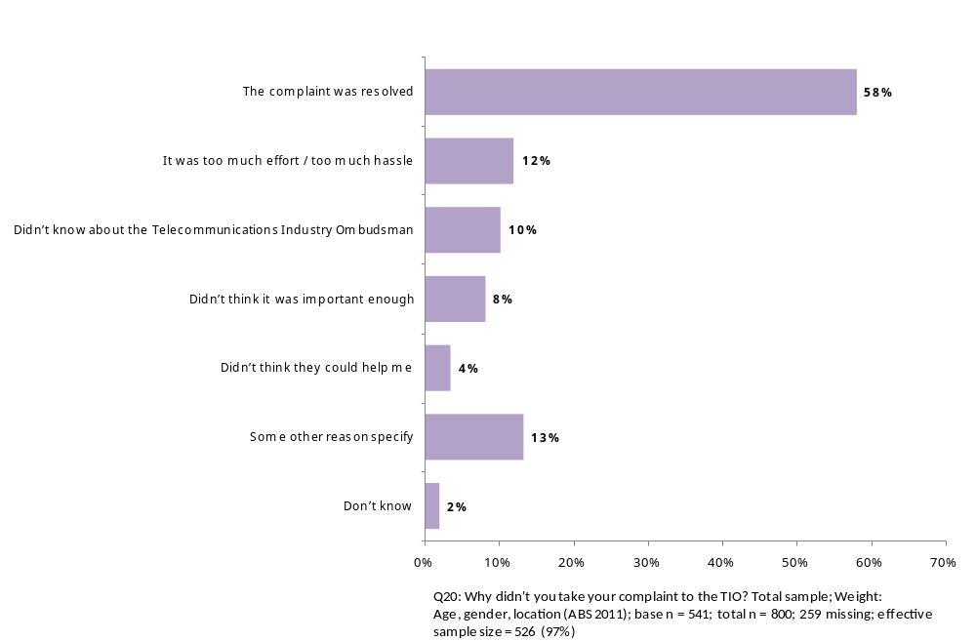
Younger respondents were less likely to know about the Telecommunications Industry Ombudsman (TIO). As shown in Figure 52, respondents aged between 18 and 34 years of age were significantly more likely to say they didn’t know about the TIO (19%, compared with 10%), while respondents aged between 35 and 54 years of age were significantly less likely to say they didn’t know about the TIO (5%, compared with 10%).
Figure 52: Reasons for not taking complaint to TIO
 | Total | Male | Female | 18-34 years | 35-54 years | 55+ years
The complaint was resolved | 58% | 53% | 62% | 46%↓ | 65%↑ | 62%
It was too much effort / too much hassle | 12% | 14% | 10% | 15% | 11% | 10%
Didn’t know about the TIO | 10% | 8% | 12% | 19%↑ | 5%↓ | 6%
Didn’t think it was important enough | 8% | 10% | 7% | 9% | 6% | 10%
Didn’t think they could help me | 4% | 5% | 3% | 5% | 2% | 4%
Some other reason specify | 13% | 16% | 11% | 14% | 14% | 12%
Don’t know | 2% | 3% | 1% | 2% | 1% | 3%
Column n | 541 | 253 | 288 | 146 | 226 | 169

Hardship
Respondents were asked whether they had experienced hardship as a result of a bill from a service provider in the last 12 months. The results are shown below in Figure 53. Nine in ten respondents (91%) said they had not experienced any of the difficulties listed in the survey. A very small proportion said they had had their service disconnected (5%) or had committed to an instalment repayment plan (4%).
Figure 53: Whether experienced hardship as a result from a bill
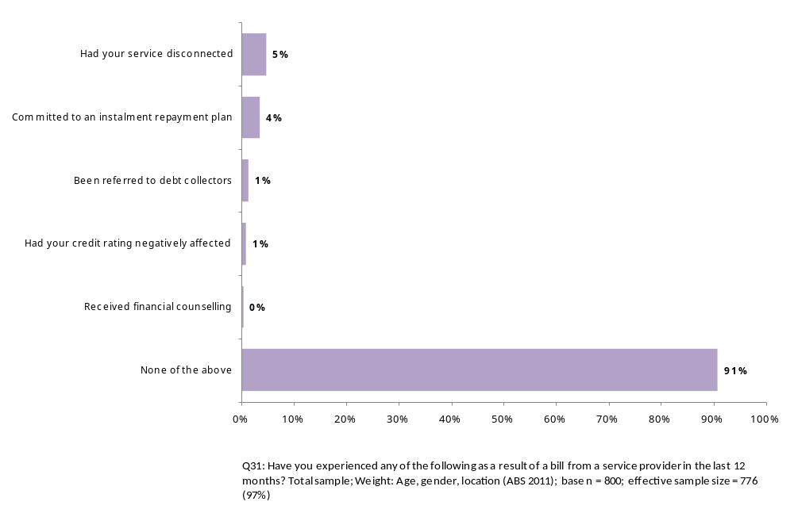
Younger respondents aged between 18 and 34 years were significantly more likely to have had their service disconnected (11% compared with 5%). This group was also significantly more likely to have been referred to debt collectors (3%, compared with 1%).
Figure 54: Whether experienced hardship as a result from a bill
 | Total | Male | Female | 18-34 years | 35-54 years | 55+ years
Had your service disconnected | 5% | 5% | 5% | 11%↑ | 4% | 0%↓
Committed to an instalment repayment plan | 4% | 2% | 5% | 4% | 5% | 1%
Had your credit rating negatively affected | 1% | 1% | 1% | 2% | 0% | 1%
Been referred to debt collectors | 1% | 1% | 1% | 3%↑ | 1% | 0%
Received financial counselling | 0% | 1% | 0% | 1% | 0% | 0%
None of the above | 91% | 92% | 90% | 85%↓ | 90% | 97%↑
Column n | 800 | 391 | 409 | 201 | 312 | 287

Appendix A

QUOTAS:

 | Capital City | Rest of State | Total
Vic | 151 | 50 | 201
NSW | 164 | 93 | 257
Qld | 76 | 83 | 159
SA | 47 | 14 | 61
WA | 64 | 19 | 83
Tas | 8 | 11 | 19
NT | 4 | 4 | 8
ACT | 12 | - | 12
Male | - | - | 391
Female | - | - | 409
Age 18-34 years | - | - | 241
Age 35-54 years | - | - | 292
Age 55+ years | - | - | 267
Mobile only (sample) | - | - | 160
Counter on Mobile only  (Not code 1 in Q1) | - | - | -

