
Annual Report
2009
ACCAN
Australian Communications Consumer Action Network
Suite 402, 55 Mountain Street
ULTIMO NSW 2007

Telephone: 02 9288 4000
TTY: 02 9281 5322
Fax: 02 9288 4019
Email: info@accan.org.au
Website: www.accan.org.au
Australian Communications
Consumer Action Network
(ACCAN)
Annual Report
2009


accan goals and activities

• Improved accessibility, affordability and availability of communications services to all consumers;
• Better informed consumers with access to Australian information and communications technology resources;
• A strong, co-ordinated voice which uses our diversity as a point of strength for communications consumers, nationally and internationally;
• Effective advocacy for consumers to Government, regulators and the industry in the development of policy, legislation and industry practices;
• Inclusive consultation with stakeholders to identify areas and priorities for industry and/or regulatory responses;
• Robust research to support evidence based policy development and consumer education programs;
• Meaningful participation in regulatory and co-regulatory activities including industry codes, standards and guidelines
• Outreach, campaigns and activities that involve consumers in the communications arena
• Enhanced capacity for consumer representatives through information seminars, training and international engagement
• Openness, transparency and inclusion of all parties interested in
representing consumers on communications issues

Chief executive officer’s message


Welcome to ACCAN’s first Annual Report.
ACCAN was created from the need for a strong, co-ordinated consumer perspective in advocacy and representation in communications and information technology with the capacity to present high level policy submissions to government.
Our purpose is to give consumers a strong, unified voice, to improve dialogue and engagement with government and be the interface between consumer groups and industry.
In the short time that ACCAN has been in operation we have already made an impact on the landscape.
We have commissioned foundational research on emerging consumer issues in telecommunications, convergent communications and media; we will be looking at the role and effectiveness of customer service charters and finally we are investigating the issue of informed consent with relation to communications services.
We will work towards building our capacity to empower consumers to make markets more competitive and to effectively address the needs of disadvantaged groups including the disability sector.
The outlook is an exciting one, as we plan campaigns to keep the industry accountable to consumers, work with regulators to ensure they enforce legislative measures and lobby government to develop policy with the interests of consumers.
ACCAN would be in no position to launch its operations so soon after our formation in October 2008 were it not for the solid foundations built by the predecessor organisations, the CTN and TEDICORE.
Members can be confident that ACCAN will develop and advocate dynamic and responsible policies that will include their active involvement and participation.
I also look forward to working with the ACCAN Board in delivering on our strategy in consumer representation across a range of existing and emerging issues in the communications sector over the coming years.


Allan Asher, CEO

Chief executive officer’s message


Many new organisations face a mix of energy, enthusiasm, support and time needed to properly lock in direction. ACCAN has been no different in its first formative year. At the start we relied on a management agreement with CTN and all of the board contributed its range of skills to get the tasks done. We had a contractual agreement with the Federal Government to negotiate, three research reports to complete, an organisation and office to establish and a CEO to hire all within a few months. For this enormous task I particularly thank my fellow board members who gave their time and effort freely and generously.
Our funding base is secure and we are appropriately accountable for the public monies under our guardianship. We have been fortunate to both recruit the very experienced campaigner Allan Asher as CEO and retain the core staff of CTN, including Teresa Corbin in the position of Deputy CEO. The research reports, backed by extensive consumer consultation, have provided both insight and timely direction into the main issues ACCAN must pursue.
Early indications are that we can act as a powerful voice for the consumer and that government and industry will take notice. That is what will drive ACCAN in its fully operational phase; the needs of the consumer and ensuring that everyone is treated fairly.


Alex Varley, Chairperson

ACCAN Founding board
Nan Bosler
President, Australian Seniors Computer Clubs Association, Director of Consumer Telecommunications Network. Nan brings advocacy and non government consumer experience across a range of areas particularly for seniors incorporating interests in outcomes for low income, regional, rural and remote, culturally and linguistically diverse backgrounds as well as the internet and emerging technologies. She has extensive experience in telecommunications specific consumer representation.
Len Bytheway
ACT for Kids and Director (Deputy Chair) of Consumer Telecommunications Network. Len has strong governance experience and brings range of skills and knowledge on disability issues indigenous youth, regional and remote area issues, as well as QAS and strategic planning.
Aaron Davis
Chief Executive Officer, Indigenous Consumer Assistance Network. Aaron’s experience includes Indigenous consumer affairs, Community Council operation, and financial counselling, strategic planning, mass media and online communication.
Gerard Goggin
Professor of Digital Communication, and Deputy Director Journalism and Media Research Centre, University of New South Wales. Gerard has an extensive background in academic and consumer representation across a broad range of communication issues. He also has research, publication and presentation skills; governance skills, communications law experience and experience in not for profit setting.
Catriona Lowe
Co-Chief Executive Officer, Consumer Action Law Centre and Chair of Consumers Federation of Australia. Catriona’s key skills include consumer representation with strong governance and policy advocacy experience, specific telecommunication consumer advocacy, not for profit company establishment and specific merger experience including HR matters, branding and strategic planning. She was a member of the ACCAN working group.
Kyle Miers, Secretary
Disability Representative, Manager, of National Information and Projects with Deaf Children Australia, President of Deaf Australia, and founding member of Federation of Disability Organisations. Kyle’s key skills and experience include community advocacy, particularly for the disability sector, management of community based organisations and strategic planning experience.
ACCAN Founding board
Holly Raiche, Deputy Chair
Executive Director, Internet Society of Australia, Director of Consumer Telecommunications Network. Holly brings legal, strong policy development and governance experience. Holly also has extensive experience in policy advocacy including: privacy, emerging technology and small business issues. She was a member of the ACCAN working group.
Alex Varley, Chairman
Disability Representative Chief Executive Officer, Media Access Australia. Alex’s key skills and attributes include strong governance and marketing experience, links with seniors’ organisations and international contacts.
Sue Salthouse
Disability Representative Director, Didactic Enterprise, Chair of the Communications Alliance Disability Council. Sue’s experience includes governance, women’s and human rights advocacy and diverse community sector board experience. She was a member of the ACCAN working group.

ACCAN
A stronger voice for consumers
In May 2008 the Minister for Broadband, Communications and the Digital Economy (DBCDE), Senator Stephen Conroy, held a forum to consider ways that consumers could have a stronger voice in telecommunications issues. The forum held in Canberra, was attended by representatives from consumer groups, government and industry.
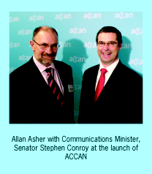
The Minister highlighted his belief that consumers must be adequately represented in telecommunications policy making, especially in an environment of continual technological change, globalisation, evolving market structure and new business models. He expected consumer groups to be “fearless friends” and to speak out and be “feisty”.
At the forum a number of industry organisations presented their perspectives including: The Telecommunications Industry Ombudsman (TIO), Communications Alliance (CA), the Australian Competition & Consumer Commission (ACCC), Consumers’ Telecommunications Network (CTN), Telecommunications Disability and Consumer Representation (TEDICORE), Choice, Australian Telecommunications Users Group (ATUG) and Small Business and Enterprise Telecommunications Group (SETEL).
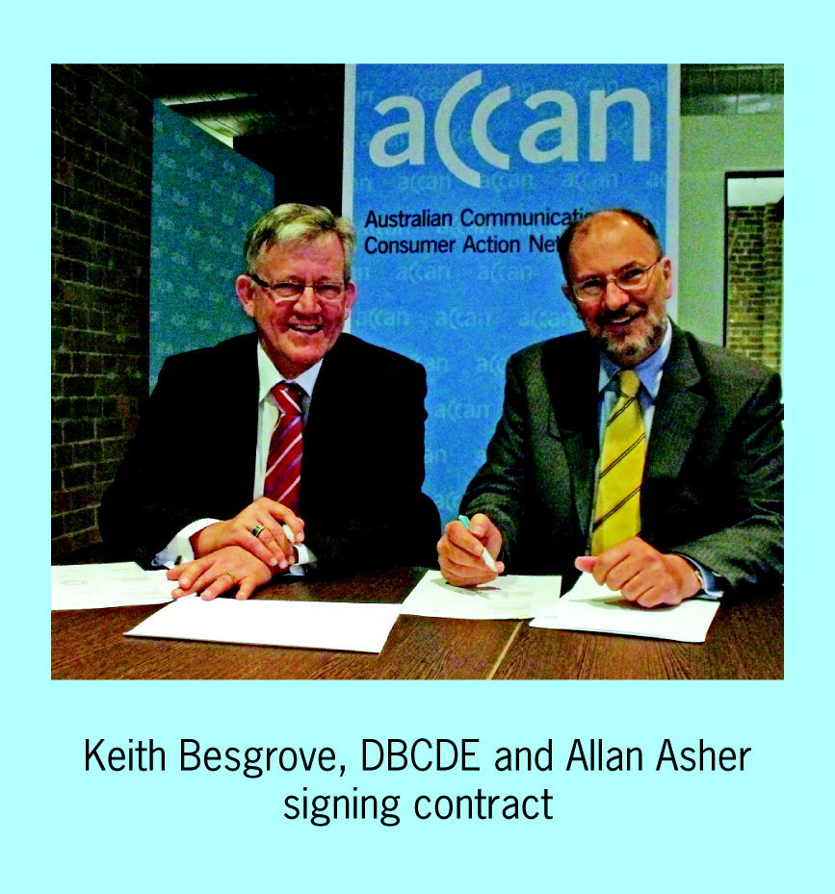
Those present gave a commitment to work towards the establishment of a new peak communications consumer body that represented the diversity of all consumers’ interests.
The role of the consumer peak body would include representation, research, advocacy, information dissemination, capacity building, policy review and comment. It would be structured as a single entity model to ensure that it was a member based organisation. It was proposed that core funding for this new peak body would come from government with a multi-year contract.
A working group was established to prepare a proposal and transition plan. The working group was supported and resourced by DBCDE (the Department) and the Consumers’ Telecommunications Network which was appointed as the co-ordinating consumer group and Philippa Smith, AM, the independent facilitator for the working group and consultation
ACCAN
A stronger voice for consumers
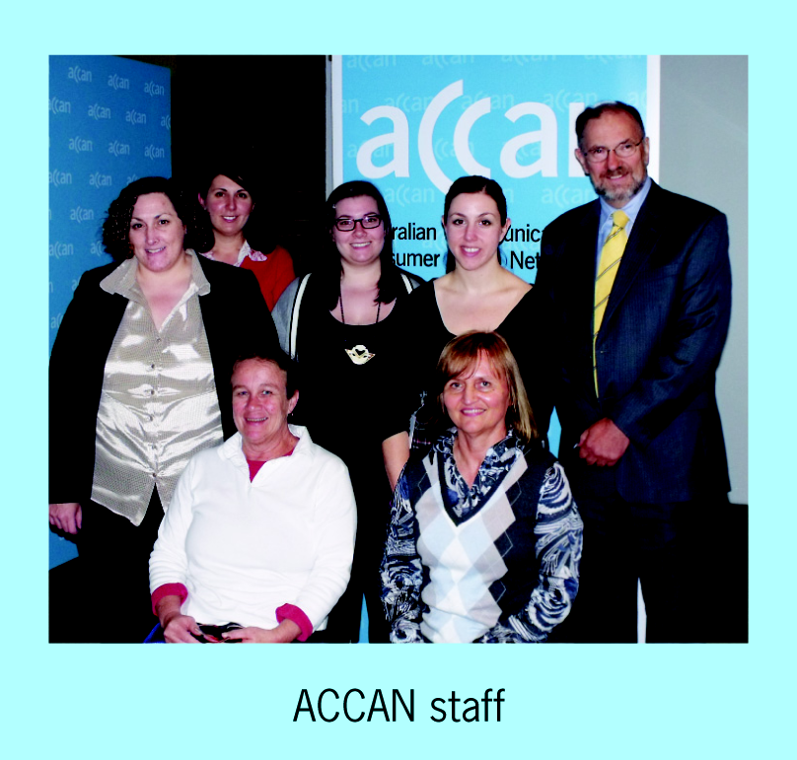
process. Members of the Consumer Representation Working Group included: Gunela Astbrink, National Coordinator TEDICORE; Ewan Brown, CEO SETEL; Cheryl Langdon-Orr, Internet Society of Australia (ISOC-AU); Holly Raiche, ISOC-AU; Christopher Newell, Australian Federation of Disability Organisations (AFDO); Sue Salthouse, Women With Disabilities Australia; Rosemary Sinclair, CEO ATUG; Su Robertson, Acting Director of Communications Law Centre and Teresa Corbin, CEO CTN.
The working group met five times with the Department and also held a number of separate meetings. Feedback was sought from and incorporated into the proposal from a wide range of consumer and small business groups.
Subsequently the purpose, name (Australian Communications Consumer Action Network or ACCAN), and governance structure including an independent grants panel and a proposal for transitional arrangements were developed for the organisation.
In June 2008 the Minister allocated $87,000 in seed funding to enable the working group to engage Maddocks Lawyers to draft a constitution, prepare financial modelling, develop a logo and purchase a domain name
www.accan.org.au, ACCAN’s first web presence.
On 1 August 2008 the working group submitted its proposal for the creation of a new peak body ACCAN to the Minister for consideration by Cabinet in the 2009 Federal Budget.
The founding ACCAN Board was also announced and on 15 October 2008 ACCAN was incorporated and became a legal entity.
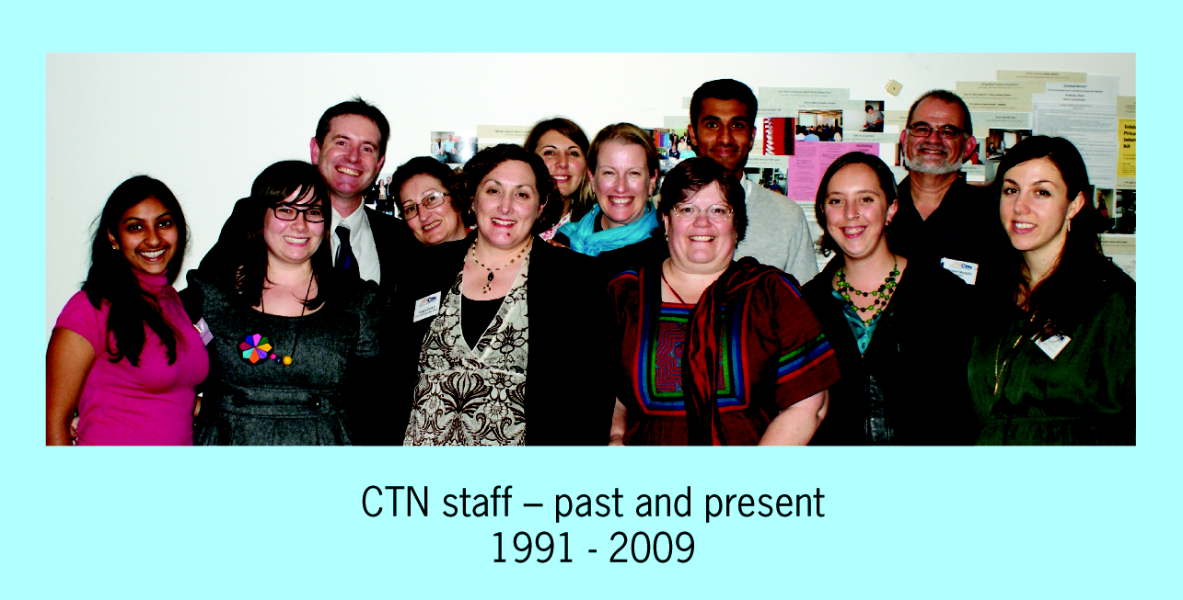
In December 2008 the Minister announced a grant for ACCAN of $500,000 for establishment and $200,000 for research. This enabled the ACCAN Board to meet and begin the next stage of the formation of the new peak body. The Consumer’s Telecommunications Network was appointed as project co-ordinator to oversee this phase.
The ACCAN Board held its inaugural meeting on 17 December 2008 in Sydney and elected Alex Varley as the Founding Chairperson; Holly Raiche as Deputy Chairperson; Aaron Davis as Treasurer, Kyle Miers as Secretary and Gerard Goggin
ACCAN
A stronger voice for consumers
ACCAN
A stronger voice for consumers
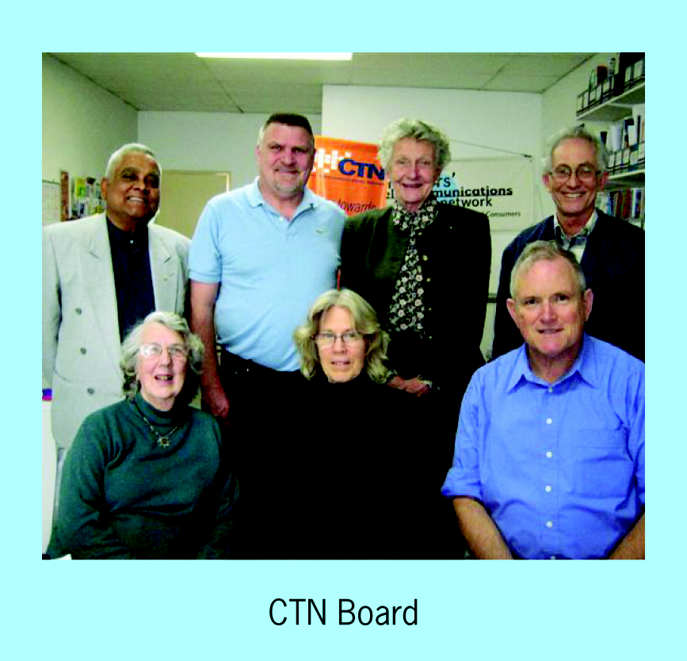
as Media Spokesperson. In the past financial year the ACCAN Board undertook an enormous amount of out of session work to establish ACCAN as a fully operational peak body.
One of the key tasks the board completed was the recruitment and appointment of the ACCAN Chief Executive Officer. On 18 April 2009 ACCAN announced the appointments of Allan Asher as the ACCAN CEO and Teresa Corbin as Deputy CEO, who take up their positions in July.
During this period ACCAN commissioned several consultants to complete three major research projects on Informed Consent; Customer Service and the Future Consumer. ACCAN also moved to agree on Memorandums of Understanding with CTN and TEDICORE. These outlined that staff, any assets and property, intellectual property and representational positions from both organisations would transfer to ACCAN from 1 July 2009. This would ensure that ACCAN would have a base from which to build its new peak body.
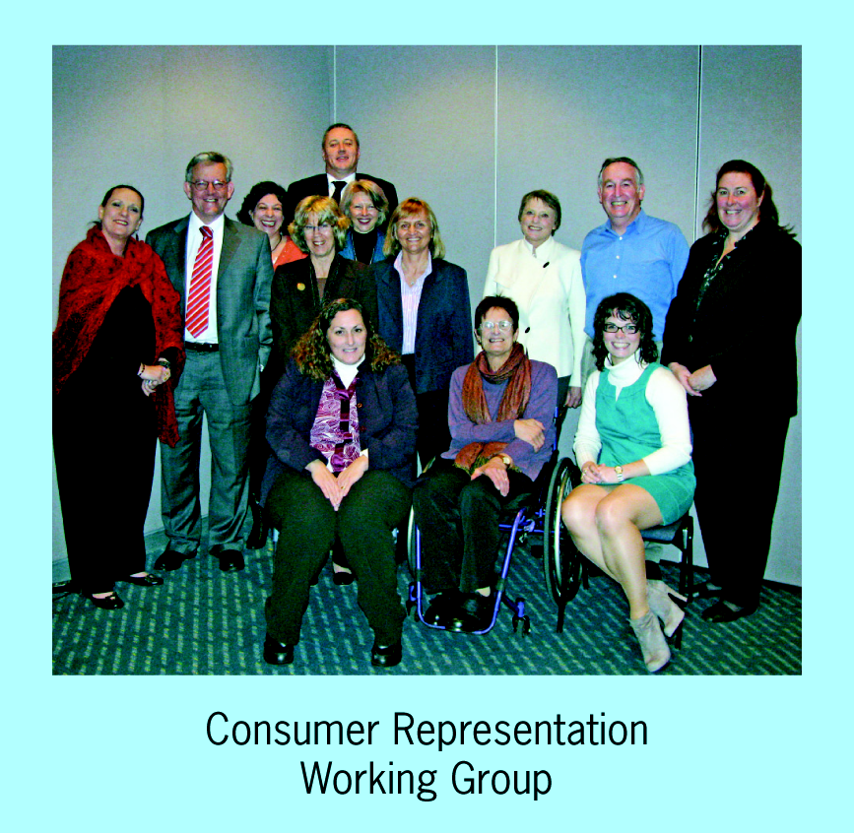
The Consumer’s Telecommunications Network provided a secretariat for the ACCAN Board and for project managing the establishment of a fully operational, accessible office for ACCAN by 30 June 2009. This also involved the development of a website, communications plan and running several events for ACCAN including a Consumer Representation Workshop and a Seminar on the National Broadband Network on 19 May 2009 and a Research Forum on 21 May 2009.
The 2009/10 Federal Budget included funding of $2 million indexed per annum for ACCAN to commence from 1 July 2009 for a four year period. This enabled ACCAN to move into its next stage of establishment and sign a lease for an office in Ultimo, Sydney. ACCAN’s new management team led the negotiations with DBCDE for the multi-year funding contract for 2009 -2013. The Consumer’s Telecommunications Network commissioned work on ACCAN’s office fit out, signage and the installation of cabling and information and communications equipment.
On 30 June 2009 ACCAN launched its new website and moved into its new premises marking the beginning of a new era in consumer advocacy in communications. In just over 12 months a committed group of consumers, industry and government representatives had changed and improved communications consumer representation and research in Australia to a point where the organisation is recognised as a beacon of best practice for the rest of the world.

ACCAN organisation structure

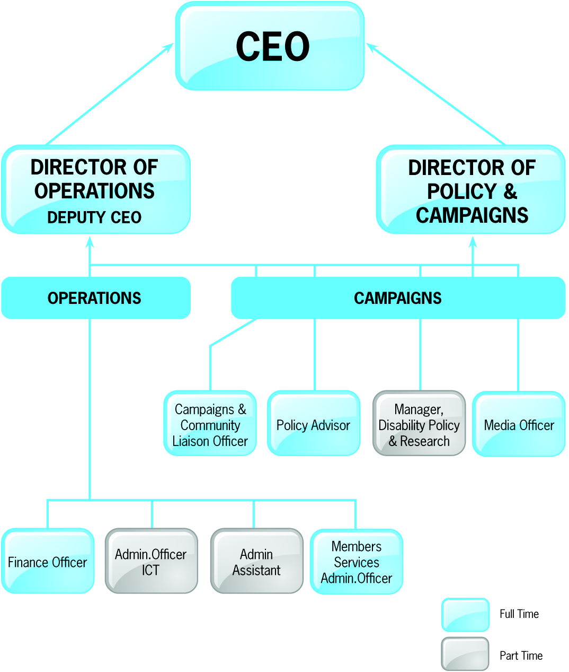

Acknowledgments

ACCAN would like thank the following people for the part they have played in these historic changes and the establishment of the organisation;
Senator Stephen Conroy, Minister for Communications, Broadband and the Digital Economy and his staff; Patricia Scott, Keith Besgrove and the staff at the Department of Broadband Communications and the Digital Economy
Members and their organisations of the Consumer Representation Working Group and Philippa Smith for facilitating the process
CTN Board, members and staff
ACCAN Board
Australian Federation of Disability Organisations and TEDICORE
Consumer representatives and their organisations that provided support and feedback
Community members, too numerous to be named, who have provided comments, input, and support along the way
Maddocks Lawyers, NGO Recruitment and Hoyne Design for going above and beyond their service briefs. Purruna IT; Bowermans Office Furniture; Deans Property; Bay Electrical and Data
We look forward to continuing to work with you in the future as ACCAN implements its vision, mission and strategic plan.
a


Financial Statements
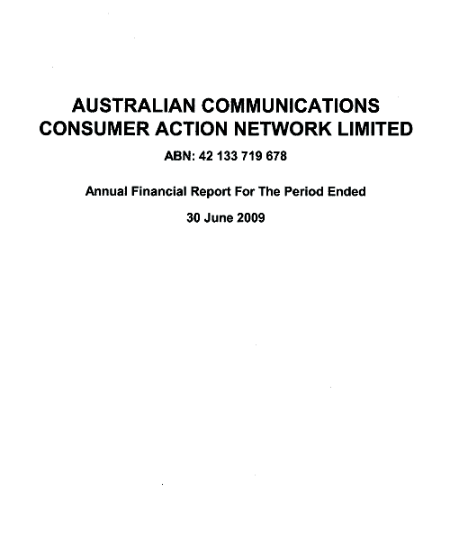
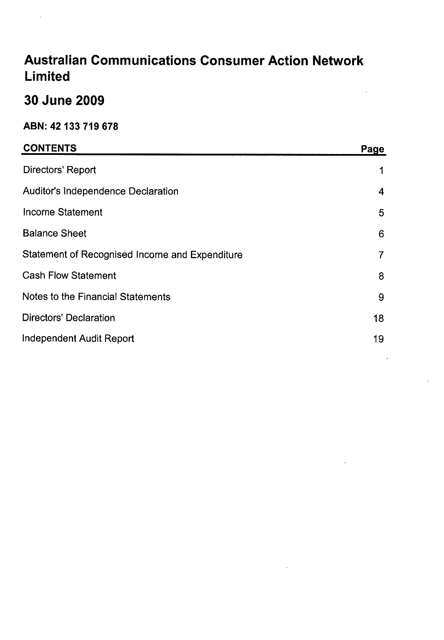a


