Ellesmere Camp c.1885

Reconciliation Week 2023

I live in Kingsgrove, which forms part of the Georges River Council, home to the Bidjigal people of the Eora Nation who have been the traditional custodians of this land for more than 40,000 years. A prominent historical marker close to my area is the Ellesmere Camp, near Endeavour Street reserve, Sans Souci. In 2019, it has been recognised as one of the area’s most cultural and historical markers.
The place is significant as it was home to a number of Aboriginal fishing people in the 19th century. Fishing has been a sacred practice in Aboriginal people’ culture and livelihood for years. The place is located near the water and overlooks Kogarah Bay. The camp has been home for families such as the Malone and Fussill families and has served as a legacy in the Aboriginal culture³. For generations, descendants of these families who were born and lived on this land still have a strong and ongoing connection to the area³.
The image below shows the historical marker that commemorates the Aboriginal Camp along with a marker transcription that inscribes: “Ellesmere Camp, c.1885. Aboriginal people, including the Malone family, lived on the shores of Kogarah Bay, sharing the 'Ellesmere' estate, then owned by NSW Premier, Joseph Carruthers.”²
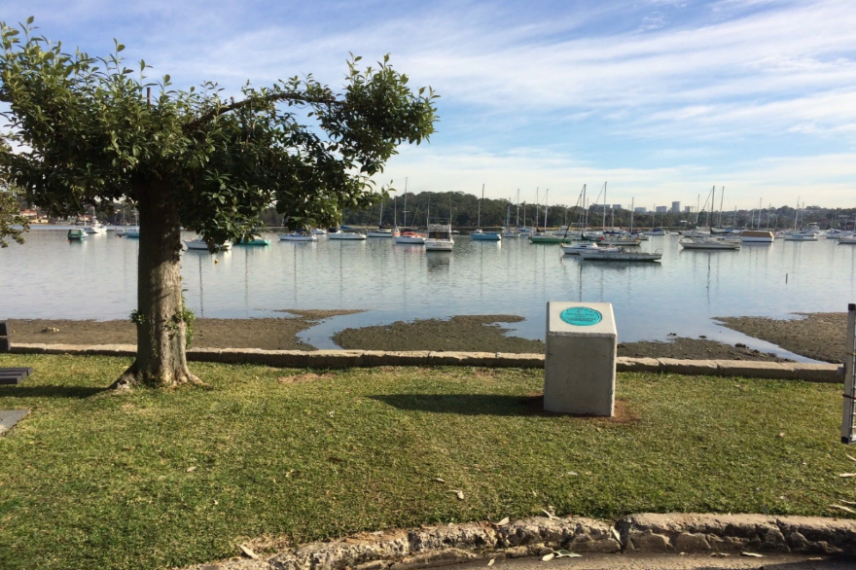

Image: Ellesmere Camp, Sans Souci
Georges River Council²

Georges River Council, ABORIGINAL AND TORRES STRAIT ISLANDER COMMUNITIES, https://www.georgesriver.nsw.gov.au/Community/Our-Community/Aboriginal-and-Torres-Strait-Islander-Communities
Georges River Council, HISTORICAL MARKERS PROGRAM, https://georgesriver.stqry.app/1/tour/7553/item/81579?show-detail-modal=true
Georges River Libraries Local Studies, ELLESMERE CAMP, https://georgesriverlocalstudies.home.blog/2019/09/04/ellesmere-camp/

