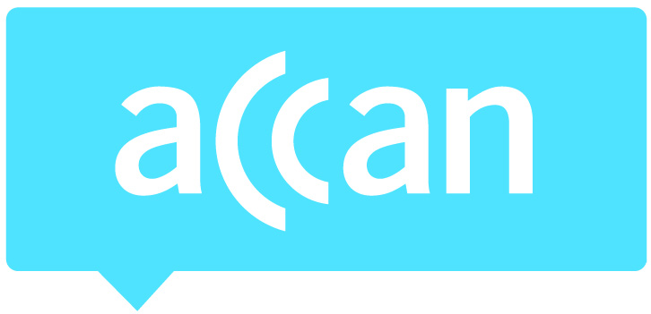
- For immediate release 10th April 2014

App challenge launches to raise accessibility awareness
MEDIA
CONTACT
Mark Callender
Mobile: 0409 966 931
mark.callender@accan.org.au
Phone: 02 9288 4017
TTY: 02 9281 5322
The Australian Communications Consumer Action Network (ACCAN) is Australia’s peak communications consumer organisation. The operation of ACCAN is made possible by funding provided by the Commonwealth of Australia under section 593 of the Telecommunications Act 1997. This funding is recovered from charges on telecommunications carriers.
The Australian Communications Consumer Action Network and the Australian Human Rights Commission have today launched the inaugural Apps For All Challenge 2014, a competition to find Australia’s most accessible apps.
Apps For All is Australia’s first and only competition for accessible mobile apps, aiming to raise awareness of the issues faced by people with disability and older Australians with inaccessible apps.
“This challenge will recognise the apps that excel at including everyone, while encouraging all Australian developers to become leaders in accessibility,” said ACCAN disability policy advisor Wayne Hawkins. “As apps continue to increase in popularity, we can’t leave millions of people behind,” said Mr Hawkins.
It’s estimated that 47,000 apps are downloaded every minute worldwide, while in Australia there were 4.45 million Australians who downloaded smartphone apps in June 2012, increasing 85% from the previous year.
However, millions of Australians may be missing out on the digital revolution if apps aren’t made accessible. According to the ABS, the proportion of Australians aged over 65 will increase from 13% in 2007 to 23-25% by 2056, while in 2009 there were almost 1 in 5 Australians living with a disability. Globally, a report from the International Telecommunication Union claimed over one billion people have a disability that affects their access to modern communications.
“My iPhone is always in my pocket and I use apps for news, weather, travel, reading blogs and of course Twitter, Facebook and LinkedIn. An app that is inaccessible is like closing the door to an area of my life. I just feel shut out,” said Australia's Disability Discrimination Commissioner Graeme Innes.

“This challenge will raise awareness about the value of access for everyone, and show app developers that they can increase their market share by making their apps accessible” said Mr Innes.
Apps For All will award the best mobile apps in the following categories:
1. Most accessible mainstream app
2. Most innovative app designed for people with disability or older Australians
3. Most accessible children’s app
4. Most accessible gaming app

Nominations will close on Monday 14 July 2014 and winners will be announced at the ACCAN National Conference in September 2014.
“As someone who is blind, apps can have an extraordinary benefit on my life, but too often I come across an app which is inaccessible. It’s often fairly simple and inexpensive to include accessibility in an app and there are already the guidelines out there explaining how to do it. It’s just a matter of getting it done,” said Mr Hawkins.
Ends
Media contact: Mark Callender 0409 966 931 or mark.callender@accan.org.au
More information on Apps For All Challenge 2014: www.accan.org.au/app

