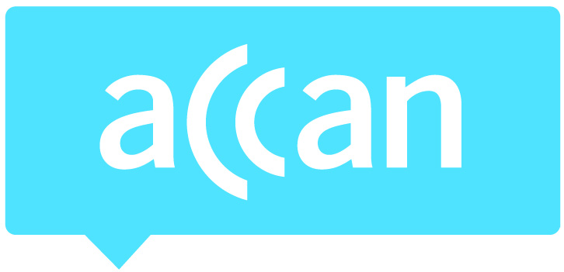
For immediate release 9 November, 2015
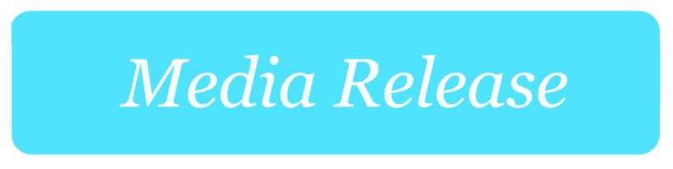

Online video captions must be accurate and readable
The Australian Communications Consumer Action Network (ACCAN) has formed an alliance of organisations representing the interests of Australians who are Deaf, hearing impaired and those who rely on captions for information, to bring attention to the growing issue of inaccessibility of online audio/visual content being posted to websites. Specifically, there are concerns around the amount of video content that is being auto-captioned on YouTube as the vast majority of these videos are not being reviewed for accuracy or readability.
An ad hoc survey of Australian Government websites found a range of problems with video captions, including videos with no captions, video captions with minor misspellings and videos with completely incomprehensible captions. Go to ACCAN’s Facebook page to view a photo album containing examples of incomprehensible captioning. The websites of many Australian politicians, political parties and Government agencies feature these inaccessible videos.
“There is an increasing amount of captioned audio visual content on the internet and we expect all captions to be accurate, readable and comprehensible,” said ACCAN Disability Policy Adviser, Wayne Hawkins. “Bad auto-captions are not only inaccessible, but they reflect badly on organisations and make their videos look like an unintended joke.
“In the same way that any text document published online is reviewed and edited for accuracy, captioned content needs to be reviewed and edited for readability and comprehensibility before being published on the web. If this content isn’t accurate, then a large portion of the Australian population misses out on vital information from Government agencies.”
The latest ABS statistics on disability report that 1 in 6 Australians suffer from hearing loss and this is anticipated to increase to 1 in 4 Australians by 2050. Research undertaken by ACCAN and Media Access Australia indicates that more than 30 per cent of Australians use captions some of the time when viewing video.
“When significant numbers of the population are excluded from government information there are not only consequences for these individuals, but consequences for the whole community,” added Mr Hawkins. “Access to government information and services, political party policies and parliamentary member’s communications is an integral aspect of our democratic society. When inaccurate captions bar access to this information people who rely on captions are at risk of being excluded from full economic, social and political participation.”
ACCAN and the organisations involved have distributed a letter to Federal Members of Parliament and all major political parties informing them of this ongoing issue.
The alliance strongly supports Google’s initiative of providing automatic captioning on YouTube videos. However, we believe that Google can have a greater role in both helping to increase awareness of the importance of closed captions, and ensuring that closed captions on YouTube videos are accurate, readable and comprehensible. We have been in contact with Google to discuss possible solutions and enhancements to the YouTube platform which would address these problems.
The supporting organisations of this initiative are: Australian Federation of Disability Organisations, Australian Seniors Computer Clubs Association, COTA Australia, Deaf Australia, Deafness Forum of Australia, Media Access Australia and the National Ethnic Disability Alliance.
There are a number of online resources available to help make the editing of automated captions straightforward. Some of these resources include: Amara, Google YouTube support, No More Craptions and How to caption a YouTube video by Media Access Australia.
For more information, contact Luke Sutton on luke.sutton@accan.org.au or 0409 966 931 or 02 9288 4000. For the latest updates, follow ACCAN on Twitter or like us on Facebook.

