Regional, Rural and Remote Communications Coalition statement
We the undersigned join together as a Coalition to highlight our collective concern about the lack of equitable access to reliable and quality telecommunications services in regional, rural and remote Australia. We represent the businesses, communities and families of rural and regional Australia.
Our members include some of the most innovative businesses and individuals in Australia. Yet we remain locked out of future economic growth and prosperity through the digital divide – undermining Australia’s productivity.
We firmly believe that access to better communications services across regional Australia will lead to better outcomes for the entire nation.
As a Coalition, we believe there are five fundamental outcomes that must be addressed to ensure equitable connectivity for regional and remote consumers. These are:
- A universal service obligation that is technologically neutral and provides access to both voice and data;
- Customer service guarantees and reliability measures to underpin the provision of voice and data services, to deliver more accountability from providers and nbn;
- Long term public funding for open access mobile network expansion in rural and regional Australia;
- Fair and equitable access to Sky Muster for those with genuine a need for the service, and access which reflects the residential, educational and business needs of rural and regional Australia
- Fully resourced capacity building programs that build digital ability, and development of effective problem solving support for regional, rural and remote businesses and consumers.
These outcomes are ambitious, achievable, and reflect the pressing need for change.
However, they cannot be achieved without leadership and cooperation from government, opposition parties and the private sector. A united ongoing commitment and strategic approach is needed.
Without leadership, and without change, Australia risks growing and entrenching the digital divide between urban and rural telecommunications users. We risk undermining the opportunities presented by digital innovation to the farming community and rural Australia as a whole.
We call on all relevant parties to take action to deliver equitable telecommunications access for regional Australians.

Members of the Coalition are:
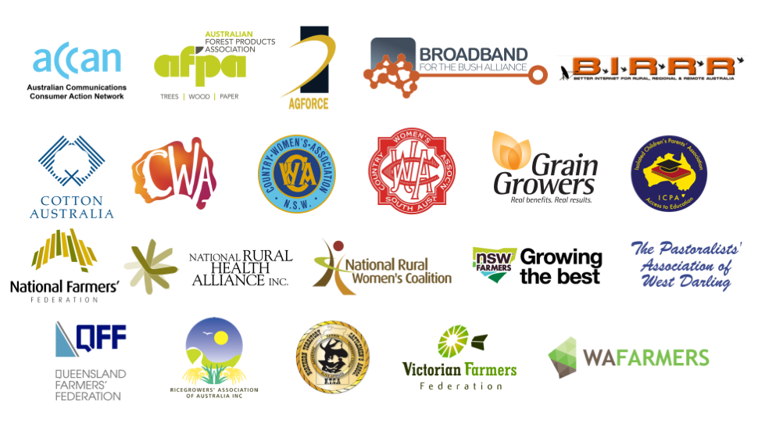

Member websites:
  - ACCAN
  - AgForce Queensland
  - Australian Forest Products Association
  - Better Internet for Rural, Regional & Remote Australia
  - Broadband for the Bush Alliance
  - Cotton Australia
  - Country Women’s Association of Australia
  - Country Women’s Association of NSW
  - GrainGrowers
  - Isolated Children’s Parents’ Association
  - National Farmers’ Federation
  - National Rural Health Alliance
  - National Rural Women's Coalition
  - Northern Territory Cattlemen’s Association
  - NSW Farmers
  - The Pastoralists' Association of West Darling
  - Queensland Farmers’ Federation
  - Ricegrowers' Association of Australia
  - South Australian Country Women’s Association
  - Victorian Farmers Federation
  - WAFarmers

